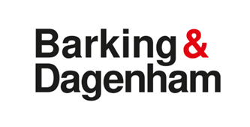

[**https://signvideo.co.uk/nhs111/**](https://signvideo.co.uk/nhs111/)

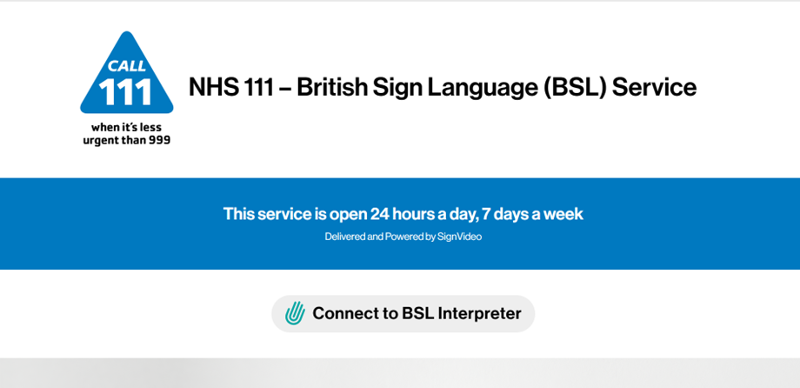

**How the service works in BSL, scroll down page:**

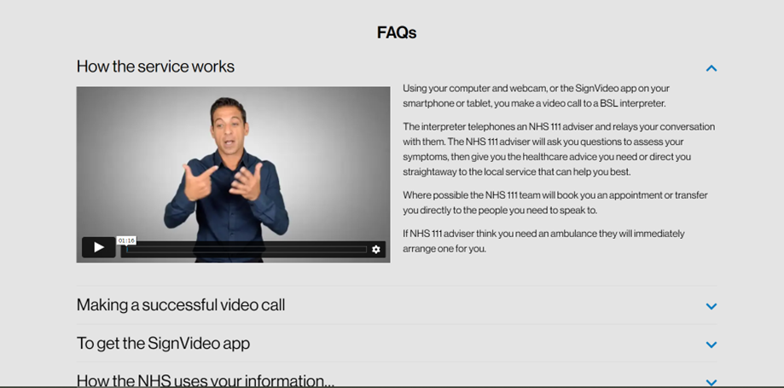

[**https://signvideo.co.uk/nhs119/**](https://signvideo.co.uk/nhs119/)

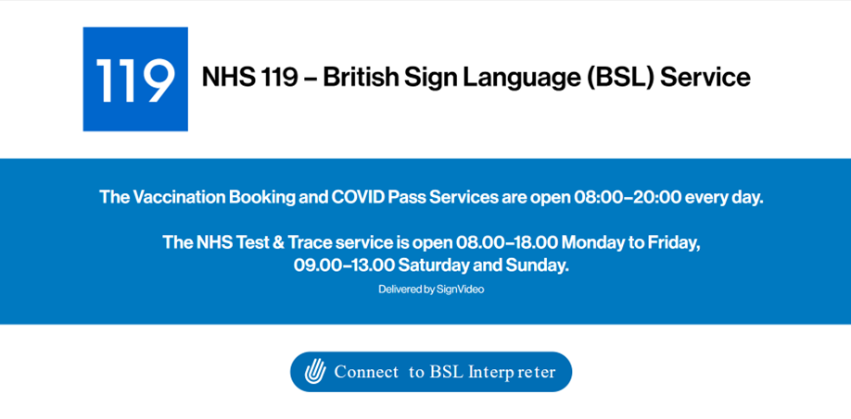

**How the service works in BSL, scroll down page:**

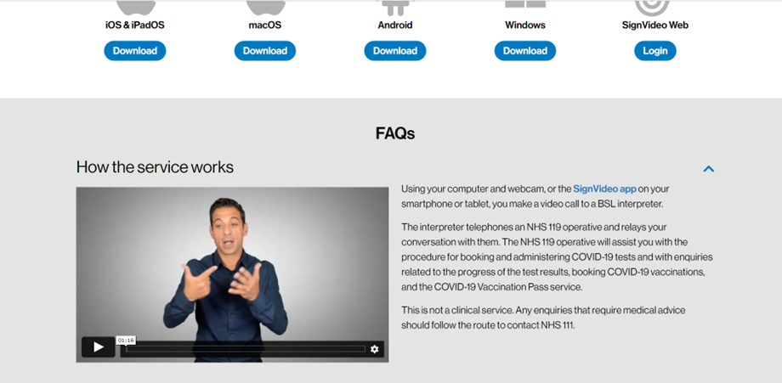

[**https://999bsl.co.uk/**](https://999bsl.co.uk/)

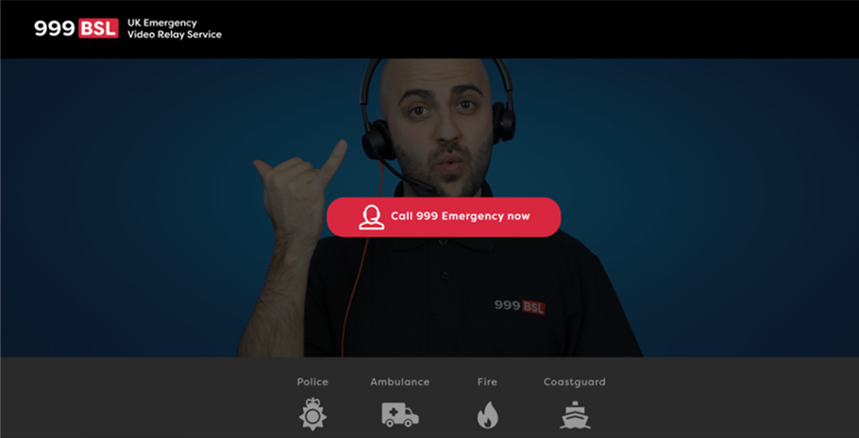

**How the service works in BSL, scroll down page:**

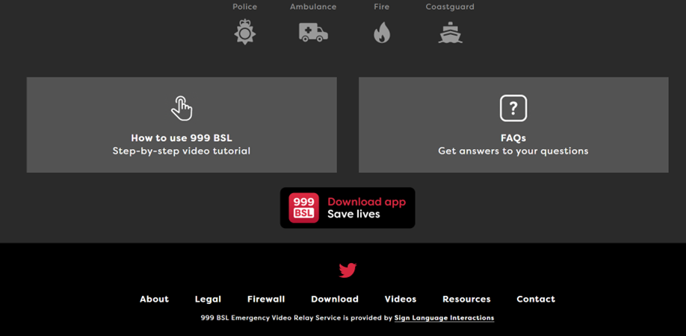

Logo for LBBD investors in people GOLD award logo, Disability confident employer logo and weblinks for LBBD  website, facebook and twitter weblinks: www.lbbd.gov.uk
www.facebook.com/barkinganddagenham
@lbbdcouncil