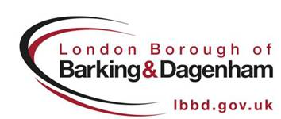

Occasional Sales Licence Application Form

|  |
| --- |
| 1.a. Date of Sale: |
| 1.b. Time of Sale Start:   End: |
| 2. Maximum Number of Stalls, Vehicles, Pitches, etc: |
| 3. Duration of Sale (applicable only if sale is on two or more consecutive days): |
| 4. Location of Sale (include exact area within site): |
| 5.a. Full Name & Full Home Address of Person holding sale: |
| 5.b. Telephone Number: |
| 6.a. Full Name & Full Home Address of Person appointed to receive and answer complaints: |
| 6.b. Telephone Number: |
| 7. Estimated number of people attending: |

|  |
| --- |
| 8. Car Parking Facilities & Arrangements: |
| 9. Proposed Arrangements for controlling:-  (a) Road Congestion:  (b) Litter Collection:  (c) Noise Pollution: |

|  |
| --- |
| Signed: |
| Name in CAPITALS: |
| Date: |

The current licence fee can be found by telephoning 020 8215 3007.

If you would prefer to pay by credit/debit card, please phone Barking and Dagenham Direct on 020 8215 3007, provide the address details of where the licensable activity

will be taking place and ask to pay into cost code F01F270805167600000000000000000000000. You will then need to contact us with your details, the date of transaction and transaction number, and post in your application form for us to process

**Incomplete or incorrect applications will not be accepted or processed**

Please return to:

Licensing Department,

Roycraft House

15 Linton Road

Barking Tel: 020 8215 3007

IG11 8HE