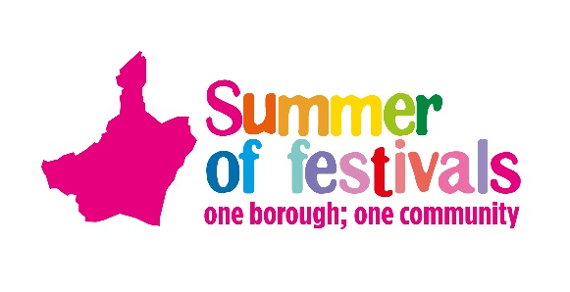
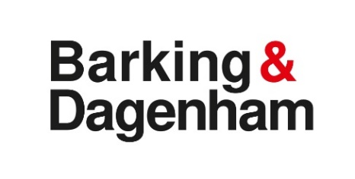
Steam & Cider Fair, Old Dagenham Park, Dagenham, 10 September 2022
Miniature Steam Engine Booking Form

You are invited to exhibit your miniature steam engine at the Steam & Cider Fair on Saturday 10 September at Old Dagenham Park, Ballards Road, Dagenham, RM10 9SA.
Please complete and return by 11 July 2022.
Please bring proof of your insurance on the day.

Contact Sarah Belchambers/Gurvinder Bhaker, if needed, on 0777 708 838 / 07977 018 821.
Return to: summeroffestivals@lbbd.gov.uk or by post to:
Events Team, Barking Town Hall, 1 Town Square, Barking IG11 7LU
Exhibitor Details
Name
Address
Telephone
Email
Full size engine
Please provide a short description and history of your exhibits in order to assist commentator on the day

- 50kg of coal will be provided and a contribution of £50.00 towards your expenses but this is on a first-come first-served basis
- Your engine should be in steam by 10.45am and there will be a parade of engine later in the day time (to be confirmed)
- If you are affected by the Low Emission Zone, please contact us to discuss further.
Declaration
I wish to enter my miniature steam engine to the Steam & Cider Fair on Saturday 10 September and I confirm it is insured in accordance with the road traffic acts and is suitable for the use it will be put to during the event - I accept this is solely my responsibility.
My engine will not be left unattended at any time whilst it is in steam.
I indemnify in full the Steam & Cider Fair and the event organisers in respect of any claims, demands or penalties, damages or costs how so ever arising as result of my participation of the exhibit or equipment as part of the event.

Sign........................................................................... Print Name................................................................................

