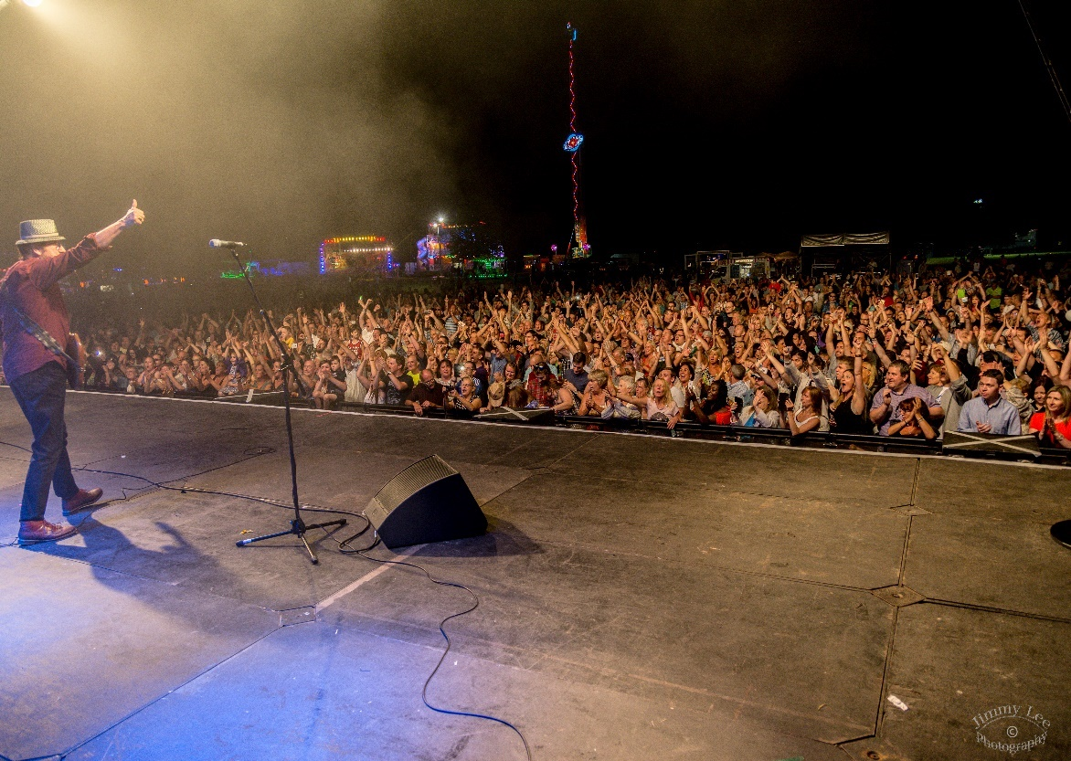 |  | Events and Park Hire Guidance Pack  - Application process

Section 1

The Events Team pride ourselves on being professional, friendly and supportive to event organisers.
The team will consider a wide range of event applications for all types of events including fun days, concerts, sports events and festivals. Funfairs and circuses applications are welcome and are reviewed by the Parks Team.
For street parties please refer to the specific guidance found on www.lbbd.gov.uk/parkhire
Organisers can be commercial companies or charitable organisations.
References
References may be sort for event organisers or promoters if the Council has no prior experience of the event organiser and their work.
This is to ensure the organiser and their team has the necessary skills and experience to ensure they deliver a safe and successful event.

Application Form
Forms can be found in section 3 of this pack or on our website www.lbbd.gov.uk/parkhire
Applications must include the named organiser who can be identified in law as the person with overall responsibility for the event.

The event organiser, either an individual or collective has prime responsibility for protecting the health, safety and welfare of those working at or attending the event.

Applying to hire a park or open space
Please note the Events Team do not process applications for filming or road closures, please see Useful Contacts section for the correct team to contact.
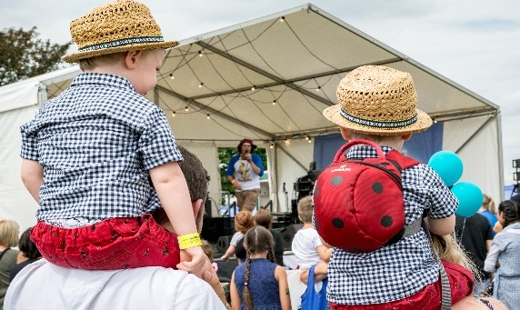
Events will be assessed on the details included on the application form so please fully complete the form with as much detail as possible.
Forms cannot be processed without the application fee.

Timeline
It is essential adequate time is given when applying to hire a park or open space for an event. Insufficient time may lead to your application being rejected.
Organisers should apply in the application window September – February for events for more than 1000 people. Applications submitted out of this window cannot be reviewed. Smaller scale events should apply as early as possible at least 6 weeks prior to the event, otherwise the application will be rejected.
The timeline of the application process depends on the scale of the event and which license is required.

1. Application form and fee

Send your application form, signed terms and conditions and the application fee. The fee can be paid by cheque (payable to LBBD) or an invoice can be requested to be paid within 14 days.

2. Acknowledgement of application
Within 10 working days the Events Team will acknowledge your application by email. If additional information or references are required, this be requested.

3. References and review
When received your application form, supporting information and references will be reviewed by the Events Team and when necessary other colleagues in the Council or Emergency Services.
This stage can take 1-4 weeks.

4. Meetings
The event organiser or organising team will be invited to attend an initial meeting with the Events Team to discuss their application and next steps. In some cases, this is conducted on the phone.
Small and less complex events may not require a face to face meeting.
If the organiser is required to do any form of consultation regarding their event this will be discussed at the meetings. Licensing will also be discussed, in most cases the organiser will need to apply for their own licence.
Follow up meetings, an invite to the SAG and site visits will be arranged as needed.

5. Agreement in principle
If the Events Team feel the event application meets Council priorities and the proposed event is appropriate, safe and there is availability (each park has a maximum number of licensable events per year) and time for a successful delivery an agreement in principle will be sent by email.

6. Proposal to Safety Advisory Group (SAG)
The event will then be referred to the SAG for consideration. The organiser should talk through their application and present their draft Event Management Plan or give an example of a previous plan.
For small scale events the SAG will be informed and the organiser will be required to attend the SAG (for small scale events) nearer to the event date.
The SAG will ask questions, raise any concerns, and give their initial feedback to the organiser. Members of the SAG have 5 working days after the meeting to respond with any questions, objections or concerns.

7. Agreement subject to terms and conditions, licence and SAG sign off
If there is adequate time and park availability, and the Events Team and SAG feel the application demonstrates a safe and appropriate event to take place in Barking and Dagenham - an agreement letter will be issued subject to licensing, SAG sign off and T&Cs.
Terms and conditions should have already been signed.

8. Licence application and other statutory requirements
Licensing can take 10 days to 3 months depending on the type of licence required. You can apply for your licence as soon as your application form is submitted but this is at your own risk and your licensing fee will not be reimbursed if the application is not successful or if the Council/SAG reject your application.
We ask the event organiser to stay in touch during this period if they require support and inform the Events Team if their licence has been successful.
If you require a Temporary Traffic Management Order (TTMO) you should allow 3 months and discuss your requirements with the Events Team and Highways.
The Food Safety Team require paperwork for every caterer 6 weeks prior to the event to approve them. Failure to do so may incur fees or the rejection of the caterer.
Further details can be found later in the guidance pack (Section 2)

9. Health and Safety and SAG
Once your premises licence has been agreed (if applicable) and at least 2 months prior to the event organiser will be required to attend the SAG meeting/s to give a full presentation of their event management plan (EMP).
The EMP including your risk assessment is required at least 2 weeks before this SAG meeting at least 2 months prior to your event.
Feedback on plans will be received at the SAG however members will have 5 working days to respond with any objections, concerns or queries. The Events Team will email if any further amendments are required to the EMP which should be re-submitted within 2 weeks, unless another deadline is set. When amendments have been made, a confirmation email will be sent to confirm the SAG has approved the EMP meaning the event can go ahead subject to T&Cs being met.
It may be necessary to attend the SAG meeting again just prior to your event if requested.
Small events still need to submit their EMP including their risk assessment and any requested information to the Events Team 1-2 months prior to the event and will be required to attend the SAG). Please remember the SAG can reject event plans.
Again, the Events Team will deal with any needed amendments and a confirmation will be sent to confirm the EMP has been approved, meaning the event can go ahead subject to T&Cs being met.
Failure to submit paperwork to the SAG by the set deadline can lead to a rejection by the SAG.

10. Fees
The due date for fees, including the deposit, is 2 months prior to the event.

11. Final site visit
A final site visit will be arranged as your event build period commences; when the park/open space/event area will be handed over to the organiser and, if appropriate, keys signed over to the organiser. The meeting will be attended usually by the Events Team and the Parks Team.

12. Event
The Events Team and other Council officers may attend the event depending on the scale/risk to ensure the EMP is being followed and the license conditions met. If this is the case they should be part of the Emergency Liaison Team (ELT).
The Events Team will always be present if the organiser is using the Council’s premises license.
During build or at the event, emergencies should be reported to the Emergency Services if required and the Council’s Careline number.

13. Post event
The Parks Team will inspect the park after the event breakdown concludes. If there is no damage and the park has been cleaned sufficiently the deposit will be refunded.
We encourage event organisers to debrief with the Council after their event.
Consultation
As part of the application process organisers will be required to consult with park stakeholders (friends groups or clubs) or local residents. This may entail:
- Pre event public notices dispayed in park including timings and any changes to access (essential 2 weeks before)
- Attending a formal meeting or arranging a meeting with key stakeholders
- Writing to local residents/stakeholdlers regarding event plans

EVENT SCALES
Small events - 0-999 people
Medium events -1000-4999
Large 1 events – 5000-14,999
Large 2 events -15,000-40,000
MEDIUM/LARGE SCALE EVENTS SHOULD APPLY SEPTEMBER-FEBRUARY
The Events Team will advise what consultation is necessary. It is always good practice to do a leaflet drop to local residents and venues prior to the event.

Safety Advisory Group (SAG)
The SAG meets every month (except January) on the 1st Wednesday of the month.
The SAG is chaired by the Events Team and membership includes representatives from:
- London Borough of Barking and Dagenham
- Metropolitan Police
- London Fire Brigade
- London Ambulance Service
- TFL
- Event personnel (security/first aider providers etc.)
Event organisers of medium and large-scale events are expected to attend the meeting/s to present their plans.
- Initial event proposals
- Presentations on EMPs
The SAG meeting allows consultation with key partners where members will consider event proposals and plans in detail. Once the event organiser has presented their plans the SAG group has 5 working days to respond with recommendations and concerns.
The Events Team will inform the organiser on the final decision and hopefully give approval.
Small events should attend the SAG to present their EMP 1-2 months prior to the event only.
Fees
Fees vary depending on the scale and nature of the event.
Fees can be paid by invoice or by cheque made payable to LBBD.
Staffing support on the day from the Events Team will required for most medium and large events.
Traffic management, licensing or other costs available on application.
Application fees (exclusive of VAT)
Scale | Commercial | Voluntary
 | £100 | £25
Damage/cleansing deposit (refundable)
Small | £500 | £500
Medium | £1000 | £750
Large (1) | £4000 | £1000
Large (2) | £10,000 | £2000
Park hire fees
(build/event/breakdown days)
All | POA | POA
Environmental fees
All | POA | POA
Staff Support (event days only, per day)
All | POA | NA unless scale exceed 1,000 people
Payment schedule
The non-refundable application fee is due with the application form which cannot be processed without payment.
Other fees will be invoiced and must be paid according to the payment terms of the invoice at least 1 month prior to the event.
Your damage deposit will be refunded if granted after the inspection. This can take up 1 month to be refunded.
Parks & venues
Barking and Dagenham are proud to boast 25 stunning parks and open spaces. To find out more about parks in the borough visit www.lbbd.gov.uk/parks

Some parks are more suited to hosting events than others due to on site facilities, current park usage (sports pitches etc) and transport links. For advice on which parks may be best to hire please contact the Events Team.

Currently a Strategy for Parks and Open Spaces is being written to give further guidance on our parks which will be avaliable soon.

To hire the civic space e.g Barking Town Square please contact the Facilities Team at Barking Learning Centre (see useful contacts).

To hire a park for a circus or funfair or a park venue please contact the Parks Team (see useful contacts).

For all other venues please contact the duty holder for the venue.

Please ensure you adhere to our terms and conditions, designed to protect our parks.
Pl

Event organisers
Applications are welcome from professional events companies, promoters and local organisations and committes. Event orgainsers and their teams must have the correct skills and expereince to organise the event. Organisers must be competant to ensure the health, safety and wellbeing of all event stakeholders.

The Events Team are happy to give advice and support but as they deliver a programme of large scale events themselves they do not have the capacity to be part of your core management team.

To ensure organisers have adequate experience and skills the Events Team reserve the right to gain professional references from other local authorities or stakeholders the event organiser has worked with and their contractors (security companies).
Checks may also be made on proposed contractors e.g security companies.

Useful contacts
Events Team
events@lbbd.gov.uk
Parks Team
rangers@lbbd.gov.uk
Facilities (Town Square hire)
medavies@lbbd.gov.uk
Licensing
licensing@lbbd.gov.uk
Food Safety
foodsafety@lbbd.gov.uk
Highways
highways@lbbd.gov.uk
Noise & Nuisance
noise.nuisance@lbbd.gov.uk

The Events Team can provide more contact details on request for Council Teams and emergency services.

Application timeline chart
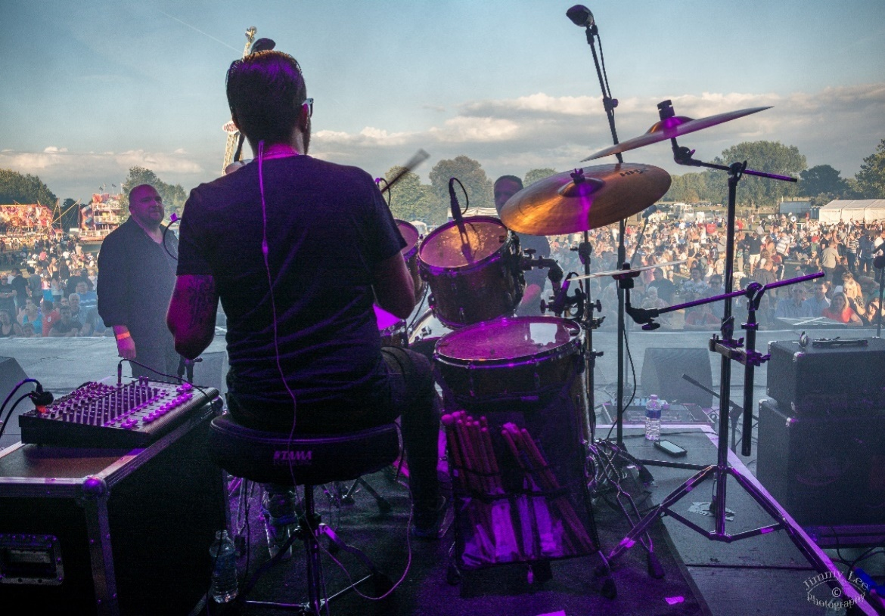 |  | Events and Park Hire Guidance Pack  - Event management

Section 2

Planning your event

In the intial planning phase it’s vital to set a vision for what you want your event to be, asking yourself some important questions:
- Why are we staging the event?
- Who is our audience?
- What type of event?
- Where should it be held?

Once you have a clear vision for your event and what you are hoping to achieve by staging it you can then start to consider other factors, many of these will need to be included in your park hire application form.

Considerations:
- Your team (do your have the right skills, experience, time and knowledge?)
- Budget! (do you have adequate funds to stage this event safely?)
- Time (have you got time to plan and deliver; to fullfil the park hire procedure, consult, gain a licence and market the event?)
- Likely numbers attending
- Are you aware of the booking procedure if you are hiring a park/venue?
- Timings and duration
- Ticketed or free event
- Transport links
- Acessibility of venue
- Closures to roads or transport links
Venue Selection
When selecting a venue you should consider:
- Size and capacity
- Availability
- Location
- Facilities, services and ground conditions
- Other park users, local residents and other events
- Venue hazards
- Access (visitors, contractors and the emergency services)
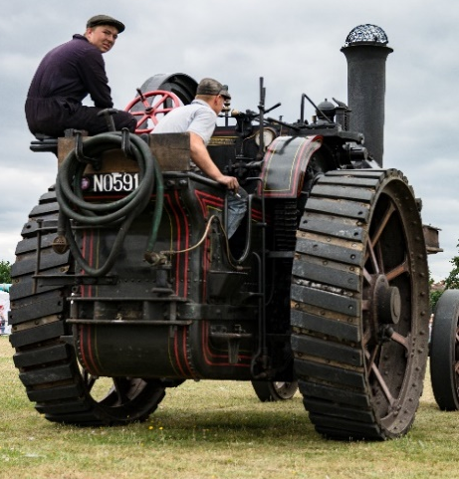

Event management team
In order to stage a safe and sucessful event the team must share the same vision and demonstrate good teamwork and communication. Team members must have clearly defined roles and responsibilities both in the planning and delivery phases including at the event itself. Suggested key roles within the event management team are detailed below:

Event Manager/Director
Holds overall responsibility for the delivery of the event and coordinates and manages the team and all stakeholders. Legally accountable for event.

Site Manager
Responsible for build and breakdown phase. Control site operations and logistics.

Health and Safety Officer
Responsible for the health and safety for all persons at and affected by the event. This person must be competant and if this is not the case a professional company may be required to be employed. Compile or contribute to the the Event Management Plan working with the core team. Ensure all contact details of the team are made available.

Security Manager
Responsible for site and event security. Including the briefing, deployment and management of stewards and security operatives, crowd management and response during an incident.

The event orgainser would be required to hire in a professional security company - this is always the case for licensed events.

Site preparations and infrastructure
Site planning
To ensure public safety and eliminate pinch points its important to plan out your site carefully. It is vital you allow adequate space around stalls and exhibits, stages and entertainment areas and attractions. There

must be no obstructions to visitor routes and at entrances and exits which must be managed and kept clear for:
- Regular access/egress
- Emergency Services access/egress
- Emergency access/egress in the case of a part or full evacuation
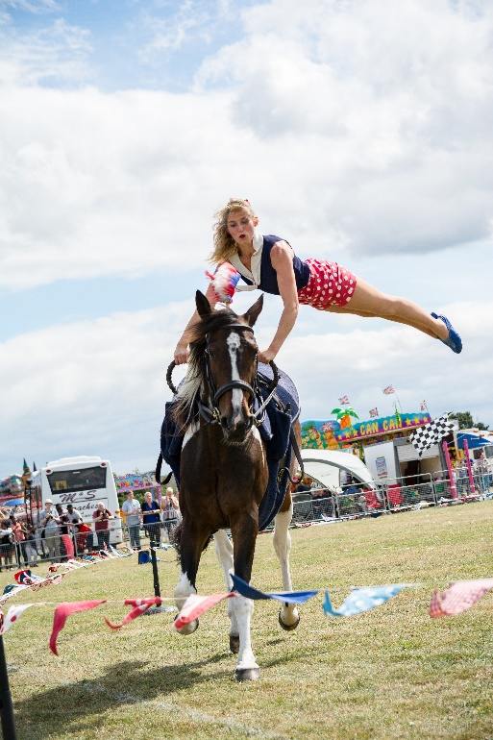

A site plan will need to be submitted showing your event site and the surrounding area. This should be available to your team and crew.
When planning your site you must consider other park users and stakeholders. In the majority of park hires, free access must be given to footpaths, cycle routes and other areas of the park.

Lighting
To ensure the event site is safe during the build and breakdown and the event itself it is important to consider whether you require lighting depending on the time of year and timings and duration of the event and build/breakdown.

Provision of sanitary facilities
It is essential you have adequate toilet facilities for the expected numbers on site. You must have accessible units on site for those attending with a disability and baby change facilities.
Toilets must be hired in as park toilets will not be sufficient and cannot be relied upon.

Toilets should be kept clean throughout the event and may need to be emptied for large scale events during the day or in the case of longer duration events. Facilities including toilets must be clearly signed and located in an accessible and flat area/s of the park.

You will be required to supply details of the number of toilets hired and your supplier to the Events Team on your application form.

The following table should be used as a guide on the number of toilets required:
Female | Male
Events (gate time of less than 6 hours)
1 WC per 100 | 1 WC for 500 plus 1 urinal per 150
Events (gate time of more than 6 hours with little/no food and alcohol)
1 WC per 85 | 1 WC per 425 plus 1 urinal per 125
Events (gate time of more than 6 hours with food and alcohol)
1 WC per 75 | 1 per 150 plus 1 urinal per 250

Provision of drinking water
Drinking water must be available on site. If you are using mains supply this must be discussed with the Events Team as you will need ensure the supply is sanitised.
Alternatively water bowsers or bottles can be used.

Prohibited on site
Glass is not permitted in our parks, which is usually a condition of most Premises Licences. Broken glass is hazardous to park users and animals. Please ensure when using plastic glasses/bottles you should consider recycled materials and then recycling where possible.

Petrol generators are not permitted in our parks, proof will be needed that diesel generators have been booked.

See Terms and Conditions for a full list of prohibited or restricted activities.
Please ensure when you set your entry conditions to the event site these should be clearly displayed, conditions we would expect are:

- No drugs or legal highs
- No weapons
- No uncontrolled dogs (all dogs on a lead)
- No alcohol (if applicable)
- No food (if applicable)
- Drive at 5 mph (if applicable)
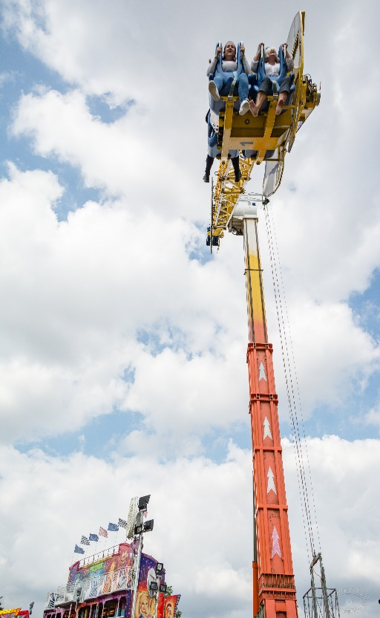
Consider the locations that require power when site planning and mark generators on your site plan.

To ensure your site plan works mark out pitches/areas prior to the build.
Disabled persons
It is essential you consider the needs of disabled visitors and make your event accessible for all. You should consider ground conditions and ensure the event site is as flat as possible. Paths should be suitable for wheelchair users and those with limited mobility as well as buggies.

You should consider the accessibility of attractions and viewing areas for entertainment where possible. We encourage event organisers to arrange for an accessible changing area located near the toilets for those that require this facility.

Information point and welfare
This is where the public and in some cases other stakeholders (stallholders etc) can ask questions and make enquiries. This will help with the reporting of problems which should speed up problems solving at the event. This area is usually also the location for lost children and welfare, lost property and sometimes a meeting point.

Personnel on the informataion point must have all the information needed to field problems and deal with enquiries as they arise. They must be able to communicate with key personnel on site via either a radio or phone. A site book/file will be required to support personnel including maps and programmes. Public signage at this point and others around the site will be required.

Infrastructure

Depending on the size and scale of the event will help determine what infrastructure will be needed which may include:
- Toilets
- Marquees & structures
- Portacabins
- Staging
- Sound and light equipment
- Barriers
- Fencing and gantries
- Generators
- Lighting towers/lights
- Trackway/roadway
- Fire extinguishers
- Support equiment

You will need to know the following to be able to analyse what infrastructure you will need:
- Type of the event
- Outline programme and attractions
- Likely numbers
- Audience profile
- Current facilities on site
- Budget

On your application form you must indicate the types of infrastructure you will bring onto the site including the quantity and supplier. When the form is initially completed this information may not be known but we will require this 1 month before the event.

When booking temporary structures (marquees) as well as reviewing their risk assesment and method statement please ensure you check the manufacturer’s fire test certification. Guy ropes and stakes must not obstruct any route leading to a place of safety. They must be adequately marked so they are clearly visible.

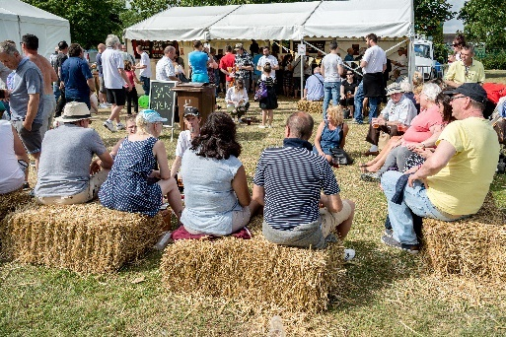
Gain quotes early for infrastructure and equipment as many reputable suppliers will get booked up over busy periods (summer and holidays).
Programming and attractions
The best way to attract an audience is by offering an exciting, engaging and varied programme tailored to your target audience.

Acts and attractions you may consider will include
- Stage headliner and acts (music and dance)
- Arena acts (thrills and spills)
- Walkabout acts
- Meet and greets
- Shows (theatre, magic, comedy etc)
- Workshops and activities
- Competitions, master classes and have a go sessions
- Demonstrations
- Re-enactment
- Inflatables
- Funfair rides
- Talks
- Art or lighting installations
- Exhibitions
- Film screenings
- Balloon race
- Experience areas (chill out, play, vintage make up, fancy dress, beach etc)
Always remember to make the event come to life and enhance your visitor experience presentation, dressing and branding of the event is very important.

In order to programme your event successfully and safely you should consider the following:
- Type of the event
- Audience profile
- Health and safety
- Following of the act
- Budget
- Licensing
- Contract and hospitality rider
- Technical rider and requirements and costs
- Space requirements
- Likely numbers
- Ground and weather conditions
- Build and breakdown and logistics
To ensure your acts and attractions compliment each other consider the programme as a whole and the site layout. Time clashes and noise pollution should be avoided and adequate change over times should be allowed for acts on stage or other performance areas.

Your application should include your proposed and the confirmed programme and attractions.

For high profile named acts the police and SAG may undertake checks to ensure the act is suitable for the event ensuring public safety. Acts and attractions can be rejected based on health and safaty reasons or if the acts profile contradicts Council priorities.
Inflatables and rides
Bouncy castles, inflatables and rides are a popular attraction at family event if run as free or paid but can pose health and safety risks.

It is vital a reputable supplier is used and health and safety and insurance documents checked meticulously. It is good practice to request the following documentation:
- Public liability insurance (Council requires £5m)
- Risk Assessment
- Method Statement
- Operating and safety procedures
- Technical specifications of equipment used on site including safety certificates issued at the time of manufacture
- Maintenance records and current certificates of inspection from an authorised inspection body (PIPA or ADIPS)
- Membership detail of authorised body or organisation
- Evidence of compliance with HSE best practice or legislation
- Proof of staff training
- Details if the company or individual has been prosecuted under any health and safety legislation
More information on HSE website:
http://www.hse.gov.uk/entertainment/fairgrounds/inflatables.htm
Licensing and insurance
If your event includes one of the following licensable activities it is likely you will require either a Temporary Events Notice (TEN) or a Premises Licence.
- The sale of alcohol
- Musical performance
- Film screenings
- Dance, plays or theatrical performances
- Indoor sports (including inside marquees)
- Serving hot food between 11pm and 5am

Events over 499 attendees will require a Premises Licence and those under a TEN. For advice on licensing and to discuss if you require any additional licences and confirm fees contact the Licensing Team.

TEN | Allow 10 working days
Premises License | Allow 3 months

To apply for your licence:
https://www.lbbd.gov.uk/business/licenses-and-permits
Some of our parks have their own premises licences but in the majority of cases event organisers are required to apply for their own licence.
If the event includes a bar a Designated Premises Supervsior (DPS) Form must be completed 6 weeks prior to the event to transfer the current DPS over to your DPS and bar operator. The DPS or personal licence holder must be site during the event.
Insurance
Event organisers may be held legally responsible for injuries that occur during the event/build and could be liable for costs or damages, therefore it is important to take out public liability insurance.

Barking and Dagenham Council require a minimum cover of £5 million for public liability insurance. For large events, including fun fairs, concerts, firework displays or circuses, cover of £10 million may be required.

If the event organiser employs staff, who are directly answerable to them, then employer’s liability insurance cover of £5 million will also be required. This should be requested if your contractor employs more than 5 members of staff.

Please note that public liability insurance only covers the event organisers liability as the organiser of the event unless the policy specifically includes the liability of those participating in the event such as attractions, rides, food stalls, etc.

It is the responsibility of the event organiser to ensure that all participants in the event hold appropriate public liability insurance for their activity. The event organiser must ensure appropriate insurance cover is in place for all rides, attractions, food concessions and inflatables.

Public liability should also be gained from contractors working on site. The insurance must be in the name of the organisation, association or company. They must not be in the name of an individual.

It is vital that accidents, incidents and near misses are recorded as they may lead to a claim. In the case of damage to property or an injury full details must be written down and reported to your insurance company immediately.

Check hire agreements with your contractors to check who is responsible for insuring hired equipment as it does vary but you may need to take out insurance for loss and damage.

Other types of insurance
for events include all risk cover against damage to the venue or against bad weather causing financial loss or event cancellation.

Proof of your public liability and other insurances will be required by the Events Team and should be included in your Event Management Plan.
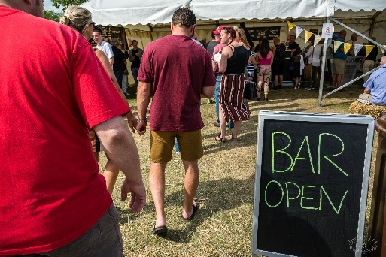
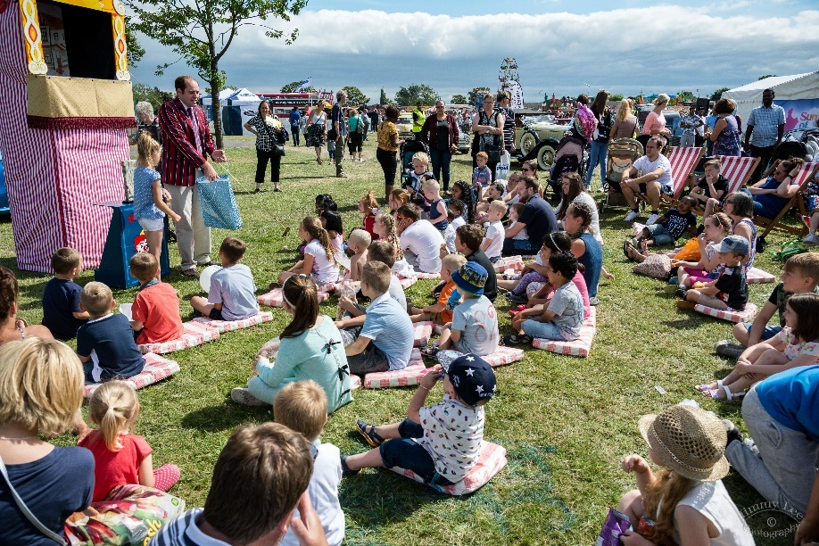
Other statutory requirements
In additon to licensing you may need to discuss event plans with other regulatory services within the Council such as the Food Safety Team.

Food safety
Our Food Safety Team can advise on food safety and hygiene. They will require the following documentation sent for each caterer at the event at least 6 weeks before the event.
- Proof of local authority
- Registration and hygiene rating
- Food hygiene certificates
- Risk assessment
- Fire risk assessment
- Hazard analysis and critical control point assessment
- Method statement
- Gas safety certification
- Completed food safety questionnaire
- Supporting documetation if requested
If paperwork is not submitted by the deadline you may be subject to fees and approval for your caterer/s may not be granted.
Please note the Food Safety Team may inspect during the event, if this is the case they will inspect using the criteria set out in the food safety checklist.

Temporary traffic management orders
When considering traffic management for your event depending on the scale, numbers of attendees and the park location you may need to apply for a Temporary Traffic Management Order (TTMO) for your event. This will be the case if you need to temporarily stop or limit vehicular access on the highway, stop or limit parking near to the event site or alter the usual flow of traffic (e.g no right turn out of the event site).

You should allow 3 months for your TTMO and please note fees apply for this application.

During your intial meeting with the Events Team it will be discussed whether your event can be part of our annual blanket TTMO for multiple events that will be taking place in the borough which may decrease the cost slightly. This will only be possible if we have adequate notice and if the Highways Department agrees to this inclusion.

Waste management
It is important to plan how you will manage your waste on site as early as possible.
As the event organiser you are responsible for ensuring the park is left as it was found at the start of the hire agreement. If the clean is not acceptable the deposit will not be reimbursed after the event.

You must manage the following types of waste:
- Cardboard and paper containers and packaging
- Cans and plastics
- Food waste from visitors and concessionnaires
- Water waste
- Human waste

You should ensure you have adequate bins that are regularly emptied on the site. To keep on top of the waste it is advisable to have regular litter picking and cleansing throughout the event. For large scale events we would recommend you contract a professional company, they should have a waste licence.

If you wish to gain a quote from the Council for this service please request contacts from the Events Team.

We encouarge event organisers to recycle where possible and promote the use of biodegradable and sustainable products.

Noise management
It is important that your event does not cause excessive noise disturbances to local residents. Noise levels may be set as part of your Premises Licence and the management of noise is an area which must be covered in your EMP. This should include a detailed plan of what noise is expected and from which areas; and monitoring procedures in place to ensure noise is kept to an acceptable level.
Event personnel
In order to run a safe and successful event you will require the services of the following:
- First aid
- Security and stewards
- Car park attendants (possibly)

First Aid
First aid must be provided for your event, the level of cover will depend on:
- Numbers attending
- Duration of event
- Risks associated with attractions and entertainment at the event
- Alcohol on site

A medical risk assessment should be carried out to assess the level of cover needed.

The London Ambulance Service should be informed of medium and large scale events. This can be done via the SAG or your first aid provider.

All staff providing medical cover must hold current certificates of qualifications, for example, paramedics and technicians hold certificates of proficiency in paramedical and/or ambulance aid skills issued by the Institute of Health Care Development (IHCD). First aiders must hold a current certificate of first aid competency, accredited by the Health & Safety Executive (HSE).

First aid should be located on site in a central and well signed location which offers cover for on site treatments. First aiders should arrive at least an hour before the event and stay until the site is clear or after. First aiders may need to be deployed to mobile locations on the site also.

Under the Health and Safety (First Aid) Regulations 1981, employers are responsible for ensuring that first aid facilities, equipment and personnel are provided for their employees if they are injured or become ill at work. It is strongly recommended that a written agreement between the various employers (e.g. contractors working at the event) is made to ensure that the first aid provided is adequate. Therefore, it is important to consider cover for the build and breakdown as well as the event. Employees who are appointed as first aiders must have successfully completed the necessary training with an HSE approved training organisation.

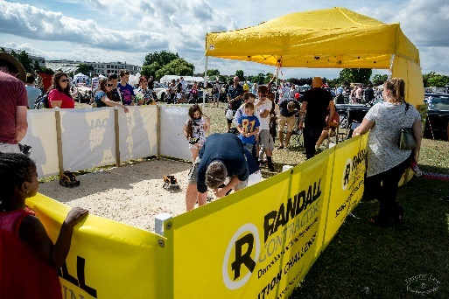
It is vital that all personnel working on site attend a briefing/s to ensure everyone is following the key procedures of your EMP!

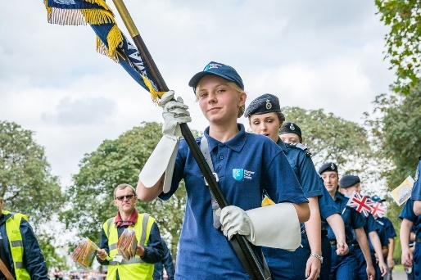
Your medical risk assessment will determine your first aid numbers

Security and stewarding
The role of security and stewards is interlinked but is different and can be easily confused. It is important security and stewards communicate to ensure effective crowd management. Usually stewards and security are provided by the same company but this is not always the case.

The role of stewards is to provide information and advice to people attending the event.

The main responsibility of security officers is crowd management. They are also there to assist the police and other emergency services if necessary. They can also undertake specialist work provided for the protection of performers.

When choosing your security company, you should ensure they have appropriate event security experience - you may wish to gain references to review along with their health and safety paperwork.

The Council requires organisations employing stewards to ensure they have been adequately trained in dealing with potentially violent or aggressive behaviour and diffusion and de-escalation techniques. They must have a Manned Guarding Licence from the Security Industry Authority (SIA), as required by the Private Security Industry Act 2001.

If the event is licensed (Premises Licence or Temporary Event Notice) door supervisors with an SIA licence will be required. The Events Team will need evidence of your security/steward licences 1 month in advance of the event which will checked against SIA website.
Security operatives should be easily identified and should display their SIA badge at all times.

A guide on numbers is one security operative per 100 persons however more accurate numbers should be determined from a risk assessment and following a site visit. Where there is a stage, sufficient numbers should be deployed on the barrier line to prevent access over the barrier and to rescue persons in need of first aid or if an incident occurs, for example, an altercation at the front of stage.

Areas of the event where security are usually deployed are:
- Stage including the pit
- Backstage
- Arenas/entertainment areas
- Bar
- Access/egress points
- Emergency entrance/exits
- Mobile units (response roaming teams)
- Car parks (but this may be car park attendants)
- High crowd density areas
- No entry, restricted entry or queues

It is imperative that organisers retain control of their event with a definite chain of command where stewards and security officers are aware to whom they are responsible and can refer matters for decisions. Briefing of stewards and security is essential to ensure everyone is aware of procedures, roles and responsibilities and entry conditions to the event.
Stewards/security officers should confine themselves to acting on the instructions given by the event organiser or on direction or advice received from the police.

The security operatives are responsible for the discipline within the event. Remember police may or may not be on site and you should not plan for police presence within security plans.

If in attendance the police will usually only intervene if there is:
- Breach of the peace or the law
- Security officers failing to take action as requested
- Attendees ignoring steward/security requests

The use of tact and good humour cannot be over emphasized as it has the effect of defusing potentially difficult situations. People attending any event are likely to respond positively to organisers and their stewards and security officers who display the ability to control the event. The response is more likely to be achieved if stewards or security ensure that they give attendees or participants polite, clear, and accurate directions and advice, which they cannot do if not fully briefed themselves.

Volunteers
Volunteers can assist with stewarding and marshalling however strictly they should not be within your stewarding numbers. They must be included in your risk assessment.

The Council understands voluntary sector groups organising events may have limited budgets to stage events so hiring in paid security and stewards will be challenging. However, it is essential that the security and stewarding plan is robust and appropriate for the scale of the event and the risks associated with that event. It is a legal requirement for licensed events to have SIA security operatives.

Volunteers are a great asset and have an important part to play in the event but they are not security!

It is important to consider the welfare of your volunteers who, under the Health and Safety at Work Act, are the responsibility of the event organiser, the same as staff and contractors on site.

Please ensure volunteers are given
the right role for their capabilities and experience. They should be fully briefed including matters of health and safety and what to do in an emergency and must understand who and where to go to if they have a problem or question. You may consider volunteer training in advance of the event.

Volunteers should have regular breaks and if possible a sheltered and comfortable rest area and if agreed subsistence (drinks/food).

A volunteer that feels appreciated will be the best ambassador for
your event, a thank you goes a long way in building a great
motivated team! Building teamwork between staff, volunteers and contractors is very important for all involved. A strong team with good communication should result in a great event.

Duties you may wish to consider for volunteers are listed below.
- Giving information to the public and way finding
- Distributing marketing (before/during the event)
- Assisting with family and low risk activities
- Marshalling activities and routes
- Time keeping and overseeing competitive elements of an event (races/sports)
- Litter picking
- Assisting with car parking (not alone)
- Running and assisting with hospitality
- Surveying

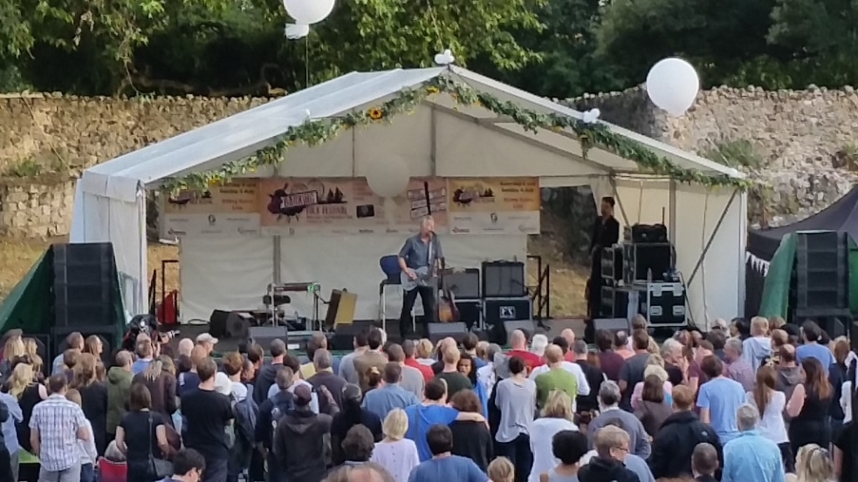

Car park attendants
It is important to have competent personnel responsible for your car park area/s to ensure it is safe, well laid out and organised to minimise traffic build up in/out of your event that may affect the public highway.

Car park duties include directing traffic, parking and cash handling.

Car parks can be the responsibility of your security company or a specialist company.

Other Personnel
Depending on the nature and scale of your event you may need other personnel offering specialist services to your event. If this is the case the same rules apply, you should seek references if necessary and review their health and safety paperwork.

Health and safety management

The event organiser has prime responsibility for protecting the health, safety and welfare of everyone working at, or attending, the event under the Health and Safety at Work Act and other supporting acts and regulations. The event organiser must develop a formal event health and safety management plan (also known as the Events Management Plan (EMP)) and keep a file of supporting information.

A full risk assessment must be carried out. This is a legal requirement and is key to managing risk. The risk assessment should be included in your EMP. In addition, you must also consider what could go wrong on the day and draw up a contingency plan to deal
with each emergency or contingency.

Risk assessments
To meet the Council’s requirements, you must carry
out a risk assessment to:
• Identify all possible hazards
and decide who might be
harmed and how;
• Check the risks, the likelihood and effects of hazards happening and decide on the action you will take to minimise the risks; and
• Work out how you will put your planned action into practice and keep a written record

Identifying the hazards
All hazards should be identified including those relating to the individual activities and any equipment. A hazard is something with the potential to cause harm. Only note hazards which could result in significant harm. The following should be considered:
- Any slipping, tripping or falling hazards
- Hazards relating to fire risks or fire evacuation procedures
- Any chemicals or other substances hazardous to health e.g. dust or fumes
- Moving parts of machinery
- Any vehicles on site
- Electrical safety e.g. use of any portable electrical appliances
- Manual handling activities
- High noise levels
- Poor lighting, heating or ventilation
- Any possible risk from specific demonstrations or activities
- Crowd intensity and pinch points
- Noise exposure

This list is by no means exhaustive and care should be taken to identify any other hazards associated with the activities at the event or during the build.

Identifying those at risk
A risk is the likelihood that any hazard will cause harm.
For each hazard identified, list all those who may be affected. Do not list individuals by name, just list groups of people including:

- Stewards
- Employees
- Volunteers
- Contractors
- Vendors, exhibitors and performers
- Members of the public
- Disabled persons
- Children and elderly persons
- Local residents
- Expectant mothers
- Potential trespassers

Examples of areas to consider:
- Type of event
- Potential major incidents
- Build, running and breakdown of event
- Site hazards e.g. equipment
- Vehicle movement and car parking
- Types of attendees such as children, elderly persons and the disabled
- Crowd control, capacity, access and egress and stewarding
- Provision for the emergency services
- Provision of first aid
- Provision of facilities
- Fire safety
- Security and cash collection
- Health and safety issues
- Exhibitors and displays
- Rides and attractions
- Structures
- Waste management
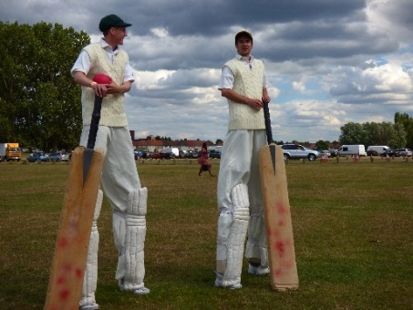

Assessing the risk
The extent of the risk arising from the hazards identified must be evaluated and existing control measures considered. You should list the existing controls and assess whether any further controls are required.

Existing controls would include information, instruction and training regarding the event and the activities involved. Compliance with legislative standards, codes of good practice and British Standards.

The existing controls should have reduced the risk as far as is reasonably practicable if not further action may be necessary to control the risk.

Classify risks into high, medium and low. Examples of risks falling into these categories are as follows:

High
An unsecured inflatable being used in high winds.

Medium
A display of small animals in a roped off arena.

Low
A mime artist performing amongst the crowd.

For each risk consider whether it can be eliminated completely. If it cannot, then decide what must be done to reduce it to an acceptable level. Only use personal protective equipment (PPE) as a last resort when there is nothing else you can reasonably do.

Consider the following:
- Removal of the hazard
- Preventing access to the hazard e.g. by machinery guards or use of barriers
- Implement procedures to reduce exposure to the hazard
- The use of personal protective equipment
- Find a substitute for that activity/machine

Record the risk assessment findings
It is important to record your findings in a risk assessment, the Council template in section 3 can be used if required. You could also refer to other documents you may have, such as manuals, codes of practice etc.

Review and revise
If the nature of the risks changes during the planning of the event, the risk assessments will need to be reviewed and updated.

Information
Where the risk assessment has identified significant risks, you must provide information to all those affected, regarding the nature of the risk and the control measures to be implemented.

For further information and guidance on undertaking a risk assessment please follow useful link to HSE website http://www.hse.gov.uk/risk/risk-assessment.htm

As an important part of the risk management process applies to your participants including contractors, stallholders, workshop facilitators, ride operators, caterers and specialist performers who should all provide the following health and safety paperwork:
- Risk assessment
- Method statement
- Public liability insurance
- Specialist or supporting health and safety paperwork (e.g. work permits, PAT testing certificates, accident records or proof of staff training)
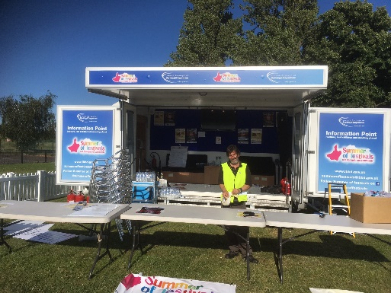

Your risk assessment is an important planning tool, try not to be put off by health and safety but embrace it as it protects you as the organiser as well as all involved in the event.

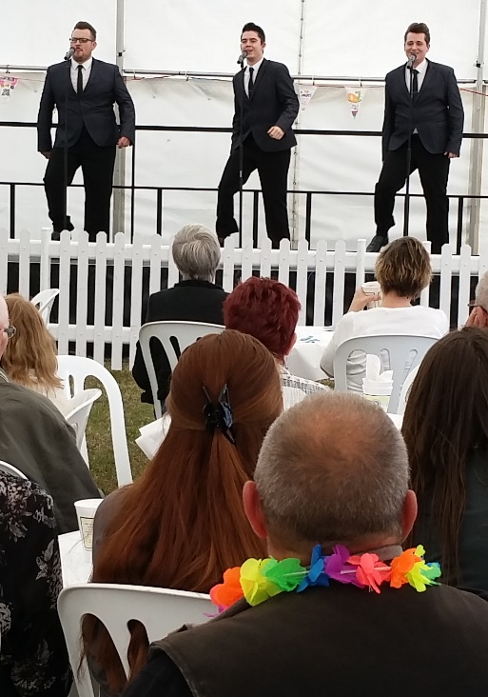
Event Management Plan (EMP)
As previously mentioned the EMP must be submitted for review by the Safety Advisory Group (SAG).
It is understood this is a working document therefore on first submission it may not be fully complete but it is important as it includes sufficient detail for the group to make an assessment. If this is not the case the event will not be able to go ahead.

Writing your EMP may seem like a daunting task but it is a great tool to help you plan and deliver all elements of your event to ensure you stage a safe and successful day for all stakeholders.

The plan/file will usually consist of the following sections and details where applicable. This is only a guide and you may want to use another template.

1. The Health and Safety Policy Statement
Include policy statement and management system to support the statement.

- Event details
- A description of the event, including any special requirements
- The programme of events and how it is to be organised
- The intended venue
- The target audience and profile
- The likely numbers expected to attend

- Site plan
- General site layout
- Numbered points of entry
- Parking areas
- Emergency exits
- Noise measuring points

- Event planning
Detail pre-event planning and de-brief, including liaison with:
- Key Council officers
- Emergency services
- Enforcement agencies
- Public transport authorities

- . Roles and responsibilities
- Contact details
- Roles and responsibilities

6. Licensing
- Licence requirements

7. Site communication
- Communication arrangements include officer communication and public address system

- . Set up and breakdown
- Service installation requirements
- Catering
- Time schedules
- Traffic management
- Standards to be complied with for marquees, temporary structures, electrical, water and gas installations
- Waste collection

- . Event risk assessments

10. Health and safety monitoring
- Arrangements for inspection and recording
- Areas to be inspected
- Structure of marquees structures
- Structure of other temporary structures
- General public areas
- Toilets
- Marquees
- Catering
- Rides and concessions
- Frequency of inspections
- Name of persons responsible for inspecting
- Inspection check list details

11. Provision for persons with disabilities
- Detail arrangements
- Sanitary provisions
- Viewing areas

12. Accident reporting
- Arrangements of reporting accidents, incidents and near misses
- Reporting of major injuries out of normal working hours
- Reporting of Injuries, Diseases and Dangerous Occurrences Regulations (RIDDOR) 1995

13. First aid
- Consultation with your provider and the ambulance service
- Detail arrangement for adequate cover
- Medical risk assessment (can be added to appendix)

14. Lost children
- See emergency procedures
- Staff looking after lost children must have completed police checks (DBS)
- A clearly signed point should be provided at which lost children can be kept until reunited with their parents/carers

15. Drinking water
- Detail arrangements

16. Sanitary facilities
Detail arrangements:
- Must comply with the recommendations of HSE event health and safety guidance
- Must comply with licence requirements

17. Transport on site
Detail arrangements
- Authorised vehicles
- Times of vehicle movement
- Speed limits

18. Control of noise
- Procedures in place to control noise nuisance

19. Insurance
Include insurance details

20. Stewarding and security
Detail arrangements
- Required qualifications and training
- Numbers and deployment
- Induction and briefing

21. Fire and emergency precautions
Include:
- Fire risk assessment (can be added to appendix)
- Fire equipment and locations
- Fire prevention (no smoking signs)
- Catering (checks to units and location of gas cylinders)

22. Emergency procedures
- Function and members of the Emergency Liaison Team (ELT)
- Incident categories or code words if applicable
- Evacuation plan and roles of personnel and security
- Detail emergency entrances/exits
- Detail rendez-vous points (RVPs)
- Location for ELT or press activity off site
- Show stop procedure

23. The major emergency plan
Include the emergency plan
- Detail Careline contact number (LBBD out of hours line)
- Link your plan to the borough’s major emergency plan

24. Contingency plans
Include plans for different contingency e.g.
- Adverse weather (inclement and heatwave)

25. Useful off-site locations
Include addresses for useful off-site locations e.g.
- Hospital
- Nearby venues you can gain access in an emergency
- Train stations

26. Appendix
This section can include
- Entertainment programme
- Contacts’ list & radio list
- Forms e.g. accident, lost children, H&S monitoring form
- Plans and procedures e.g. risk assessment, fire risk assessment, medical risk assessment and CDM plans
- Licensing conditions
- Guidance and briefings (e.g. site rules and H&S briefing sheet)
- Important supporting paperwork (this can be kept on file for review)
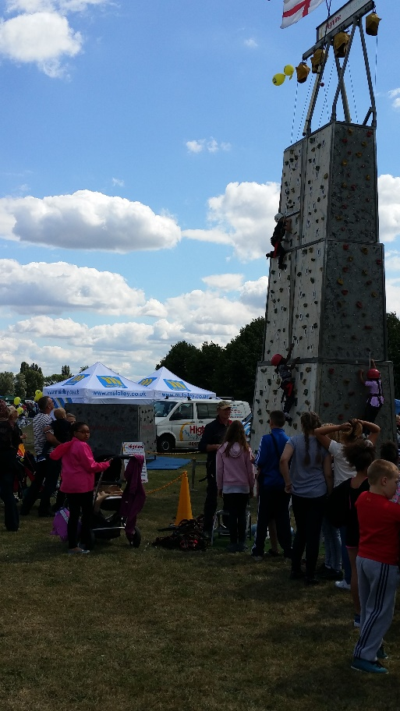
Your EMP should be printed for your site folder/file and given to key personnel (ELT). A summarised briefing sheet should be created for all personnel.

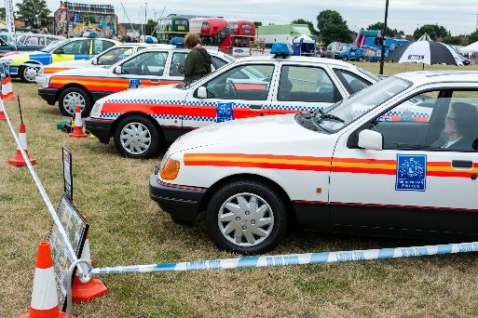

If a H&S consultant is hired to help write plans it is vital the EMP is written in conjunction with the event organiser who must be fully conversant with the plan. When you present your plan at the SAG feel free to bring along your team or security company as your wish.
Health and Safety monitoring
To ensure your plan comes to fruition and safety on the build, event and breakdown inspection and health and safety monitoring is essential.

Monitoring must be undertaken by a competent person who will resume the role as safety officer/advisor. Time must be given for feedback between the event organiser, site manager and safety officer to ensure issues can be made right.

During the build and breakdown regular checks of contractors on site must be made and recorded. These checks will ensure they are carrying out their activities in line with risk assessments and method statements submitted.

Other participants will need to be monitored including caterers, ride operators, stallholders and exhibitors and those running workshops and attractions.

Monitoring of the site must be made on the day before the event opens and during the event opening hours, areas for inspection should include:
- General public areas
- Entrances and exits
- Toilets
- Marquees and structures
- Performance areas and stages
- Inflatables and rides
- Backstage and hospitality areas

Accident and incident reporting
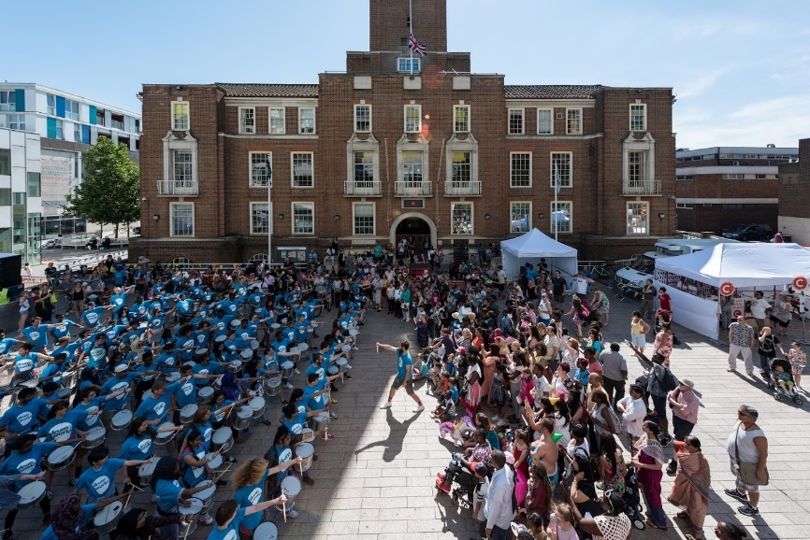
Event organisers should have an accident and incident form available for completion for accidents, incidents or near misses during the build, event and breakdown.

Forms can be completed by your safety officer, events team or first aid. Forms should be reviewed throughout the event by the safety officer to detect if there are any emerging trends that need to be addressed.

Serious or fatal injuries or illnesses must be reported immediately to the HES under the Reporting of Injuries, Diseases and Dangerous Occurrences Regulations (RIDDOR) and the Council Events Team for more information www.hse.gov.uk/riddor

Construction Design Management Regulations (CDM)
CDM Regulations 2015 are applicable to the events industry.
CDM regulations only apply to the construction phase of the event and not the event itself which would be governed by other health and safety legislation.
Site inductions must tell event participants where they can report accidents, incidents or near misses.
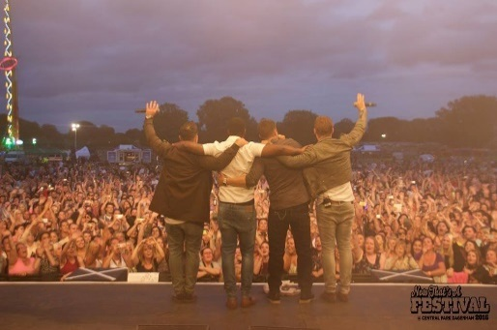
See the HSE website for more advice.
Construction on the site includes the build, breakdown, installation, dismantlement of the following:
- Marquees and structures
- Stages
- Toilets
- Fencing and barriers
- Trailers and porter cabins
- Generators & tower lights
- Funfair rides
- Inflatables
- Catering units
The regulations set out the legal duties of the following during the construction phase:
- Client
- Principle Designer
- Designers
- Principle Contractors
- Contractors

For an event, it is possible that you may have these duties fulfilled by different people or just one, but ultimately as the event organiser you would be responsible as client of the construction phase of the event.
CDM regulations states you must provide contractors with pre-construction information including communicating any risks associated with the site. As well as compiling a construction phase plan must be written including:
- Event details and timeline
- Roles and responsibilities
- Aims and objectives
- Communications arrangements
- Welfare facilities
- Health and safety arrangements and procedures including:

- Contractors selection procedure
- Site rules
- Site induction
- Site access, security and traffic management
- Health and safety monitoring
- Fire and emergency procedures

There will be considerable overlap writing your construction plan and your EMP so you may decide to include this as an appendix or write it as a separate document.

Accidents and incidents can happen during the construction phase so it is important to plan for this and monitor contractors to ensure they are following their risk assessments, method statements or any work permits in place.

Remember you are responsible for the welfare facilities of contactors for the construction phase.
For more information www.hse.gov.uk/entertainment/cdm-2015

Event day
The planning is over, the build and site preparations are done and the day has arrived, are you ready?

Top tips
- The core team should be on site early to finish final preparations and set up
- Check the weather forecast
- Hand over from overnight security
- Establish a control point to act as a main base from which to manage the event
- Establish a public facing Information Point (may be the same location as above)
- Communication is key -ensure those that need a charged radio have one and a contacts list with useful numbers
- Test communication systems
- Health and safety monitoring should start early and continue throughout the day
- Personnel briefing is the final opportunity to brief all staff and volunteers prior to the event opening
- Staff and security in place to meet, induct and manage event participants on arrival
- Check that the local authority and the core team are satisfied with the set up prior to opening
- Cease vehicle movement
- Gates open
- Continue to monitor health and safety
- Key personnel meetings should take place throughout the day
- Crowd dynamics monitored throughout
- Keep programme to time
- Car parking areas and local roads monitored
- If applicable remember to switch on lighting during the event and egress
- Close event and ensure first aid and security remain on site until clear

Section 3

Hopefully this guidance pack will support you as you begin to plan your event. Please intially complete the following paperwork:
- Application form
- Sign the T&Cs
- Remember your application fee
As you move through the planning process you may need to update the application from which must be completed in full and re-submitted as soon as possible.

You will then need to complete the following forms as per the timeline set out in section 1:
Premises Licence Application (if applicable)
- TEN form (if applicable)
- Emergency Services Summary Form
- DPS Form

You are also required to:

- Give references if requested
- Pay fees on time
- Attend meetings and site visits when required
- Consider traffic management and apply for a TTMO (if applicable)
- Attend SAG meetings
- Update the Events Team on progress and raise any issues as they arise
- Send catering paperwork to Food Safety
- Consult with park users and local residents
- Submit the EMP and requested parperwork

Thank you for choosing Barking and Dagenham as a potential or confrimed venue to hold your event.

Events and Park Hire Guidance Pack
  - Next steps and forms

The Council are committed to hosting a broad range of events in the borough that help meet our Council priorities.

The Events Team aims to offer a prompt, professional and helpful service to event organisers wishing to hire our parks and open spaces and we look forward to your application!

Please contact the Events Team if you have any questions or would like to arrange a meeting.

Other recommended resources and websites include:
www.lbbd.gov.uk
www.hse.gov.uk/event-safety
www.purpleguide.co.uk
www.noea.org.uk

London Borough of Barking and Dagenham
Park Hire Application Form

- Before completing this form ensure you have the read the Events Guidance Pack and follow the application procedure and timeline set out in section 1.
- Medium - large scale event application can only be processed in the application window September – February.
- Small scale events under 1000 must apply at least 6 weeks prior to the event date.
- Please complete this form in full, if you cannot initially complete the supplier’s information then this must be re-submitted at least 2 months prior to the event.
- Please also return your application fee and signed Terms and Conditions.
- Your site plan and EMP must be submitted for approval 2 months before.

Name of event

Event location

Event date/s

Start time
Finish time
Name of organisation

Event organiser/s
Daytime contact/s
(include landline and mobile)

Public enquires contact number

Email/s
Address
Website

Type of organisation
(if a charity please include charity number)
Event management experience

Professional referee name
Professional referee contact number
Professional referee contact email
Description of event proposed

Date/time to enter site for preparation/build

Date/time the site will be vacated after the event
Admission price or is the event free?
Approximate number of people expected to attend
Target audience profile

Possible alternative site
Possible alternative date
Do you intend to use the following in/out of the borough?
Highway directional signs |  | Street banners
Posters and leaflets |  | Social media and website
If you have ticked any of the above, please provide full details of locations, dates and times.
Please note permission will need to be given to display marketing material on the public highway or on LBBD premises by the Marketing and Communications Team. The council reserves the right to remove any unauthorised advertising and to recover the cost incurred from the event organisers.
Please tick the attractions proposed at the event?
Fireworks/pyrotechnics |  | Live entertainment
Carnival/procession |  | Live music
Fairground and rides |  | Strolling performers
Sports activities and competitions |  | Workshops
Balloon launch |  | Animals
Exhibits and stalls |  | Inflatables (e.g. bouncy castle)
Food/drink concessions |  | Alcohol
Re-enactment or military displays |  | Vehicle show or displays
Religious worship |  | Political activities
Other, please state |  | Other, please state
Please list your stage line up including your headliner if applicable or any named acts entertaining as part of the event.
Please note some of these attractions may not be permitted at all sites
A Temporary Event Notice or Premises Licence may be required if your event is public and consists of music, dance, film or the sale of alcohol.
Do you anticipate the need for the following?
Road closure (full or rolling) |  | Traffic diversion
On street parking restriction |  | Car park closure
On site car parking |  | Shuttle service from local transport hubs
Please detail the infrastructure, equipment and personnel services you will be contracting and bringing onto site for your event
Item/service | Quantity | Hire company /supplier
Marquees

Staging

Toilets

PA, sound and light equipment

Barriers and fencing

Generators (diesel only permitted)

Lighting towers

Trackway and roadway

Water (not all sites have access)

Other infrastructure

Security/stewards

First aid provider

Lost children staff

Litter picking and waste services

Health and safety consultant

Other personnel services

Please confirm if you have already contacted the following regarding your event?
Metropolitan Police |  | Licensing Team (LBBD)
Fire Brigade |  | Food Safety Team (LBBD)
Other Council Officer, please state who? |  | Other Council Officer, please state who?
Please list any questions you have for the Events Team or information/contacts you still require?
Event Organisers
Name (printed)
Signature
Dated (if form is re-submitted please add new date)
Please return to: Events Team, Room 101, Barking Learning Centre,
Barking Town Square, Barking, IG11 7LU

Email: events@lbbd.gov.uk cc in julia.pearson@lbbd.gov.uk and sarah.belchambers@lbbd.gov.uk

To contact the team to discuss call:
Julia on 020 8227 5247/Sarah on 020 8227 3192

London Borough of Barking and Dagenham
Park Hire Terms and Conditions

To be signed and returned with your application form and fee

1 Definitions

1.1 “Conditions” means these booking conditions which shall form part of the contract between the Council and the hirer.

1.2 “Council” means the London Borough of Barking and Dagenham Council and includes its successors in title.
1.3 “Due date” means 60 days prior to the date of the event unless agreed otherwise in writing.
1.4 “Event” means the purpose for which the venue/park has been booked.
1.5 “Hirer” means the company or the representative of the organisation booking the event who pays any fees due under clause 2 below. This booking is personal to the hirer and he/she may not transfer or sublet this consent to any other person.

1.6 “Events Team” means the Council team that processes the park hire applications and advise on best practise.

1.7 “Director” of the Council department means the Commissioning Director for Culture and Recreation or the duly authorised officer.
1.8 “Venue” means the location booked for the event including the immediate surrounding area open to the public. A map detailing the event site will be provided once the event application has been approved.

2 Payment

2.1 Booking fee must be paid initially to process your application. Payment of all other fees and charges must be made in full prior to the due date. If payment is not received the Council shall have the right to cancel the booking immediately.
2.2 The hirer will be liable for the full cost of the provision of any services (where available) by the Council, e.g. electricity, water, refuse collection, marking of the site, production of site maps and pitches etc. over and above the hire charge for the event.
2.3 The hirer will liable for staffing costs for officers that are required to attend on the event days. This will be discussed with the hirer when costs are confirmed.

3 Damage deposit

3.1 A deposit of £500 or in the case of small scale events £100 must be paid to the Council prior to the event which will be forfeited in the event of any damage or loss to the venue, [or loss of keys in respect of removable bollards etc.] or held as part payment of any necessary making good. The hirer will be liable for the full costs of any damage, so should this exceed the deposit the Council will issue an invoice.
4 Refusal of booking and cancellation
4.1 The Council reserves the right to refuse any application for the hiring of a venue without being required to give any reason for such refusal. Specific criteria that may lead to the Council refusing an application include the following:
- How the event meets the Council’s priorities
- Inadequate lead in time
- The impact on the park or open space
- Response from local residents
- Rallies where the intention is for religious or political recruitment or betterment
- Event organisers experience
- Risk management
- Financial risk
- Legal constraints
- Lack of security and first aid provision
- Understanding of health and safety regulations and management
- Size and location
- Promoter or organiser, the event sponsors or partners promotes illegal or unsavory activities

4.2 The Council reserves the right to withdraw permission to use the venue. However, the Council will repay any deposits paid on cancelling a hire but shall be under no liability for expense incurred or loss sustained by the hirer as a result of the cancellation.
4.3 Cancellation by the hirer of a booking must be in writing and the effective date will be the receipt of such information by the Events Team.
4.4 On cancellation of the booking the hirer shall be liable to the Council for the whole of the hire charge together with any additional expenses incurred by the Council subject to the discretionary power of the Commissioning Director to vary this provision in appropriate cases.
4.5 Hirers who do not take up their commitment for any reason or fail to notify in writing of cancellation shall forfeit any hire charge paid and shall be liable to the Council for the whole of the hire charge together with any additional expenses incurred by the Council.
4.6 Substitution and amendments of the nature of the booking must be notified in writing to the Events Team who reserves the right either to cancel the booking or amend the hire fee as he/she considers appropriate. In the event of such cancellation, the hirer shall be liable as stated in Clauses 4.4 and 4.5 above.
4.7 The Council accepts no responsibility for the non-arrival by the due date of application forms remittances or cancellations.
5 Emergencies
5.1 The Council shall have the right to cancel any booking forthwith in the event that the venue is affected by an emergency of any kind. The Council will consider refunding part or all of any fees and charges paid and the amount shall be at the Council’s sole discretion.
5.2 For medium/large scale events or any event deemed necessary by the Council will have attendance by Council officers. The Council Officer/s will be part of your Emergency Liaison Team (ELT) and reserves the right to resume control of the site in an emergency if required.
5.3 All emergencies must be reported to the Careline 020 8594 8356 and the Events Team.
5.4 Your Event Management Plan (EMP) should include your emergency procedures that must be approved by the Events Team and Safety Advisory Group at least 2 months prior to the event.
6 Use of the venue
6.1 The hirer shall keep the venue clean and tidy and shall ensure that the venue is regularly litter picked during the event. The hirer shall further ensure that the Council’s obligations under the Environmental Protection Act 1990 – Code of Practice on Litter and Refuse are discharged.
6.2 All litter and refuse generated by the event shall be removed from the venue by the hirer. Otherwise the deposit may be lost, see clause 3.1.
6.3 The hirer must, at all times, take good care of the venue and will be responsible for any damage to the venue or any part of it or any equipment or other property of the Council whether forming part of the hire or not.

6.4 The property of the hirer and the hirer’s agents must be removed at the end of the period of hire or by a time and date to be agreed with the Events Team. The Council accepts no responsibility for any property left on the venue before, during or after the hire period.
6.5 If the hirer fails to perform any of its obligations set out in clauses 6.1, 6.2 and 6.3 above the Council reserves the right to perform any such obligations and any costs incurred by the Council in the performance of such obligations shall be borne by the hirer.
6.6 The hirer is responsible for the administration, organisation and running of the event and for having sufficient and suitably qualified security stewards, first aiders and staff to fulfil these conditions. Failure to provide adequate and appropriate cover the Council reserves the right to cancel the event forthwith.
6.7 The hirer is responsible for the supervision and control of event participants, staff and volunteers, officials, visitors and contractors.
6.8 The hirer shall not be permitted to remove or obscure Council notices or marketing materials displayed on the venue without the prior written consent of the Council.
6.9 Where it has been necessary to make a temporary traffic management order (road closure etc.) the hirer shall ensure that the road closure equipment provided by the Council is not moved and shall maintain the integrity of the closure. Costs associated with any traffic management would be the responsibility of the hirer.
6.10 The hirer shall not interfere with or attach anything to any item of street furniture or parks furniture without prior consent.
6.11 The hirer shall not excavate or drill pinning holes into the venue except with the prior written consent of the Council.
6.12 The hirer shall ensure that any unwanted liquids are removed from the venue and not disposed of into the sewage system or on the venue. Where chemicals are used by the hirer or sub contracted staff, it is the hirers responsibility to ensure a clearly displayed COSHH record is available for inspection by the Council or duly nominated officer.
6.13 The hirer shall ensure that no vehicles are parked or driven across any public footpath located within the venue. Designated car park areas must be agreed with the Events Team.
6.14 The hirer shall ensure that pedestrians are allowed unrestricted access along any public footpath located within the venue unless prior written consent is given by the Council.
6.15 The hirer shall not interfere with or make any alteration to the layout or arrangement of the venue without the prior written consent of the Council.
6.16 Where the Council has agreed that the venue shall be used for a fun fair then the hirer shall supply full details of all sideshows and rides prior to the due date and shall comply with and ensure that the operators of the rides comply with the guidance given in the publication Fairgrounds and Amusement Parks – Guidance on Safe Practice published by the Health and Safety Executive (HSE), and all other statutory requirements. Copies of health and safety and insurance documentation may be sought for each ride operator.
6.17 The hirer shall ensure that no noise nuisance shall be caused to occupiers of properties surrounding the venue or users of the immediate surrounding area of the venue. If amplified music is to be played a noise limiting device should be installed and consultation made with the Council’s Noise Nuisance Team who will advise on further preventative measures to pre-empt any problems. This may be included in your Premise Licence conditions in some cases.
6.18 The event must cease at the specified hours as agreed with the Events Team. The site build and clearance time must be completed at a time specified by the Council.
6.19 The Council reserve the right to require the hirer to provide at his/her own expense temporary sanitary accommodation including those for disabled persons and baby changing facilities for the event, build and breakdown. The number of toilets should be appropriate for the scale and nature of the event, failure to provide adequate provision the Council reserves the right to cancel the event forthwith.
6.20 The hirer must ensure that all general public users of the area have unrestricted access to the permanent public toilet facilities located within the venue.
6.21 The sale or consumption of alcoholic drinks is strictly prohibited unless written consent is granted from the Council. A suitable licence must be in place along with the Designated Premise Supervisor (DPS) or an authorised personal licence holder on site for the duration of the event. DPS forms must be completed to transfer these responsibilities to your DPS.
6.22 The hirer will not be allowed any exhibition, performance or entertainment in which animals feature without prior consent.
6.23 The hirer will not permit the operation or release of any high-flying object without the prior written consent of the Council and the Civil Aviation Authority.
6.24 It is the responsibility of the hirer to liaise with the Council, the Police and other emergency services regarding the impact the event may have on traffic arrangements in the vicinity of the venue. The hirer agrees to comply with any requirements of the Council and the Police regarding traffic management.
6.25 The hirer agrees that where the venue is to be used in the dark then they will provide appropriate lighting to cover all areas to which the public are admitted or have access.
6.26 The hirer shall not bring into the venue any article of an inflammable or explosive character or that produces an offensive smell, or CFC or any oil, electrical, gas or other apparatus without the written approval of the Council.
6.27 The hirer shall obtain approval from the Council for the use of diesel plant (generators/lighting towers) at the event. If such approval shall be granted the hirer must ensure that any generators permitted at the event are operated in a safe manner by a competent person and are segregated from the public or are protected by suitable fencing or barrier, so as to prevent access by members of the public. Additional fuel supplies are not permitted in any public areas and should therefore be stored off the main site in a lockable area. Petrol generators and lighting towers are not permitted.
6.28 The hirer shall not bring, place or erect any sign furniture, fitting or structure nor place or fix any additional or decorative lighting in or on any parts of the venue without the prior written consent of the Council.
6.29 The use of any public address system at the event must be first agreed in writing by the Council and must be operated so as not to cause a noise nuisance in breach of clause 6.17. Any necessary licenses must be obtained by the hirer.
6.30 The hirer shall repay to the Council on demand the cost, as certified by the Commissioning Director or Events Team, reinstating, repairing or replacing or cleansing any part of or property in the venue if damaged, destroyed, stolen or removed prior to, during or after the period of hire if related to or because of the hiring. The Council’s valuation of any damage/loss is final.
6.31 The hirer must at their own expense define the agreed event site and form a suitable perimeter to enable a controlled entry.
6.32 Site specific restrictions apply to the use of Barking Abbey Green and Abbey Ruins. Any marquees or temporary structures must be weighted down. It is prohibited to drive any stakes or fixings into the ground.
6.33 The hirer must provide adequate and appropriate first aid provision for the build, event and breakdown period. The cover must be appropriate for the scale and nature of the event. Failure to provide adequate and appropriate cover the Council reserves the right to cancel the event forthwith.
6.34 The hirer must ensure there is no glass on the site used by the bar, caterers, etc.
6.35 The hirer must gain approval from the Council to use fireworks, pyrotechnics or laser lighting shows. Firework only display events are not permitted as there is already an annual event in the borough.
7 Right of entry
7.1 Authorised Council officers or Members shall be permitted entry to the venue at all times during the period of hire.
7.2 The Council reserves the right to refuse admission to or evict any person from the venue.
7.3 The Council reserves the right to fix a maximum limit for the number of persons attending the event.
7.4 Hirers must erect temporary signage at the perimeter of the event site including their entry conditions which must be discussed and agreed with the Events Team, including no drugs, legal highs, alcohol, weapons and no uncontrolled dogs (off lead) allowed on site. If vehicles are allowed on site during the build or in the case of the emergency a 5mph maximum speed limit must be enforced and this should be included on temporary signage.
7.5 Hirers must erect signage at the perimeter of the park entrance points and gates to give notice to park users regarding the event specifying any changes to opening times, areas, car parking area or other arrangements that may affect them.
8 Assignment
8.1 The booking shall be personal to the hirer and the right to use the venue shall not be sublet, assigned or otherwise transferred; the hirer shall not assign the benefit or burden of any part of the agreement, or sublet or subcontract any part of the facility without the prior written consent of the Council.
9 Prohibition
9.1 The hirer shall not stage or engage in any activities that might be deemed to be ancillary to the main purpose of the booking, e.g. catering, stalls, raffles and any other fund raising/income earning activities without the prior written consent of the Council.
10 Broadcasting and television
10.1 The hirer may not carry out or allow or permit to be carried out any photography, filming, video recording, taping, television or radio broadcasts or any other recording of any kind of the event during the period of hire without the prior written consent of the Council. If such consent is given, the Council reserves the right to be a party to any negotiations and the terms and conditions of any agreements reached and to share any income and publicity derived thereafter.
11 Advertisements
11.1 No advertising material may be issued nor tickets sold until a binding agreement to hire has been made.
11.2 Any contravention of the Town and Country Planning (Control of Advertisements) Regulations 1992 or any amendments or variation thereto may be deemed a reason for the cancellation of a hiring or series of hiring. If there shall be any contravention of these requirements, however, wherever and by whomever caused, permitted or made by then the hirer shall reimburse or refund to the Council the cost of removing any such unauthorised or illicit advertisements or advertising material.
12 Fly posting
12.1 No advertising material is to be displayed anywhere on the venue or elsewhere in the borough unless it conforms to the permitted displays authorised by the Town and Country Planning (Control of Advertisement) Regulations 1992 and approved by the Council.
12.2 The deposit may be used in whole or in part if fly posting occurs.
12.3 Street railing banners cannot be displayed without prior consent by the Council. Banner sites can be booked with the Council but it is the hirer’s responsibility to put up and take down all marketing materials and ensure they are displayed safely. If banners and approved marketing materials are not removed after 1 week after the event the deposit may be used in whole or part to remove banners or marketing materials.
13 Permits and licenses
13.1 The hirer shall ensure that any licence, permit or other consent which may be required is obtained, whether from the Council or otherwise, before the event may take place and shall, where requested, produce to the Council on demand copies of such licence, permit or consent. If any such licence, permit or consent has not been obtained, the Council reserves the right to cancel the booking forthwith.
13.2 When promoting the event, the hirer will be responsible for exhibiting all necessary permits during the event.
13.3 Nothing shall be done by the hirer that shall or may contravene the terms and conditions of any licence. Applicable licenses in relation to this hire will be a Premises Licence, Temporary Event Notice, Occasional Sales Licence and a Personal Licence.
14 Health and Safety
14.1 The hirer agrees to undertake a risk assessment and compile an Event Management Plan for the event and is to ensure that all participants and contractors comply with all relevant health and safety legislation or any other guidelines, relevant thereto at all times during the event and while preparing and clearing the venue for the event. These documents must be submitted to the Council at least 2 months prior to the event. For medium/large scale events a draft copy of these documents must be submitted at the first Safety Advisory Meeting attended prior to your licence being submitted.
14.2 The hirer must attend the Safety Advisory Group (SAG) meeting as requested and provide information requested as well the documentation stated in clause 14.1.
14.3 Under the Construction Design Management Regulations (CDM) 2015 the hirer will be required to compile and submit a Construction Phase Plan as part of your Event Management Plan or as a supporting document. Welfare provisions must be in place for contractors and those on site during the build or breakdown of the event.
14.4 A competent person must be responsible for undertaking health and safety monitoring at the event and during the build and breakdown phase. Accidents, incidents and near misses must be recorded and should be made available to the Events Team on request.
15 Indemnity and insurance
15.1 The Council is not responsible and will not accept liability for any loss, damage, injury or death howsoever, and by whomsoever caused, whether to property or person(s) sustained by any person in the venue.
15.2 The hirer is responsible for all safety aspects of the venue prior to during the buildup, during or subsequent to the event and must accept liability for any loss, damage, injury or death howsoever, and by whomsoever caused, whether to property or person(s) sustained by any person(s) in the venue.
  - The hirer agrees to indemnify the Council against all claims, actions, demands, proceedings, cost or awards in respect of any loss, damage, injury or death to persons or property engaged by or assisting the hirer.

  - The hirer agrees to take out public liability insurance cover for a minimum of £5 million (five million pounds) unless stated by the Events Team that £10 million is required and produce evidence of such insurance to the Council at least 2 months prior to the event.

15.5 The hirer will be required to produce evidence of the existence of public liability insurance at such level as required by the Council in respect of any exhibitor, contractor, entertainer, sub-contractor, concessionaire, caterer which the hirer has instructed or authorised to appear at the event.
15.6 Failure to provide proof of insurance cover as required under clauses 15.4 and 15.5 prior to the due date will lead to cancellation of the event.
16 Catering
16.1 All catering and licensing arrangements must be made through the Council and no hirer may undertake their own catering in the venue except with the prior written consent of the Council.
16.2 All caterers at the event must comply fully with the requirements of the Food Safety Act 1990 and the Food Safety (General Fund Hygiene) Regulations 1995 and any amendments thereto and comply with all instructions given by the Environmental Health Officer and Food Safety Team.
  - All caterers must ensure that they have maintained and can produce a record HACCP, local authority registration, food hygiene risk assessment, fire risk assessment, method statement, food safety checklist, and gas certification. These must be submitted and any other requested information to the Food Safety Team 6 weeks prior to the event. Otherwise fees will be incurred or the caterer will be rejected.

  - All caterers must comply fully with the food safety checklist in order to operate on the event day. Inspections will be made and any caterer who is unable to comply will be prevented from trading.

17 Traders
17.1 A temporary sales licence must be applied for at least 28 days prior to the event.
18 Collections or Lotteries
18.1 No collections, games of chance, sweep stakes, lotteries or betting of any kind may be conducted at the venue without the prior written consent of the Council.
19 Property not removed
19.1 The Council may remove and store any property that is left by the hirer in or upon the venue after the period of hire. The hirer shall repay to the Council on demand the costs of such removal and storage. The Council shall not be held responsible for any damage to or theft of property by or during its removal or storage. The Council is entitled to remove and sell in such a manner as they think fit any property left at the venue as a result of the hiring not claimed within 28 days. The proceeds of sale of which shall be the Councils.
20 Variations to Agreement
20.1 The Council reserves the right to vary the conditions of the agreement between the Council and the hirer at any time on 7 days notice. Any variations made shall be deemed to be incorporated in these terms and conditions. The hirer may, within 7 days of receipt of such notice, terminate this agreement.

I have read and understood these conditions and agree to be bound by them.
Signed | Dated
Print Name

Organisation or company name

Position held in company

London Borough of Barking and Dagenham
Designated Premises

This form must be submitted for approval 2 months before your event

Environmental Services
Consent of individual to being specified as premises supervisor

I
[full name of prospective premises supervisor]

of
[home address of prospective premises supervisor]

hereby confirm that I give my consent to be specified as the designated premises supervisor in relation to the application for
[type of application]

by
[name of applicant]

relating to a premises licence
[number of existing licence, if any]

for
[name and address of premises to which the application relates]

and any premises licence to be granted or varied in respect of this application made by
[name of applicant]

concerning the supply of alcohol at
[name and address of premises to which application relates]

I also confirm that I am applying for, intend to apply for or currently hold a personal licence, details of which I set out below.

Personal licence number
[insert personal licence number, if any]

Personal licence issuing authority
[insert name and address and telephone number of personal licence issuing authority, if any]

Signed

Name (please print)

Date

London Borough of Barking and Dagenham
Emergency Services Event Summary Sheet

This form must be submitted for approval 2 months before your event

Name of event

Event location

Event date/s

Start time
Finish time
Name of organisation

Event organiser/s
Daytime contact/s
(include landline and mobile)
Public enquires contact number

Email/s
Address
Brief description of event including any high-risk activities
Target audience profile

Emergency vehicle gate (name, address and postcode)
Emergency access/egress point if fenced in (name/description)
RVPs (give 2 options) if site is evacuated
Name of security company
Name of first aid provider
Please tick what applies to your event
Licensed (Premises Licence) |  |  | Licensed (TEN)
Alcohol served/on sale |  |  | Gas on site (if so please include locations in EMP)
Road closure (full or rolling) |  |  | Traffic diversion or possible disruptions
Finish time each day

London Borough of Barking and Dagenham
Risk Assessment Example and Template

To be submitted as part of your Event Management Plan, other templates and risk ratings are acceptable

Event Name:_______________________ Organisation:________________________________________
Hazard | Risk | Who | Extent of Risk =  Probability / Severity | Controls | Revised Extent of Risk =  Probability / Severity

Severity
Minor injury – treatable on site | 1
Minor injury to be treated off site | 2
Major injury non-life threatening req. hospitalised stay | 3
Major injury hospitalisation/dangerous Life Threatening | 4

Probability
Highly unlikely | 1
Possible | 2
Likely | 3
Highly Probable | 4

Notes

