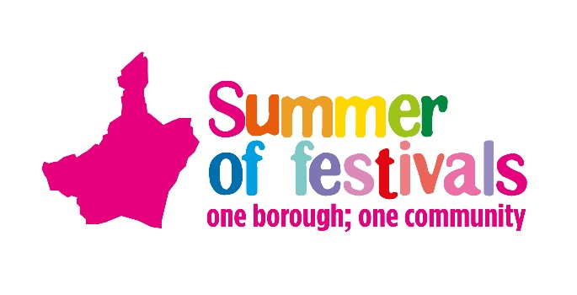
One Borough Festival, Valence Park, Dagenham, 7 May 2023, 1pm to 7pm
Classic Car Show Booking Form

You are invited to exhibit your classic car at the One Borough Festival on Sunday 7 May at Valence Park, Dagenham, RM8 3EU.
Cars and vehicles manufactured before 2000 are deemed as a classic vehicles. We welcome cars, bikes, military, emergency or transport vehicles plus tractors and machinery. Please read our site rules before booking however these will be re-issued before you attend. After the deadline you will receive confirmation of your space including important event information and site rules. For the safety of the public, vehicles need to be on site by 12noon and will not be allowed to leave the site before 6pm.
Please complete and return asap.
Please bring proof of your motor insurance on the day.

Contact us if needed on 07977 018821. Return by email to summeroffestivals@lbbd.gov.uk or by post
Events Team, Barking Town Hall, 1 Town Square, Barking,
Essex, IG11 7LU

Exhibitor Details
Name/s
Club
Address
Telephone
Mobile
Email

Vehicle Details
Make
Model
Year |  |  | Registration
Please tick the applicable section/s | Pre 1950s | 1950-59 | 1960-69 | 1970-79 | 1980-89 | 1990-1999
 | Sports & convertible | American | Kit & Custom or Replica | Commercial | Military | Emergency vehicle/other
Fun fact or information about vehicle, model or make

