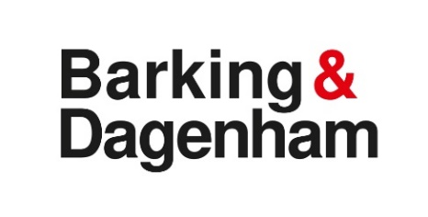
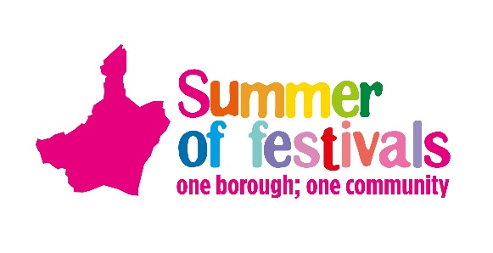
One Borough Festival, Valence Park, Dagenham, 7 May 2023, 1pm to 7pm
Steam Engine Booking Form

You are invited to exhibit your steam engine at the One Borough Festival on Sunday 7 May at Valence Park, Dagenham, RM8 3EU.
Please complete and return by 14 April 2023.
Please bring proof of your insurance on the day.

Contact Sarah Belchambers/Gurvinder Bhaker, if needed, on 0777 708 838 / 07977 018 821.
Return to: summeroffestivals@lbbd.gov.uk or by post to:
Events Team, Barking Town Hall, 1 Town Square, Barking IG11 7LU
Exhibitor Details
Name
Address
Telephone
Email
Full size engine
Please provide a short description and history of your exhibits in order to assist commentator on the day

- 500kg of coal will be provided and a contribution of £100.00 towards your expenses but this is on a first-come first-served basis
- Your engine should be in steam by 12.45pm and there will be a parade of engine later in the day (time to be confirmed)
- If you are affected by the Low Emission Zone, please contact us to discuss further.
Declaration
I wish to enter my steam engine to the One Borough Festival on Sunday 7 May and I confirm it is insured in accordance with the road traffic acts and is suitable for the use it will be put to during the event - I accept this is solely my responsibility.
My engine will not be left unattended at any time whilst it is in steam.
I indemnify in full the One Borough Festival and the event organisers in respect of any claims, demands or penalties, damages or costs how so ever arising as result of my participation of the exhibit or equipment as part of the event.

Sign........................................................................... Print Name................................................................................

