Deaf and Hard of Hearing Drop-in Service:

If you have a hearing loss and need information, guidance, or advice, please contact the Deaf Community Worker to book an appointment.

When: Online service only; please text or email first, please say if you want to meet face to face.

Where: Online by email, video call, text, or telephone

Contact: Maryan Ahmed, Deaf Community Worker

Mobile: 07561703937 Text/Video/Voice
Telephone: 0208 227 5567 Voice
Email: Maryan.Ahmed2@lbbd.gov.uk

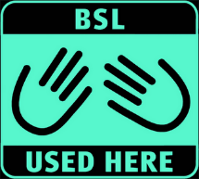

https://www.lbbd.gov.uk/sight-and-hearing-loss
Sensory Service: sensory@lbbd.gov.uk

