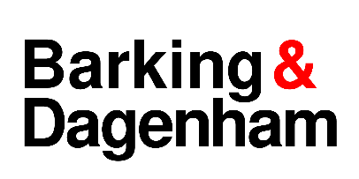
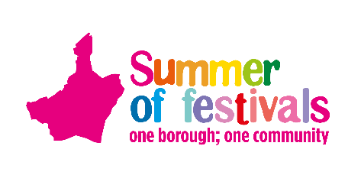

Summer of festivals 2023
Expression of Interest
Would you like to perform or showcase your skills or talents at one of our events?

Event Information

The Summer of Festivals Weekender – Coronation Day and One Borough Festival
Valence Park, Dagenham
Saturday 6 May 2023 and Sunday 7 May 2023

Coronation Day
Valence Park, Dagenham
Saturday 6 May 2023
11.00am – 5.00pm (currently awaiting broadcast times of the Coronation, so times subject)
Attendance 4,000 – 7,000
This is a new event to celebrate His Majesty the King and Her Majesty the Queen Consort’s Coronation. The event will feature a screening of the Coronation, music and family fun for everyone including rides, attractions and an afternoon tea for residents from our borough care homes.

One Borough Festival
Valence Park, Dagenham
Sunday 7 May 2023
1.00pm – 7.00pm
Attendance 4,000 – 7,000
This year we are combining elements of the One Borough Festival with the Roundhouse Music Festival and the Steam and Cider Fair to bring our residents a flavour from each of the festivals they love. Celebrating the rich musical history of the borough and the Roundhouse pub home which has played host to some of the world’s most famous rock bands. As well as elements from the Steam and Cider Fair celebrating the agricultural and industrial past of the borough including steam engines, classic cars and countryside displays. The day will host workshops, music, dance, exhibitions, stalls, a tearoom, arena acts and rides.

Eid at Eastbury
Eastbury Manor House, Barking
Sunday 2 July 2023
Time – 11am – 5pm
Attendance 3,000
This is a new event to celebrate Eid al-Adha and understanding of Islam with our residents. The event in the stunning historic setting of Eastbury Manor House will include family workshops, music and food.

Barking Folk Festival (subject to funding, this event may not take place and final decision will be made shortly and all groups will be informed)
Barking Abbey Green
Saturday 5 August 2023
1.00pm – 7.00pm
Attendance 4,000 – 7,000
Annual free family festival showcasing the best in world folk music and dance at Barking Abbey Green. The day will include poetry, art and crafts, workshops, and street theatre.

Barking Mad About Christmas
Barking Town Hall Square
Saturday 2 December 2023
11.00am – 5.00pm
Attendance 3,000
Annual festive family event including Santa’s Grotto, workshops, festival music and carols, family entertainment, crafts, rides and stalls. Concluding with the traditional Christmas tree lights switch on.
Further Information

- More information on all events can be found at www.lbbd.gov.uk/summeroffestivals

- If you require any assistance with this form or have any questions, please email summeroffestivals@lbbd.gov.uk

- Deadline for submission asap or by the latest Wednesday 12 April 2023

- Feel free to pass this form on to any friends or groups who also may want the opportunity to feature at one of our events this year.

- Please ensure all boxes are filled out.

- All content must be suitable for a family audience.

- We must receive video clips/links of past performances which will be used when reviewing your application.

- Please return asap with a high-resolution photos

- The Events Team will contact you when programming for each event commences and will send any new opportunities as they arise. For the Summer of Festivals Weekender we will contact you back by 19 April.

- We hope to include a wide variety of performers and workshops especially local artists who complete paperwork as soon as possible but the council reserve the right to select artists that suit the event and audience, therefore, not every request may be successful.

Name
(individual/group)
Name of lead
(If different from above)
Address
Contact number
(daytime)
Email

Social media links or handles
Performance, installation, or exhibit type  (Type and details of performance) | E.g., Pianist playing classical composition, dance group performing street dance or craft workshop making puppets visual arts.
Number of performers or facilitators (please include age range if under 18)
Proposed performance/activity duration | E.G 10 Mins, All day
Which event would you like to participate? | Please note:  All expenses will need to be covered by the group unless agreed prior to the event
  Event Details  (Please select which event/area you would like to perform or facilitate at. Please tick as many as you can do) | Please Tick
  The Summer of Festivals Weekender – Coronation Day - 6 May 2023
  All areas will have access to power and a PA system.
  The Right Royal Jump About Arena (marquee 15m x 9m with 12m x 9m dancefloor)
  The Playground (workshop grass area and possible small platform)
  Other area (open to suggestions on the line below)
  Proposed performance ideas:
  The Summer of Festivals Weekender – One Borough Festival - 7 May 2023
  All areas will have access to power and a PA system.
  The Jump About Arena (marquee 15m x 9m with 12m x 9m dancefloor)
  The Playground (workshop grass area and possible small platform)
  The Tearoom (5m x 2.5m raised platform)
  Other area (open to suggestions on the line below)
  Proposed performance ideas:
  Eid at Eastbury 5 June 2022 - Date TBC - 2 July
  All areas will have access to power and a PA system.
  Stage (16ft x 12ft x 2ft high platform marquee covered stage)
  Other area (open to suggestions on the line below)
  Proposed performance ideas:
  Barking Folk Festival (TBC, subject to funding) – 5 August
  All areas will have access to power and a PA system.
  The Playground (workshop grass area and possible small platform)
  The Tearoom (5m x 2.5m raised platform)
  Other area (open to suggestions on the line below)
  Proposed performance ideas:
  Barking Mad About Christmas
  All areas will have access to power and a PA system.
  Stage 5m x 5m - just checking size
  Inside workshop areas
  Other area (open to suggestions on the line below)
  Proposed performance ideas:
Web link to see demo/ film clip
(YouTube, Facebook, website)
Availability | E.g.: Only daytime/ only free 2pm – 4pm
Biography (for media or host when introducing your act)
Notes to organisers and additional information or requests
Technical/space requirements | E.g., Playback CD player or Mini Jack connection required, need a small area 2m x 2m
  Instruments with act
  Equipment with act
  Monitor requirements
  Space requirements
  Also add any hanging requirements here
  Furniture and power requirements
  Car parking (please include number of vehicles) | (We will endeavour to accommodate your request but cannot guarantee this)
  Merchandise sold | Yes/ No
  Sound check required | Yes/ No
  Please list below any equipment you may require that you will not be arriving with: (E.g. DI Box)
  Please list below any other additional information you would like the event organisers to be aware of:

