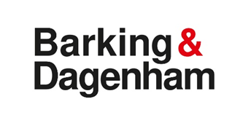

Useful Information in British Sign Language

NHS 111 in BSL free 24/7 service medical advice
https://signvideo.co.uk/nhs111/

NHS 119 in BSL free service re: tests and vaccines https://signhealth.org.uk/announcement/nhs-119-bsl/

999 Emergency Services in BSL (ambulance, police, fire brigade, coastguard)
https://999bsl.co.uk/

NHS 111 British Sign Language Service how it works: https://youtu.be/4O0js0832Ng

Book a BSL interpreter for hospital appointments:
https://www.bhrhospitals.nhs.uk/deaf-or-hearing-impaired

What is coronavirus CoViD-19 in BSL?
https://vimeo.com/397483046/7a2d548e51

Videos in BSL with latest information on COVID-19
https://signhealth.org.uk/resources/coronavirus/

https://www.gov.uk/government/publications/covid-19-vaccination-british-sign-language-resources

NHS video Hands, Face, Space in BSL
https://youtu.be/ZM05hkwKI6M

NHS 111 British Sign Language Service how it works: https://youtu.be/4O0js0832Ng

NHS How to create a Patient Access account in BSL
https://youtu.be/UyUpjONkyWg

Lateral Flow test explained in BSL
https://youtu.be/DPbowVb4OI8

Public Health England Vaccine information in BSL
https://www.gov.uk/government/publications/covid-19-vaccination-british-sign-language-resources

Additional CoViD-19 Vaccine Information in BSL https://signhealth.org.uk/health-wellbeing/covid-19-vaccine-information/
CoViD-19 Vaccine - what to expect.
https://www.youtube.com/watch?v=iRHUM1Wk254

Hospital Passport/Health Plan for deaf people
https://signhealth.org.uk/health-wellbeing/the-about-me-plan/

Access to information Standards in BSL
https://www.youtube.com/watch?v=ZJngMo37WvA

National Helpline contacts:
Royal Association for the Deaf
https://www.royaldeaf.org.uk/services/for-families/independent-living/
Telephone: 0300 688 2525
Text Phone: 0300 688 2527
SMS: 07851 423 866
Email: info@royaldeaf.org.uk
Skype: reception_ch
https://www.royaldeaf.org.uk/services/i-am-deaf/independent-living/

DeafblindUK
https://deafblind.org.uk/contact/
Telephone: 0800 132320
Text: 07950 008870
Text relay: 18001 then 0800 132320
Facetime: helpline.dbuk@deafblind.org.uk (Not BSL)
BSL Video Relay direct link to online BSLinterpreter: https://www.insignlanguage.co.uk/vrs/client-direct/cf6b3f3e-1608-4046-a8e6-a42338fa039f/

Royal National Institute for the Deaf
https://rnid.org.uk/information-and-support/information-line/bsl-information-service/
Email information@rnid.org.uk
Text message 0780 000 0360
Relay UK 18001 then 0808 808 0123
Textphone 0808 808 9000
Live chat on our website Chat to us now

SENSE
https://www.sense.org.uk/contact/contact-supporter-services/
Address: Freepost RRXE-TRES-GEUR 101 Pentonville Road London N! 9LG
Telephone: 0300 330 9250.
BSL via Sign solutions Starleaf App or weblink: https://portal.starleaf.com/webrtc?name=sense&target=sense%40interpreterslive.call.sl

REMARK: https://www.remarkcommunity.org/ https://www.remark.uk.com/supporting

Emotional support in BSL
https://www.youtube.com/watch?v=R8hvNWObRh0

https://signhealth.org.uk/with-deaf-people/psychological-therapy/therapy-service/

https://www.deaf4deaf.com/

https://www.youtube.com/playlist?list=PL7zNl2HpED2hHeK-UhArnAkhw1MXPfytQ

https://signhealth.org.uk/with-deaf-people/crisis-text-service/ text DEAF to 85258

self-help app – available guidance on different topics in BSL
https://play.google.com/store/apps/details?id=pic2.uk.nhs.ntw
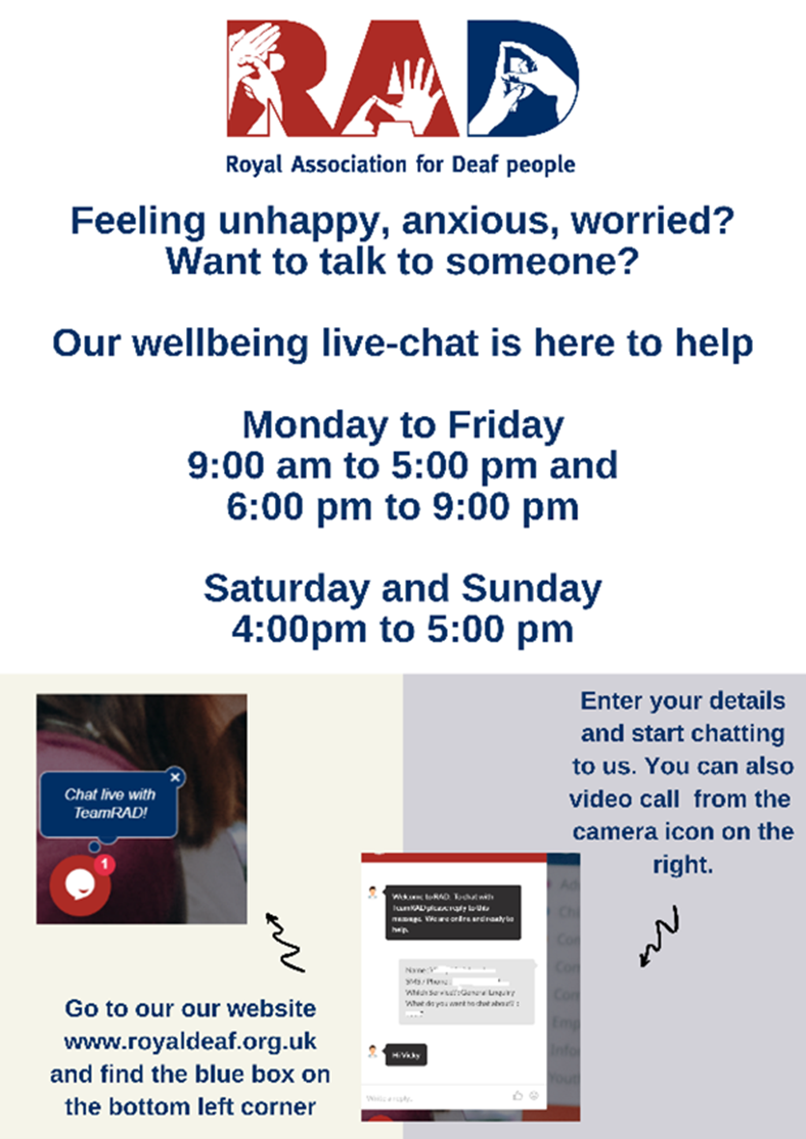

Video Relay Services

https://www.signsolutions.uk.com/video-interpreting/

https://signlive.co.uk/

https://signvideo.co.uk/business-directory/

https://interpreternow.co.uk/deaf-users

Befriending service in BSL
https://royaldeaf.org.uk/community-connect-service-continues-reducing-isolation-for-older-people-in-essex-with-hearing-or-sight-loss/

RAD online wellbeing group in BSL
https://www.sense.org.uk/get-support/holidays-short-breaks-and-activity-groups/sense-connect-referral/
DeafAge Wellbeing Wednesday Coffee Morning in BSL via Zoom. Email: deafage@royaldeaf.org.uk
mobile/SMS 07810156920 skype: kimwebster0312@gmail.com

Social Groups online for deaf BSL users of different ages.
https://www.remarkcommunity.org

https://vimeo.com/255371100
Empowering Deaf Society https://empoweringdeafsociety.org/ To join virtual group in Barking and Dagenham contact EDS: events@enpoweringdeafsociety.org.uk or text 07584687127
Keep Fit activity videos in BSL
https://www.youtube.com/playlist?list=PL3cz6p9Us2bNgIFma-n8A4qtD0j6N0-pq

Domestic Abuse support in BSL
https://signhealth.org.uk/with-deaf-people/domestic-abuse/domestic-abuse-service/

One to one specialist support in BSL
https://deafblind.org.uk/get-support/

https://www.sense.org.uk/contact/contact-supporter-services/

https://www.achievetogether.co.uk/who-we-support/learning-disabilities-hearing-impairments/

iPhone Support online/instore
https://www.apple.com/uk/contact/

Next Generation Text Relay service to contact other people
https://www.relayuk.bt.com/how-to-use-relay-uk.html

Where to find programs in BSL
https://www.bslzone.co.uk/about/how-watch-bsl-zone-tv

Programs on iPlayer in BSL including CoViD-19 News briefings
https://www.bbc.co.uk/iplayer/categories/signed/featured

Hearing Dogs for Deaf People in BSL
https://www.hearingdogs.org.uk/contact-us/bsl-interpreter/

Help contacting HMRC – select Royal Association for Deaf People weblink for information in BSL
https://www.gov.uk/get-help-hmrc-extra-support/cannot-use-telephone-different-way-to-contact

Help contacting DWP in BSL – select video relay service
https://www.gov.uk/disability-benefits-helpline

Last updated 30 September 2022

