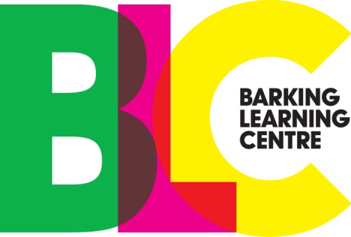

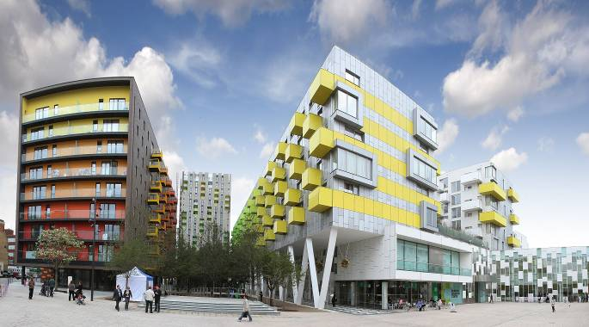

Take a look at the Barking Learning Centre and you'll find modern, comfortably appointed and well-equipped seminar rooms that are perfect for the most sophisticated presentation.

Within this booklet you will find all the information relevant to making a booking at the Barking Learning Centre. If you would like some guidance on how best to use the BLC facilities to deliver your event we would be happy to help. If you have any enquiries, please do not hesitate to contact the Centre management team either via telephone, 0208 227 3577 or email, blcroombookings@lbbd.gov.uk

Conferencing and Meeting Room Hire Booking Information

Provisional and Confirmed Bookings

Enquiries on room availability and provisional bookings may be made by phone (0208 227 3577) or email (blcroombookings@lbbd.gov.uk), however no booking can be confirmed until a fully completed booking form, signed terms and conditions are received.

Room Requirements

A completed booking form must contain details of delegate numbers, room requirements and meeting title. Layout and facilities will be allocated on this basis. It is the client’s responsibility to advise the BLC of any changes that are required to layout, timings, or numbers. The BLC will endeavor to accommodate any changes to a booking; however, no guarantee is given that this will be possible once a booking is confirmed.

Equipment

AV equipment is provided in each room (unless otherwise stated) and its use is included in the room hire charge, printing is available from the library counter at a small charge

Payments
Invoices will be sent to clients on receipt of a completed booking form. Payment must be received in full, within 14 days of receipt of the invoice. The BLC reserve the right to cancel a booking or future bookings should payment not be received on this basis.

Cancellations

This standard cancellation policy applies unless otherwise agreed in writing by us. All cancellations must be received in writing. Cancellations made 28 working days or more before the event will incur a 10% charge of the room hire; cancellations made between 14 and 28 working days of an event will incur a 50% charge of room hire. Cancellations made less than 14 working days of the event will be charged at full cost. Any additional arrangements made by the BLC on behalf of clients (e.g. catering) which cannot be cancelled or refunded will be charged in full to the client in these circumstances.

Access
There is no parking at the Barking Learning Centre, however, there is parking within Barking Town Centre only a few minutes walk from the BLC. The BLC is only a short walk from Barking station and the following bus routes run to or through Barking Town Centre: 5, 62, 169, 179, 238, 287, 366, 368, 387, 687, EL1, EL2.

Conference and Seminar Room Hire Fees

Rates | Voluntary/Community Rates
Conference Centre – Hourly | £65.00
Conference Centre – Half Day  (4 hours) | £190.00
Conference Centre – Full Day  (8 Hours) | £370.00
Small Rooms – Hourly | £37.00
Small Rooms – Half Day  (4 hours) | £98.00
Small Rooms – Full Day  (8 Hours) | £172.00
Large Rooms – Hourly | £52.00
Large Rooms – Half Day  (4 hours) | £148.00
Large Rooms – Full Day  (8 Hours) | £280.00
IT Training Suites | Large Room Rates Apply
Gallery – Half Day | £43.00
Gallery – Full Day | £80.00
Town Square – Full Day | £103.00
*Tax Included

Meeting Pod 2- £15 per hour plus vat

Meeting Pod 3- £10 per hour plus vat

Interview Room 1- £10 per hour plus vat

Interview Room 2 - £ 10 per hour plus vat

Room Layout(s)
(not to scale)

R  O  O  M  S |  | IT |  | Board room | Lecture  style |  | Dining | Horseshoe |  | Circle
Gallery | N/A | N/A | 28 | N/A | 100 |  | N/A | 20 |  | 20
Town Square | N/A | N/A | N/A | N/A | N/A |  | N/A | N/A |  | N/A
G10 | 14-16 | N/A | N/A | N/A | 20-25 |  | N/A | 16-20 |  | N/A
G11 | 14-16 | N/A | N/A | N/A | 20-25 |  | N/A | 16-20 |  | N/A
G12 | 28 | N/A | N/A | N/A | 40 |  | N/A | 30 |  | N/A
G14 | 14-16 | N/A | N/A | N/A | 20-25 |  | N/A | 16-20 |  | N/A
105 | N/A | 20 | N/A | N/A | N/A |  | N/A | N/A |  | N/A
106 | N/A | 24 | N/A | N/A | N/A |  | N/A | N/A |  | N/A
107 | N/A | 24 | N/A | N/A | N/A |  | N/A | N/A |  | N/A
110 | N/A | N/A | 14 | N/A | 16-20 |  | N/A | 12 |  | N/A
111 | N/A | N/A | 14-16 | N/A | 16-20 |  | N/A | 12 |  | N/A
112 | 14-16 | 18 | N/A | N/A | 20-25 |  | N/A | 16-20 |  | N/A
114 | 28 | N/A | N/A | N/A | 40 |  | N/A | 30 |  | N/A
115 | 28 | N/A | N/A | N/A | 40 |  | N/A | 30 |  | N/A
116 | 14-16 | N/A | N/A | N/A | 20-25 |  | N/A | 16-20 |  | N/A
117 | 14-16 | N/A | N/A | N/A | 20-25 |  | N/A | 16-20 |  | N/A
Conference Room | N/A | N/A | N/A | 25 | 120 |  | 80 | 20 |  | 25-50
Meeting Room 4 | 30 | N/A | N/A | N/A | N/A | N/A |  |  | N/A | N/A

= standard, = optional, = not available
 | Gallery | Town Square | Meeting Room 4 | G10 | G11 | G12 | G14 | 105 | 106 | 107 | 110 | 111 | 112 | 114 | 115 | 116 | 117 | Conference Centre
PROJECTOR |  |  |  |  |  |  |  |  |  |  | o | o
SCREEN
DVD / VHS PLAYER
AMPLIFIER
PC |  |  |  |  |  |  |  |  |  |  | o | o
PRINTER
VISUALISER |  |  |  | o | o |  |  | o | o | o | o | o | o | o | o
SPEAKERS
FLIPCHART |  |  |  | o | o | o | o | o | o | o |  | o | o | o | o | o | o
WHITEBOARD |  |  |  |  |  |  |  |  |  |  |  |  |  |  |  |  |  | o
PENS / MARKERS |  |  |  | o | o | o | o | o | o | o | o | o | o | o | o | o | o | o
NOTICEBOARD
BLINDS
OPENNING WINDOWS
ROOM SIZE M² | 120 | N/A | 70 | 32 | 32 | 64 | 33 | 72 | 75 | 69 | 19 | 29 | 62 | 68 | 68 | 32 | 32 | 130
CEILING HEIGHT | 2.52 | N/A | 2.75 | 2.75 | 2.75 | 2.75 | 2.75 | 2.68 | 2.68 | 2.68 | 2.94 | 2.86 | 3.63 | 3.63 | 3.63 | 3.63 | 3.63 | 3.74

Room Hire Terms and Conditions
Booking

1. Provisional Bookings
A provisional booking does not constitute a legal agreement between the parties. Provisional bookings will be held for 7days maximum.
2. Confirmed Bookings
A booking will not be confirmed until a fully completed booking form is received. This booking form must contain a full expenditure code (internal LBBD clients) or a purchase order number (external clients).
Confirmed numbers

The number of delegates stated at the time the booking is confirmed will determine the room size allocated, any associated arrangements (e.g. furniture hire) and catering requirements.
Cancellation Policy
This standard cancellation policy applies unless otherwise agreed in writing by us. All cancellations must be received in writing. Cancellations made 28 working days or more before the event will incur a 10% charge of the room hire; cancellations made between 14 and 28 working days of an event will incur a 50% charge of room hire. Cancellations made less than 14 working days of the event will be charged at full cost. Any additional arrangements made by the BLC / LBBD on behalf of clients (e.g. catering) which cannot be cancelled or refunded will be charged in full to the client in these circumstances

Payment

Payment of the booking fee and any additional costs (including VAT where applicable) must be received by the LBBD before the event date.

Fees
The fee is the total of the meeting room and service hire charges quoted on the invoice supplied.
Charity / Community Sector
For all bookings made with discounted charity / voluntary sector rates, written confirmation confirming registered charity number and / or voluntary sector status from the most senior office bearer must be provided.
Public Sector
All public sector bookings will only be processed on receipt of an authorised purchase order.
Charges
Any additional requests made for equipment / rooms will be invoiced (plus VAT where applicable).
Out of Hours Access
Access to facilities out of hours (prior to 9am or after 9pm weekdays and all day weekends) will be subject to additional charges, and must be booked at least 7 working days in advance. A list of client names will need to be received at least 24 hours before the event otherwise access will not be granted.

Your Agreement
Notices
All formal notices must be in writing.
Confidentiality
The terms of your agreement are confidential. Neither of us may disclose them without the others consent unless required to do so by the law or an official authority. This obligation continues after your agreement ends.

Compliance with the law
You must comply with all relevant laws and regulations in your use of the services and the centre. You must not use them for illegal, obscene, immoral or defamatory purposes. You must not do anything that may interfere with the use of the centre by us or by others, causing loss or damage to the owner of the BLC building or bring the centre into disrepute
Business Name
You must not use the name Barking Learning Centre in any way in connection with your business other then to specify the location of your event.
Suspension of services
We have the right to suspend the provision of services for reasons of political unrest, strikes, or other events beyond our reasonable control.
Our Liability
We are not liable for any loss resulting from our failure to provide any services unless we do so deliberately or are negligent. We are also not liable for any failure until you have told us about it and given us reasonable time to put it right.
We will not in any circumstances have any liability for loss of business, loss of profits, loss of anticipated savings, loss of or damage to date, third party claims or consequential loss.
Client Equipment
The client accepts full responsibility for their equipment whilst on the premises.
Barking Learning Centre staff reserve the right to move/remove the hirer's property and equipment if they believe it to be unsafe or inappropriate for intended use.
All electrical equipment used in the building must comply with the Electrical and Works Regulations 1989 or any subsequent relevant legislation.
Amplified music is not allowed.
BLC Equipment
The client is fully liable at all times during the hire period for the loss or damage to any of our equipment
The use of drawing pins, blue tack and adhesive tape on the walls in rooms is strictly prohibited. Any such use will incur additional charges for removal and repair where necessary.

Health and Safety
The meeting/course leader must ensure that all attendees sign in and must produce this list for use in the event of an emergency.
When making a booking with the Barking Learning Centre it is the hirer’s responsibility to note any requirements of attendees of the conference/training that will require help with exit in the event of an emergency.
Food or drink is to be consumed in the designated meeting/training room only. Food and drink must not be consumed in other areas.

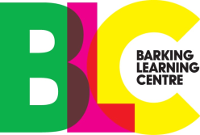

Voluntary / Community Booking Form
Please fill out the form below to request a booking of one of our rooms; please note the Barking Learning Centre conferencing team will be in contact via writing to confirm or decline your booking.
Please note this form is for external parties only. All fields must be completed before the form can be processed. A booking cannot be confirmed without a full purchase order number.

Contact Details

Contact Name: | Business Name:
Contact Address:  (Full address and postcode required) | Invoice Address, if different from contact address:  (Full address and postcode required)
Contact Telephone Number: (including local dialing code) | Contact E-mail Address:
Payment Method/Purchase Order Number:  Must be completed. | Registered Charity Number: (if applicable)
Event Details

Name of Event: | Number of Attendees:
Date of Event: | Accessibility Requirements:
Time of Hire: (inc set up time) | Time of Finishing: (inc dismantle time)
Layout Requirements:  (Please tick)  (Conference Centre only, 16+ attendees. Seminar rooms are pre-set) | □ Horseshoe  □ Boardroom (additional hire required)  □ Lecture Style  □ Dining (additional hire required)
Equipment Requirements:  (Please tick) | □ Projector (Limited availability)  □ Laptop (Limited availability)  □ Visualiser (Limited availability)  □ Flipchart □ Whiteboard
Signature: Date:
□ I have read and accept the Terms and Conditions of hire.
(PLEASE TICK)

