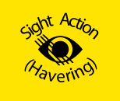
INFORMATION
DAY

Find out about support, services and equipment, available locally and nationally, for people with a vision impairment.
WEDNESDAY 6th SEPTEMBER 2023
10AM UNTIL 3PM
Y.M.C.A.
29 RUSH GREEN ROAD, RM7 0PH
Free Entry
Parking available
Refreshments on site
ALL WELCOME
Registered charity number: 1078815
www.sightactionhavering.org.uk

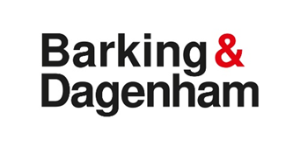

Havering Sight Action Event is being held at the YMCA in Rush Green. The 175 and 5 bus stops across the road from the YMCA, (Norwood Avenue, Stop RW), and the 103 (Norwood Avenue, Stop E), and the 174 (Rush Green Road, Stop V) stops near Rush Green Shops.

Barking and Dagenham Sensory Team have an information stand at the YMCA Havering Sight Action event on the 6 September, we hope to see you there.

If you would like to attend and need transport advice, please contact Dean Apps Rehabilitation Worker Visual Impairment.
email: sensory@lbbd.gov.uk,
mobile: 07812999648.

