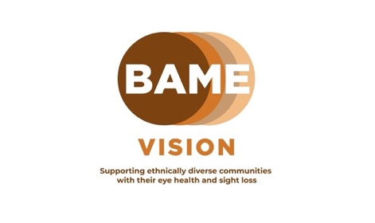
BAME Vision National Eye Health Week webinar 3 – Eye on Mental Health

BAME Vision, in collaboration with eye care & sight loss professionals and people with lived experience, are facilitating a series of informative webinars around this year’s themes of National Eye Health Week.

This year, National Eye Health Week runs from the 18th – 24th September 2023.

We are hosting 6 webinars starting from Tuesday 12th to Wednesday 27th September. These sessions are free, and are open to everyone. There will be an opportunity to ask questions to our speakers at each of the webinars.

Session 3: Eye on Mental Health
In our third session, we will cover:

- The link between sight loss and mental health
- Exploring the stages of the grieving process
- Coping strategies and techniques
- The support services available

Speakers:
Sandeep Saib - Mental Health advocate, suicide survivor, public speaker and mentor
Dr Beverly Duguid – Author, writer, poet, historian, and mindfulness teacher
Eamonn Dunne - Partnerships and Projects Development Manager, Thomas Pocklington Trust
Lived Experience Speaker:
Perm Bachu - living with a retinal dystrophy, Usher 2, and Charles Bonnet Syndrome, living by the mantra “I’m visible, not invisible.”

When : Tuesday 19th September 2023
Time : 7 - 8.30pm
Where : Online via Zoom
To register, email info@bamevision.org or visit www.bamevision.org for further information about the full schedule of webinars.
Facebook - www.facebook.com/bamevision Twitter - www.twitter.com/bamevision
LinkedIn - www.linkedin.com/company/bamevision YouTube – BAME Vision

