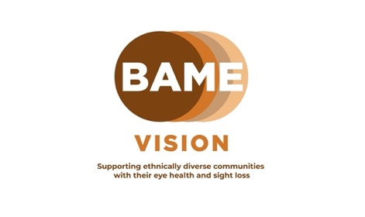

BAME Vision National Eye Health Week webinar 4 – Live Well See Well

BAME Vision, in collaboration with eye care & sight loss professionals and people with lived experience, are facilitating a series of informative webinars around this year’s themes of National Eye Health Week.

This year, National Eye Health Week runs from the 18th – 24th September 2023.

We are hosting 6 webinars starting from Tuesday 12th to Wednesday 27th September. These sessions are free, and are open to everyone. There will be an opportunity to ask questions to our speakers at each of the webinars.

Session 4: Live Well See Well
In our fourth session this year we will cover:

- Diet, nutrition, alcohol, smoking and the effects on sight loss
- How the above can negatively impact your health, focusing on eyes
- What eye conditions people are likely to develop when poor habits and unhealthy lifestyle choices are made over time, plus more
- Sharing good practice and advice for a healthier lifestyle.

Speaker:

Sonal Rughani BSc (Hons) MCOptom MPH - Specialist Public Health Optometrist

Lived Experience Speaker – Anjani Ghelani – Kinesiology Practitioner & Volunteer for Retina UK, living with Retinitis Pigmantosa.

When : Thursday 21st September 2023
Time : 7 - 8.30pm
Where : Online via Zoom
To register, email info@bamevision.org or visit www.bamevision.org for further information about the full schedule of webinars.
Facebook - www.facebook.com/bamevision Twitter - www.twitter.com/bamevision
LinkedIn - www.linkedin.com/company/bamevision YouTube – BAME Vision

