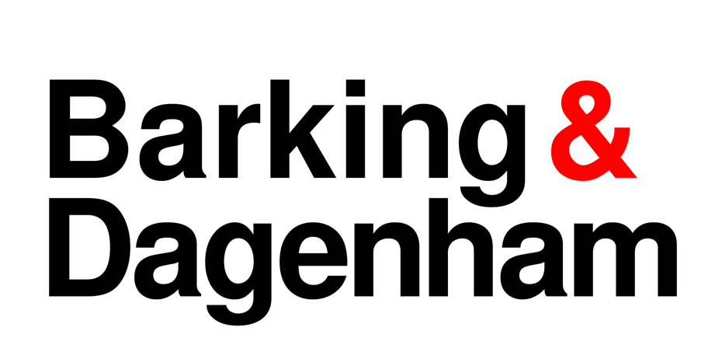

FAQ’s FAQ’
At risk or threatened with homelessness
My landlord has issued me with a section 21 eviction notice, and I don’t know what to do.
The Homeless Prevention Service is no longer located at John Smith House. Please call 020 8724 8323, Monday to Friday 9am to 4pm, or email housingadviceservice@lbbd.gov.uk and we will make every effort to respond to you as soon as possible.
Please visit the website for more information on what to do: https://www.lbbd.gov.uk/housing/housing-and-homelessness-advice/housing-advice-and-homelessness-prevention/if-your-landlord#lgd-guides__title
I am going to become homeless, what are my options?
As a council we aim to support residents who are facing housing issues or homelessness. Our priority is to prevent you from becoming homeless in the first place and we've developed a tool which will tell you what your housing options are in your circumstances by visiting: https://lbbd.ehodirect.org.uk/EhoWizard/Add
We have further information on housing and homelessness on our website, which can be found by clicking this link: https://www.lbbd.gov.uk/housing/housing-and-homelessness-advice/housing-advice-and-homelessness-prevention
Can my application be prioritised please as my landlord wants me out.
As a council we aim to support residents who are facing housing issues or homelessness. You can read more information on what to do here: Housing advice and homelessness prevention | London Borough of Barking and Dagenham (lbbd.gov.uk)

Joining the register
I applied (less than 7) months ago and haven’t heard anything.
We are currently experiencing high volumes of applications which means that the waiting time to review applications before they can join the register can take around 7 months plus. We ask that you do not contact us during this time, as this could delay the reviewing time further. To see current waiting times in LBBD and to explore alternative housing options please visit: Apply for social housing | London Borough of Barking and Dagenham (lbbd.gov.uk)
I have moved address and would like my application to be updated.
Use our form to report a change in circumstances regarding your existing application to join the housing register. If you have already been accepted onto the housing register, you can use this form to let us know of any changes to your circumstances that could affect your place on the housing register. We will usually get back to you within 4 weeks as long as you have provided all of the information we need. Please visit: Social housing register - change in circumstances | London Borough of Barking and Dagenham (lbbd.gov.uk)
My date of birth is wrong, I need to update it.
You can inform us of any changes via the change of circumstances from which can be found here: Social housing register - change in circumstances | London Borough of Barking and Dagenham (lbbd.gov.uk)
I applied for housing but I’m still waiting for my bidding number.
Due to the high volume of applications, we may not have started reviewing your application and documents yet. This can take around 7 months plus, we ask that you do not contact us during this time, as this could delay the reviewing time further. If we do accept you on the social housing register, you will receive correspondence from us with your bidding number.
I submitted a change in circumstances and have not heard anything.
We will usually get back to you within 4 weeks as long as you have provided all of the information we need. Due to the high volume of applications, and correspondence we ask that you do not contact us during this time, as this could delay the reviewing time further.
How many preferences have I been awarded?
Once you have been accepted onto the housing register we will write to tell you what kind of preference your application has been awarded. Details of how applications are prioritised can be found in our Allocations Policy available here
I do not think I have been awarded the correct preferences.
Once your application is registered and you are informed of the outcome you are entitled to request a review if you are not happy with the decision. Information on how to request a review is on the registration letter.
I would like to add to my application.
You can inform us of any changes via the change of circumstances from which can be found here: Social housing register - change in circumstances | London Borough of Barking and Dagenham (lbbd.gov.uk)
I am trying to apply but am told I already have an existing application.
If you have already submitted an application, there is no need for you to complete another one. Due to the high volume of applications, we may have not have started reviewing your application and documents yet. This can take around 7 months plus, we ask that you do not contact us during this time, as this could delay the reviewing time further. If you are certain that you have not completed an application form, please contact us on: socialhousingregister@lbbd.gov.uk
How many hours do I need to work to get a working preference?
To qualify for the non-statutory employment reasonable preference the main applicant and /or their partner must provide evidence that they are in contracted employment or self employed working 16 hours or more per week. More information about the evidence of employment which needs to be provided can be found at What documents do you need? | London Borough of Barking and Dagenham (lbbd.gov.uk)
I applied for social housing but have not received confirmation of my application.
We are currently experiencing high volumes of applications which means that the waiting time to review applications before they can join the register can take around 7 months plus. We ask that you do not contact us during this time, as this could delay the reviewing time further. To see current waiting times in LBBD Apply for social housing | London Borough of Barking and Dagenham (lbbd.gov.uk)
I have sent loads of emails regarding my application and my assessment officer has not responded to me.
We will usually get back to you within 4 weeks as long as you have provided all of the information we need. Due to the high volume of applications, and correspondence we ask that you do not contact us during this time, as this could delay the reviewing time further. Your assessment officer will make contact with you once they have assessed your application or reviewing information you have sent us.
Additional preferences, documentation and decisions
I sent in documents and have not heard back.
Due to the high volume of applications, we may have not have started reviewing your documents yet. This can take around 7 months plus, we ask that you do not contact us during this time, as this could delay the reviewing time further.
When I applied your email stated that someone would contact me within 16 weeks, but I have not heard anything.
Due to the high volume of applications our assessment officers are working hard to get through these all. However as stated on our website, the current wait time for reviewing applications to join the social housing register is 7 months plus.
I would like to appeal/review preferences awarded to my application.
As an applicant, you have the right to request a review of a decision in relation to the assessment of your application. You must request a review within 21 days of being notified of the decision. The details of how to request a review can be found on the outcome letter sent to you.
Why has my application been cancelled/suspended?
There could be a few reasons for this:
- You have not met the eligibility criteria for social housing (more information can be found here Who can apply to join the housing register? | London Borough of Barking and Dagenham (lbbd.gov.uk)
- You have not provided all the documentation required; we will process your application based on the information you provide, failure to provide all relevant documentation may result in your application being rejected. Information about the documents required can be found at What documents do you need? | London Borough of Barking and Dagenham (lbbd.gov.uk)
I am a keyworker; I would like to know if I can have a priority.
Please visit this page to see how preferences are awarded based on priority: https://www.lbbd.gov.uk/housing/apply-social-housing/bidding-social-housing
The conditions I am living in are impacting on my mental health.
We are sorry to hear this, if you are living in conditions which are impacting your mental health we would need to see evidence of this and you will need to submit a change of circumstance form which can be found here: Social housing register - change in circumstances | London Borough of Barking and Dagenham (lbbd.gov.uk) Details of mental health support available is also available here Mental health | London Borough of Barking and Dagenham (lbbd.gov.uk)
I am a priority home seeker, but I am still unable to get close to getting a property.
This is because the demand for social housing is much higher than available properties. It could be years before a successful applicant gets social housing. Even those in the most need may have a very long wait. Most people who apply for social housing do not get housed. It is suggested that you explore other housing options, these can be found here: Apply for social housing | London Borough of Barking and Dagenham (lbbd.gov.uk)
I did not receive a letter from the council, but my application has been cancelled.
We will always inform the customer of a decision and reasons around this, however if you feel that you need further information, you can email us at socialhousingregister@lbbd.gov.uk
My application will be cancelled if I do not submit medical evidence, but I am still awaiting a copy of my medical history from my GP.
If you are still awaiting documents, you can let us know by emailing: socialhousingregister@lbbd.gov.uk
I am registered for a 4-bed need but there are no properties advertised - can I be registered for a 3-bed instead?
No. In line with the allocations policy, we assess on the need of the family, for example if you require a 4 bed, you will be registered for a 4 bed property. The demand for social housing is much higher than available properties. The current waiting times for social housing in Barking & Dagenham and details of other housing options you might wish to explore can be found here: Apply for social housing | London Borough of Barking and Dagenham (lbbd.gov.uk)
I am overcrowded and my children are sharing a room, and this is impacting on their schoolwork.
The demand for social housing is much higher than available properties. It could be years before a successful applicant gets social housing and even those in the most need may have a very long wait. To check waiting times and explore what other housing options may be available to you please see Apply for social housing | London Borough of Barking and Dagenham (lbbd.gov.uk)
I am unable to get onto my bidding account, I am receiving an error message.
If you are seeing error messages then please email: socialhousingregister@lbbdd.gov.uk
I am a Council Tenant and my home is too big for me, and I would like to downsize.
Due to the shortages of family sized accommodation we want to help you downsize and have a team in the Council who can help. Please contact ComSolTS@lbbd.gov.uk providing your address and contact details and you will be contacted by a member of the team to discuss what we can do to help.
Repairs to property
I have mould and damp in my property, what do I need to do?
Please follow the advice on mould and damp which can be found on this link: Removing Mould | London Borough of Barking and Dagenham (lbbd.gov.uk)
My landlord won't fix the repairs in my property,
Please visit this page for more information on repairs in private properties: Dealing with problems in private properties | London Borough of Barking and Dagenham (lbbd.gov.uk)
Who do I contact to get the repairs fixed in my council property?
Please visit this page for more information on how to report repairs in your council property: https://www.lbbd.gov.uk/council-tenant-and-leaseholder-services/repairs#d3182cf4

