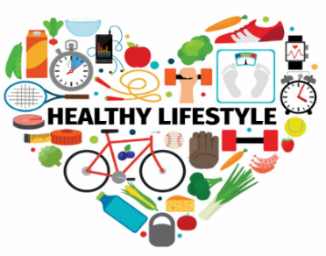
t
LEAN Living – Eat Healthier
‘Helping you to lead a healthier lifestyle
Day | Time | Facilitator | Venue | Session Information
Monday | 11am | Amy | Park Centre  RM10 9SA | 12 Week Programme  Starts 4 March 2024
Monday | 1pm | Simon | Thames Community Hub Bastable Avenue  IG11 0LH | 12 Week Programme  Starts 15 January 2024
Monday | 6pm | Seun | Online - Teams | 12 Week Programme, you can join in on any session.
Tuesday | 10.30am | Seun | Barking Learning Centre  IG11 7NB | 12 Week Programme  Starts 27 February 2024
Wednesday | 10am | Sandra | Barking Learning Centre  IG11 7NB | WOMEN ONLY  Starts 17 January 2024
Wednesday | 10am | Peter | Kingsley Hall  RM9 5NB | 12 Week Programme  Starts 17 January 2024
Wednesday | 1pm | Peter | Kingsley Hall  RM9 5NB | 12 Week Programme  Starts 17 January 2024
Thursday | 10am | Simon | Valence Library  Becontree Ave, RM8 3HT | 12 Week Programme  Starts 22 February 2024
Thursday | 1pm | Seun | Barking Learning Centre  IG11 7NB | 12 Week Programme  Starts 7 March 2024
Friday | 10.30am | Simon | Dagenham Library  RM10 9QS | 12 Week Programme  Starts 2 February 2024
Saturday | 10am | Simon | Online - Teams | 12 Week Programme, you can join in on any session
Sunday | 11am | Julian | Online – Teams | 8 Week Programme  Starting 14 January 2024
Sunday | 2.30pm | Julian | Online – Teams | 8 Week Programme  Starting 14 January 2024

To book using the following link: https://zjishiyuepalxtudzj.10to8.com

Session Topics:
“We enjoyed learning about nutrition, how we should organise the food on our plates and living a balanced life. We learnt more about what type of foods we should be eating and what foods we should eat less off. Also, we learnt about keeping fit and how to increase our strength. When we both started this course, we were both 120 KG. We have both lost around 4 KG each. We are both excited to keep on going”
Elle and Faustina, LEAN Living Graduate
Week | 12 Week Programme - Topics | 8 Week Programme – Topics
1 | Key to Healthy Eating | Goal Setting and Motivation
2 | Get your HR up | Sugars and Fats
3 | Food is fuel | Food Groups and Exercise
4 | What are your external triggers? | Eating Patterns and the importance of breakfast and water
5 | Build your strength | Triggers and Rewards
6 | Breakfast Benefits | Physical Activity
7 | Fats under the spotlight | Dinning Out and Setbacks
8 | Understand your internal triggers | Programme recap and Looking Ahead
9 | Make every day active
10 | Make meals matter
11 | Sugars under the spotlight
12 | Eat out and party

