Public Health Team
Barking Town Hall
1 Town Square
Barking
IG11 7LU
15th April 2024

Dear Parent/Carer,
With the rise of measles cases in London, the NHS is advising parents to take measures to protect their children against this serious disease.
Any child aged 4 – 16 years who has not already received two doses of the MMR vaccine is invited to receive a free vaccination on Saturday 20 April at Valence library (Becontree Avenue, RM8 3HT) between 10am and 5pm. Measles, mumps and rubella can be serious, and two doses of this vaccine gives lifelong protection.
There's no need to book an appointment – simply drop in between 10am and 5pm.Free family activities will be provided to keep children entertained while you wait.
To make the process smoother, please bring your child's red book or vaccination record if you have it. If you're unsure whether your child has had two doses of the MMR vaccine, you can speak to staff at the clinic. And if your child is not registered with a GP, they can still get vaccinated. For a quicker process give a consent for your child's immunization: https://london.schoolvaccination.uk/polio/2023/BarkingAndDagenham If you have any questions, please call Vaccination UK on 0208 0174292.

Kind regards,
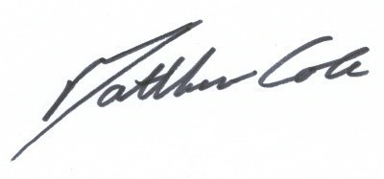
Matthew Cole
Director of Public Health
London Borough of Barking and Dagenham

