**PLAY AND COMMUNICATE**

**FOR CHILDREN 0-5 YEARS WITH SPEECH & LANGUAGE NEEDS**

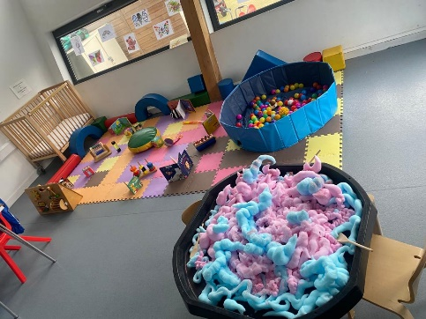

**The next sessions would start on Thursday 5th, 12th , 19th,26th, of June and 3rd and 10th of July**

**Come along with your child to explore different range of activities that support their communication. You will meet other parents/guardians, and you will be able to speak to professionals about concerns related to your child’s growth and development for advice and suggestions.**

**Address: Becontree Community Hub**

**Stevens Road Dagenham**

**RM8 2QR**

**Main Hall**

**THURSDAYS: 4:15-5:45 PM**

**Click** [**https://app.10to8.com/book/cypd-hub/1921925**](https://app.10to8.com/book/cypd-hub/1921925)

**Thursday Morning DAY: 1O:00-11:30AM**

**Click** [**https://app.10to8.com/book/cypd-hub/1921928**](https://app.10to8.com/book/cypd-hub/1921928)

**020 8227 5500/07849836795**