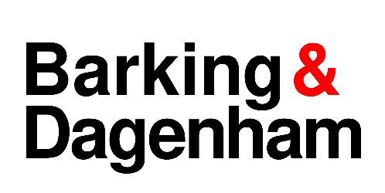

**LICENSING ACT 2003 NOTICE OF APPLICATION TO VARY A PREMISES LICENCE**

Notice is given that Vijeisangar Balasingham has applied to the London Borough of Barking & Dagenham on 20 May 2025 to Vary a Premises Licence under Section 34 of the Licensing Act 2003 for:

|  |  |
| --- | --- |
| Premises | Two Travellers PH  Wood Lane  Dagenham  RM10 7DS |

|  |
| --- |
| The Licensable activities are: |
| Proposed variation to the licensable activities:   * Additional hours for the sale of alcohol for consumption on/off the premises. * Update premises licence scale plan. * Amend/Delete/update inconsistent and or duplicated existing licensing conditions. * Alcohol sales everyday – 08:00 to existing current daily terminal hours. |

Anyone who wishes to make representations regarding this application must give notice in writing to the: Licensing Department, Regulatory Service**,** Barking Town Hall, 1 Clock House Avenue, Barking IG11 7LU or by email to [licensing@lbbd.gov.uk](mailto:licensing@lbbd.gov.uk)

Representations must be received by:

17 June 2025

The Application Record and Register may be viewed during normal office hours at the above address or at [www.lbbd.gov.uk](http://www.lbbd.gov.uk).

The Licensing Authority must receive representations by the date given above. The Licensing Authority will have regard to any such representation in considering the application. It is an offence, under section 158 of the Licensing Act 2003, to knowingly or recklessly make a false statement in or in connection with an application for premises licence. To do so could result in prosecution and a fine of any amount.