**London Borough of Barking and Dagenham**

**Annual Parking Report**

**2023/2024**

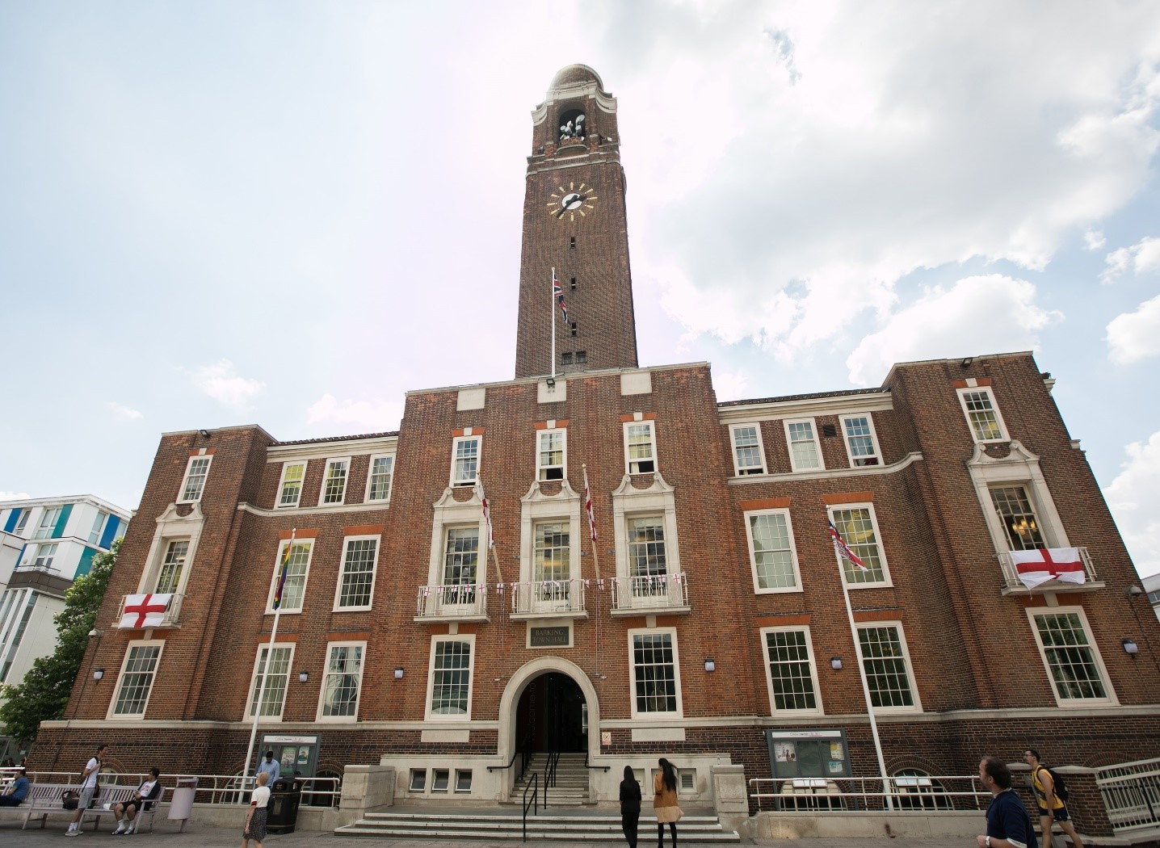

Contents

**Foreword: Cllr Syed Ghani, Cabinet Member for Enforcement & Community Safety** 3

**Overview** 4

**Controlled Parking Zones (CPZ)** 4

**School Streets** 6

**Blue Badge Holder (Disabled Bay) Project** 6

**Traffic Management Order Process** 6

**Parking Suspension Process** 6

**Operational Summary (Performance Data and Information)** 8

**Parking Permits** 9

**Parking Around the Borough & Shopping Parades/Town Centres** 10

**Parking Removals** 10

**Paid-For Parking** 11

**Council Car Parks** 11

**Lines and Signs Maintenance** 15

**Service Performance** 15

**Corporate Complaints** 15

**Financial Information** 16

**Initiatives and Aspirations for 2024/2025** 17

**APPENDIX 1: PERMIT TYPES** 19

**APPENDIX 2: Pay-By-Phone by Location** 23

# **Foreword: Cllr Syed Ghani, Cabinet Member for Enforcement & Community Safety**



I am delighted to welcome you to our Annual Parking Report.

This year’s report demonstrates the activities of the Parking Team over the past financial year and includes an overview of the financial accounts.

It also demonstrates the significant achievements of the service, which includes continually using new technologies, as well as making sure we have a personal touch available for all our users through our new Parking Customer Service Team.

Parking and traffic management is an important public service, which provides benefits to pedestrians, cyclists, motorists and the wider community, as well as our borough’s economy through maintaining road safety, access to jobs, goods and services.

Improving air quality is a key focus for the council and our Parking Strategy directly contributes to this objective by reducing carbon emissions through easing congestion. We have also developed a set of policies that aim to reduce car ownership of polluting vehicles and encourage the use of electric alternatives by making sure the infrastructure for charging is developed across the borough.

I would like to thank the Parking Team for their ongoing support, their commitment to continuously improve and their exceptional response over what has been extremely challenging times in the last two years.

Thank you for taking the time to read our Annual Parking Report, I hope you will find it interesting.

Yours,

Councillor Syed Ghani, Cabinet Member for Enforcement and Community Safety

**Overview**The current parking strategy sets out a clear vision for parking in the borough. This vision was supported by 75% of respondents to the consultation. The vision is “To provide safe, fair, consistent and transparent parking services”. This vision is supported by five main priorities that have been designed to reflect the competing parking needs in the borough. These priorities reflect the needs of residents, businesses, commuters, cyclists and pedestrians alike. The priorities are:

• Reduce congestion caused by parked vehicles and improve road safety

• Make best use of the parking space available

• Enforce parking regulations fairly and efficiently

• Provide appropriate parking availability where needed

• Ensure that the low emissions and air quality strategy for London is at the heart of our decision making

# **Controlled Parking Zones (CPZ)**

The Parking team has been consulting and implementing CPZ schemes since 2018 as part of a dedicated CPZ project. Since the CPZ project commenced, we have introduced 22 new or expanded schemes across the borough in key locations including near schools, train stations, shopping parades and other community hubs.

By introducing these CPZs we have been able to deliver many benefits to the community including:

* + Improved access to parking for residents, visitors, businesses and blue badge holders​ by designating only those with a valid permit or who have registered with Pay By Phone to park​.
  + Improved road safety​, particularly around schools and community hubs. By the end of this current project, it is estimated that 47 schools will have restrictions helping to reduce conflict between motorists and school children by clarifying where it is safe to park and by discouraging the use of the motor vehicle around school buildings.
  + Improved air quality - in line with the requirements of the Mayor of London’s Transport Initiatives and Manifesto, we have been encouraging members of the public to choose healthier and more sustainable methods of transport including walking, cycling and public transport through our emissions-based permit tariffs and a cap on the number of permits available per household.​ Where CPZ restrictions apply, this also reduces the number of motorists “cruising for a parking space” and idling.
  + Encouraging more sustainable forms of transport by funding active travel schemes to encourage more walking, cycling and other green forms of transport.
  + Reduced Traffic Congestion – the introduction of CPZs​ reduces the amount of parking related journeys being made within the borough by restricting the overall demand for parking and mitigating instances of illegal and obstructive parking.
  + Parking bays and yellow line restrictions help to ensure motorists can safely travel along the road without obstruction. This is particularly important for the London Fire Brigade (LFB) who continue to raise concerns about access in certain parts of the borough, as well as other emergency services such as ambulance drivers.​
  + Improved access for pedestrians​ - parking bays and yellow lines help to ensure pedestrians can safely use the footway which is especially needed for vulnerable residents such as wheelchair users, young children and those who are partially sighted.

As part of the final phase of CPZ project 1 and since the previous annual report, (2022/2023), we have consulted upon and implemented of 5 CPZs, all of which are based around schools within the borough.

The breakdown of these schemes is as follows:

|  |  |  |  |
| --- | --- | --- | --- |
| **Area** | **CPZ Prefix and Ward** | **Scheme type** | **School location** |
| S6 | ‘STR’ CPZ Monday to Friday 8.30am – 5.30pm (Parsloes and Mayesbrook Wards) | School Scheme | St Teresa RC and Rodin Primary Schools |
| S7 | **‘STR’ CPZ  Monday to Friday 8.30am – 5.30pm (Parsloes Ward)** | Southwood Primary and Sydney Russell Secondary Schools |
| S8 | **‘WB’ CPZ Monday to Friday 8.30am – 5.30pm (Heath Ward)** | William Bellamy Primary School |
| S14 | **‘RCS’ CPZ Monday to Friday 8.30am – 5.30pm (Heath Ward** | Robert Clack School of Science |
| S16 | **‘CH’ CPZ Monday to Friday 8.30am – 5.30pm (Becontree Ward)** | Becontree Primary School |

**CPZ Project 2**

Since the summer of 2024, we have been consulting on the introduction of a further 6 CPZ schemes across Becontree, Valence and Chadwell Heath Wards as we continue the Councils vision to ensure “Residents live in, and play their part in creating, safer, cleaner, and greener neighbourhoods” as well as our commitment as a parking department to reduce car ownership and improve air quality. The outcomes of these consultation will be fed back to the community in Spring 2025.

# **School Streets**

Since the previous annual report and in collaboration with Be First colleagues, we also continue with our commitment to School Street and there are plans to consult and implement on the following school locations:

* Furze Infants
* Godwin Primary
* Thomas Arnold
* Manor Primary
* Valance Primary (Bonham Site)

# **Blue Badge Holder (Disabled Bay) Project**

The introduction, removal and refreshing of Blue Badge holder bays is supporting the parking needs of some of our most vulnerable residents in the borough. The parking environmental design team work closely with the Council’s mobility team to ensure those with mobility or mental health issues, (who hold a blue badge), are supported with the installation of a disabled bay. Since the last report we have undertaken the following:

* Number of new disabled bays installed this year - 35
* Number of disabled bays refreshed after this year - 13
* Number of disabled bays removed this year – 51

We are also currently processing our next round of blue badge bays and have 20 new locations planned, with 5 to be refreshed (1st quarter).

**Blue Badge Enforcement**

Blue Badge enforcement commenced in November 2021. From this date, until March 2024, a total of 156 Blue Badges were confiscated for being stolen, lost or used after the badge owner had deceased.

To date, we are progressing with prosecutions for misuse for most of these cases.

# **Traffic Management Order Process**

Since the previous report the Parking and Environmental Design Team have processed 85 TTMO and over 20 TMO requests which has legally facilitated the introduction of parking schemes, traffic calming schemes, road closures, new developments and events.

# **Parking Suspension Process**

Since April 2023 – March 2024, we have processed approximately 578 suspension applications which facilitates various utility works across the borough and ensures that motorists are clear that a parking bay is not in use for a period of time. A suspension may be required for works such as gas, electric or water works.

**Useful Links**

All New parking schemes and road closures are displayed here: <https://www.lbbd.gov.uk/new-and-proposed-traffic-and-parking-schemes>

Criteria for the introduction of a CPZ – Ref to Appendix A for summary: <https://www.lbbd.gov.uk/sites/default/files/attachments/Criteria-used-for-decision-Implementation-of-CPZ.pdf>

CPZ related FAQs: <https://www.lbbd.gov.uk/sites/default/files/attachments/FAQ%2015.7.21.pdf>

Traffweb System: <https://www.barking-dagenham-traffweb.co.uk/main.html>

Dropped Kerb Policy: <https://www.lbbd.gov.uk/dropped-kerbs-footway-crossings>

The dropped kerb policy was amended in April 2022 so that it’s more flexible for those who are valid blue badge holders or electric vehicle owners to obtain a dropped kerb, subject to other criteria. The reason for this is that we are looking to support our most vulnerable residents as well as promote more healthy and sustainable modes of transport.

Blue Badge Bays: <https://www.lbbd.gov.uk/disabled-and-blue-badge-parking>

# **Operational Summary (Performance Data and Information)**

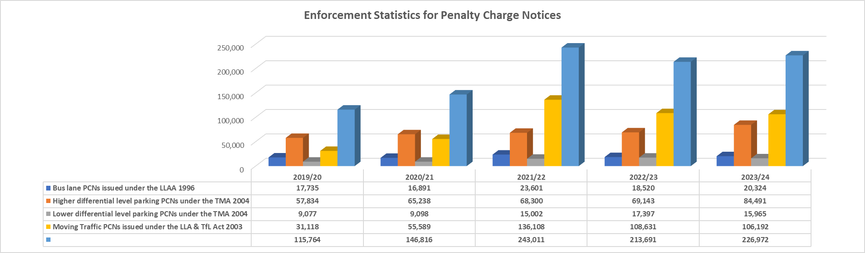

Key Notes:

LLAA – London Local Authorities Act

PCN – Penalty Charge Notice

TFL – Transport for London

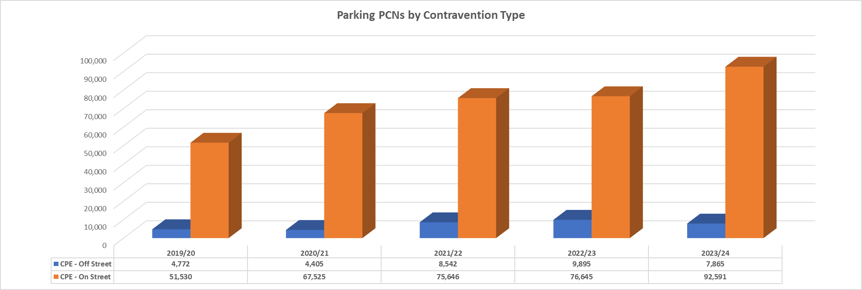

Keynote:

CPE – Civil Parking Enforcement

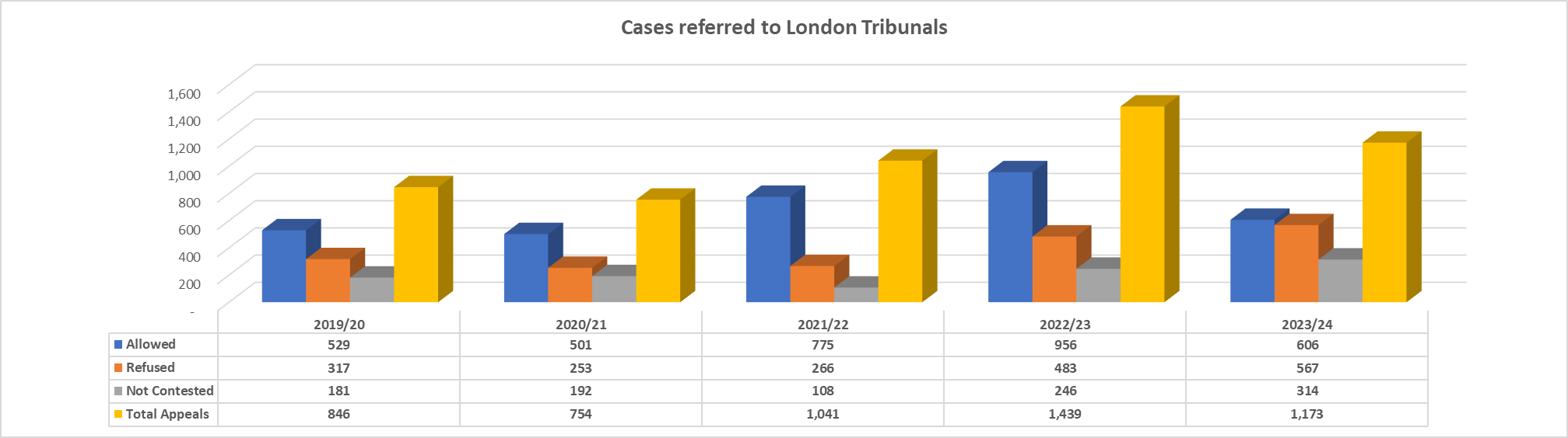

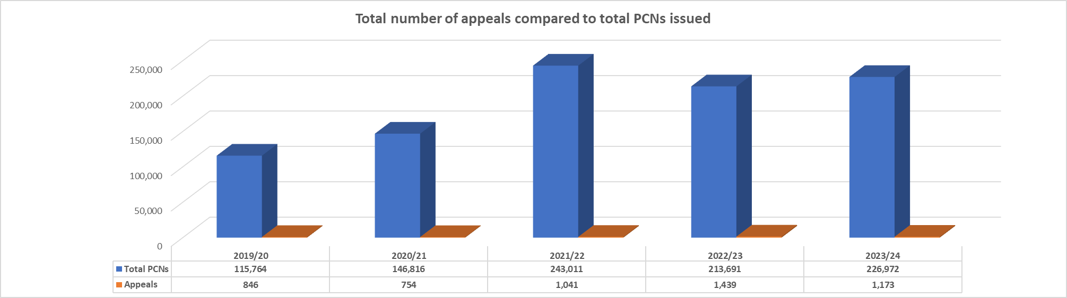

**Parking Permits**  
In line with the Council’s commitment to service improvement, ease of use and encouraging ‘Digital by Design’, we have focused customer permit interactions through the website. Our residents can apply for parking products at home, at work or on their smartphone. All permits are now administered online.

In a bid to assist our customers, we introduced the following changes:

* No tariff increases in the last year
* Introduction of a zero charge for all vehicles with 0-50 co2 emissions to improve air quality
* Introduction of Community and Healthcare Permits for Key Workers and community workers
* Introduction of Associate Commuter Permits for London Ambulance service etc.
* Introduction of Short-Stay Boroughwide Permits
* Introduction of boroughwide Trade Permits for small business etc.
* Introduction of free Courtesy Blue Badges to help prevent vandalism and theft
* Introduction of Dropped Kerb Permits to enable residents to park on their own dropped kerbs without the need for a resident parking permit

**Resident Parking Permits**  
The table below compares the sales of residents permits in the 2023/2024 financial year compared with previous financial years.

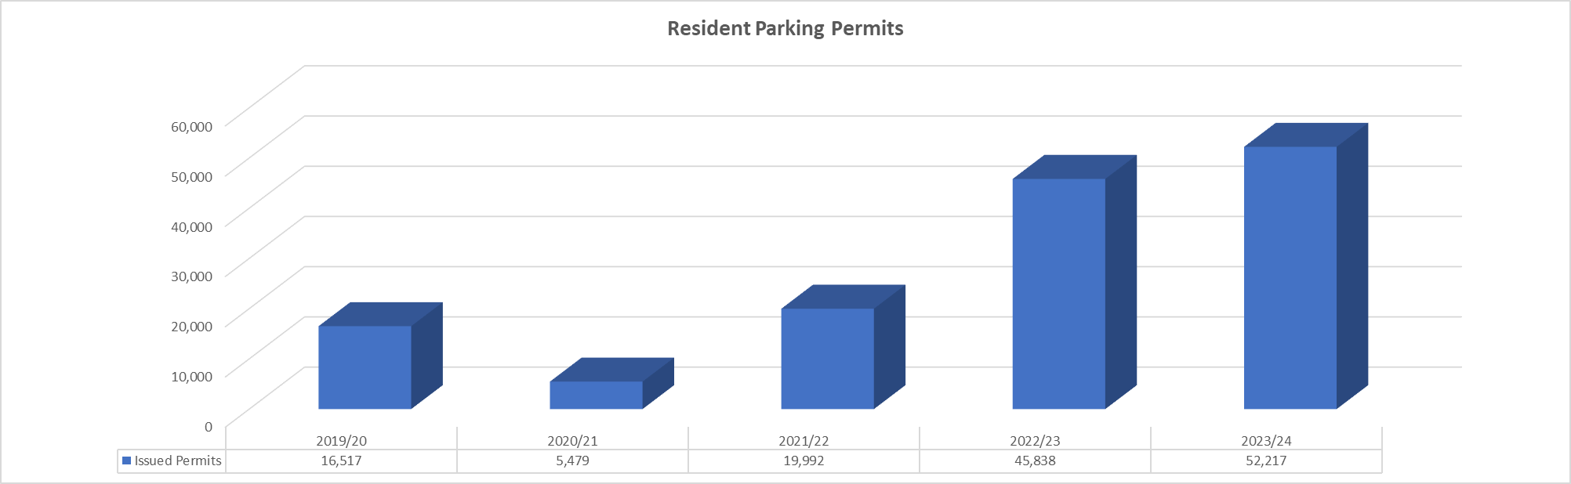

Other Parking Permit Types

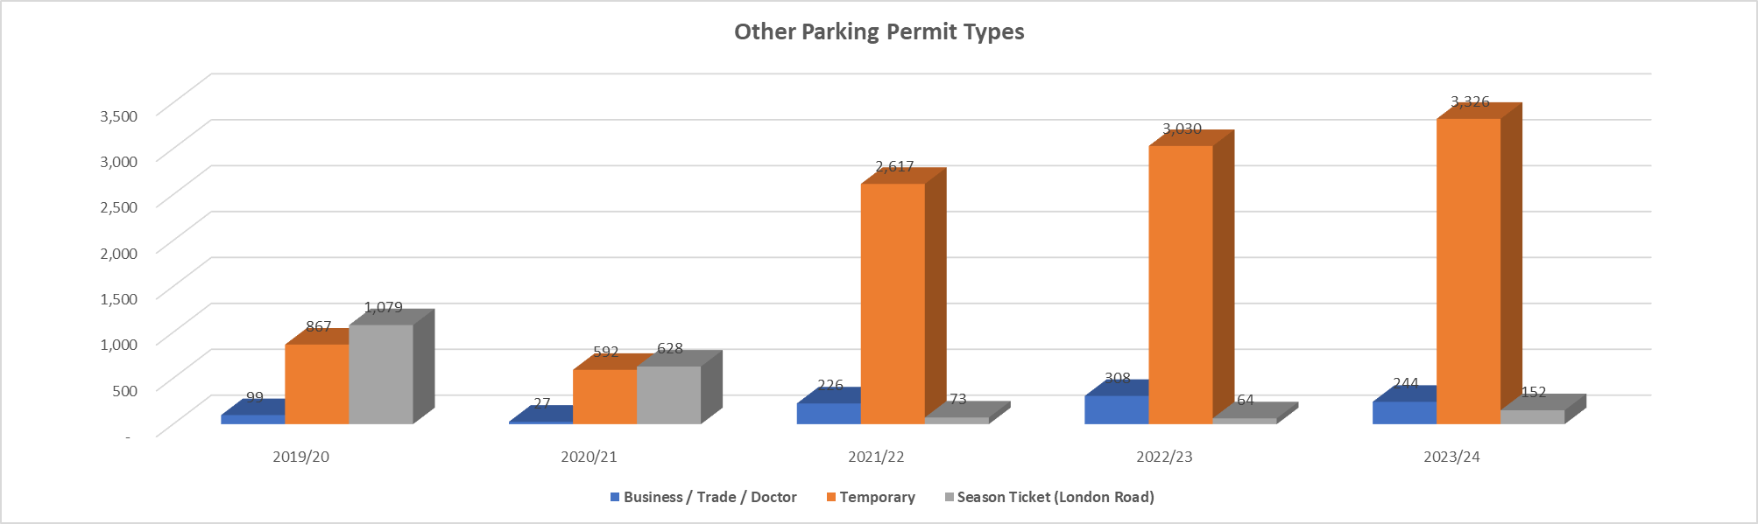

# **Parking Around the Borough & Shopping Parades/Town Centres**

Neighbourhood parades/local shopping parades play an important role in serving residents’ shopping needs. These businesses rely on the local community as well as passing trade. Additionally, there is a requirement for loading/unloading facilities.

Patrols by our Civil Enforcement Officers support the need to maintain access, regulate the flow of traffic and maintain road safety and this is done by providing parking bays which are supported by Pay by Phone, thereby ensuring bays are not misused. These responsibilities are set within the content of national and London- wide strategies including the Mayor’s Transport Strategy.

Our ambition to support businesses and to sustain thriving retail opportunities through our Core Strategy and Economic Development Strategy is set alongside our duty to manage traffic flows and congestion.

# **Parking Removals**

The Parking service, in some circumstances, have to remove vehicles. These include:

* Vehicles which are parked dangerously
* If the vehicle is a persistent evader
* If a vehicle is in contravention of the parking controls
* Vehicles which are causing a serious obstruction
* Blue Badge Misuse and fraud
* If the vehicle has incorrectly purchased permit

The General Regulations for Clamping and the Removal and Disposal of Vehicles (Amendment) (England) Regulations 2007 for removals state when you have to wait either 15 or 30 minutes after the issue of a PCN before removing a vehicle and when you can immediately remove a vehicle after the issue of a PCN. Vehicles not identified as persistent evaders that are parked in a parking place must not be removed until 30 minutes have elapsed since the end of any period of paid parking.

Vehicles that have been identified as persistent evaders that are parked in a parking place will be removed once 15 minutes have elapsed since the end of any period of paid parking. Vehicles that are not parked in a parking place, such those observed on yellow lines, those misusing blue badges or those parked in dedicated spaces without complying with the restrictions (such as but not limited to a disabled bay or suspended bay) may be removed immediately after the issue of a PCN.

The Parking Investigation and Removals team have managed to remove 523 vehicles and disposed of 159 vehicles in the 2023/2024 financial year. That’s an increase of approximately 20 vehicles being removed compared to the previous financial year.

­­The disposal rate has remained steady; however, the income has improved to £94,920 but totals £196,311 when the recovered PCN monies are included.

The Parking Investigation and Removals team have managed to deal with 91 cases of disabled blue badge misuse since April 2023

From the above figures we have had 37 (92.5%) successful prosecutions, with some further progressing to the prosecution stages.

**Paid-For Parking**  
The Council has many paid-for parking places throughout the borough. These include off-street locations, (multi-storey car parks and surface car parks), and on-street locations, (parking bays and spaces). The below provides a list of the locations and the related Pay by Phone codes.

We now have emissions-based paid-for parking which, like our resident permit pricing structure, is designed to encourage healthier transport options such as the use of public transport, walking and cycling or alternatively the use of less polluting vehicles such as electric vehicles.

# **Council Car Parks**

**Axe Street Service Road car park**

(PayByPhone Code 805623)

**Barking Park Western car park**

(PayByPhone Code 805624)

**Bobby Moore Way car park**

(PayByPhone Code 805625)

**Heathway multi-storey car park**

(PayByPhone Code 805654)

**London Road multi-storey car park**

(PayByPhone Code 805626)

A season ticket is available for this car park. Also, you should note that there is a height restriction of 2.05m (6ft 9in) in this car park.

**Riverside area car park**

(PayByPhone Code 805629)

**Wantz Road car park**

(PayByPhone Code 805656)

**Paid-For Parking Locations**

|  |
| --- |
| **Locations by zone number** |
| 805623 - Axe Street Service Road Car Park |
| 805624 - Barking Park Western Car Park |
| 805625 - Bobby Moore Way Car Park |
| 805626 - London Road Multi Storey Car Park |
| 805627 - London Road Season Tickets (8pm-6am weekdays only) |
| 805629 - Riverside Area Car Park |
| 805633 - Season Tickets (6am-8pm only) for London Road |
| 805634 - Season Tickets 24hr for London Road Multi-storey |
| 805654 - Heathway Multistorey Car Park |
| 805655 - Season Tickets (6.30am-7.30pm only) Heathway MSCP |
| 805656 - Wantz Road Car Park |
| 805735 - Cartwright Road |
| 806633 - John Smith House Car Park |
| 806796 - Charlotte Road Area Car Park |
| 805621 - Bastable Avenue |
| 805622 - Chelmer Crescent |
| 805635 - Abbey Ward Area |
| 805636 - Barking Town Centre (P/D Clockhouse Avenue) |
| 805637 - Faircross Parade |
| 805638 - Harrow Road |
| 805639 - Longbridge Road |
| 805640 - Park Avenue |
| 805641 - Ripple Road (Cemetery) |
| 805642 - Ripple Road (Westbury) |
| 805643 - Rippleside Industrial Estate |
| 805644 - Wakering Road |
| 805645 - Bennett Road |
| 805646 - High Road, Chadwell Heath |
| 805647 - Morden Road |
| 805648 - Barnmead Road |
| 805649 - Beverly Road (opposite 114 - 106) |
| 805650 - Halbutt Street (outside 147- 145) |
| 805651 - Halbutt Street (outside 69) |
| 805652 - Oxlow Lane (o/s Catholic Church of Holy Family) |
| 805653 - Parsloes Avenue (opposite 260 - 242, 106 - 96) |
| 805657 - Blithbury Road & Porters Avenue |
| 805658 - Broad Street |
| 805659 - Dag Heathway 1 |
| 805660 - Fiddlers Shopping Area |
| 805661 - Gale Street |
| 805662 - Green Lane Area |
| 805663 - Heathway - Outside Heathway Methodist Church |
| 805664 - Osborne Square |
| 805665 - Royal Parade, Church Elm Lane |
| 805666 - Goresbrook Road |
| 805667 - Dagenham Avenue |
| 805668 - Urswick Road |
| 805731 - Goresbrook Road (o/s John's Church & Comm Centre) |
| 805732 - Hatfield Road |
| 805733 - Levet Road and Hurstbourne Gardens |
| 805734 - Vincent Road |
| 805736 - Chaplin Road |
| 805821 - Ripple Road |
| 805825 - John Burns Drive |
| 805826 - Blake Avenue |
| 805831 - Sisley Road |
| 805832 - Eastbury Square |
| 805834 - New Road |
| 805835 - Centre Road |
| 805839 - Oval Road North |
| 805842 - Lodge Avenue |
| 805843 - Hedingham Road |
| 805844 - Neasham Road |
| 805845 - Markyate Road |
| 805846 - Ilchester Road |
| 805847 - Waldegrave Road |
| 805848 - Burnside Road |
| 805849 - Haydon Road |
| 805850 - Greenway |
| 806207 - Five Elms Road |
| 806208 - Halbutt Street |
| 806209 - St Georges Rd |
| 806210 - Heathway |
| 806634 - Woodbridge Road |
| 806797 - Charlotte Road |
| 806798 - Church Elm Lane |
| 806799 - Church Elm Lane |
| 806800 - Church Elm Lane |
| 806801 - Church Street |
| 806802 - Crown Street |
| 806803 - Exeter Road |
| 806804 - Vicarage Road |
| 806982 - Tenby Road |
| 806983 - Tenby Road |
| 806984 - Ashton Gardens |
| 806985 - Ashton Gardens |
| 807179 - Merrielands Crescent |
| 807494 - Bonham Road, Dagenham |
| 807495 - Grafton Road, Dagenham |
| 809170 - Mizzen Street |
| 809171 - Tide Street |
| 809172 - Mast Street |
| 809173 - Ketch Street |
| 809221 - Hewett Road, Dagenham |
| 809222 - Hobart Road, Dagenham |
| 809223 - Cornwallis Road, Dagenham |
| 809224 - Keppel Road, Dagenham |
| 809225 - Parsloes Avenue, Dagenham |
| 809226 - Verney Road, Dagenham |
| 809227 - Braintree Road, Dagenham |
| 809228 - Rusholme Avenue, Dagenham |
| 809229 - Stansgate Road, Dagenham |
| 809230 - Stour Road, Dagenham |
| 809231 - Althorne Way, Dagenham |
| 809232 - Gosfield Road, Dagenham |
| 809233 - Gainsborough Road, Dagenham |
| 809234 - Mayesbrook Road, Dagenham |
| 809235 - Stevens Road, Dagenham |
| 810034 - Farr Avenue |

# **Lines and Signs Maintenance**

Lines and signs maintenance is an essential aspect of ensuring parking and traffic compliance within the borough. Ambiguous and/or faded lines and signs increase the potential for non-compliance, thereby increasing the risk of congestion and other negative factors.

We have two approaches to parking maintenance- planned maintenance and reactive maintenance.

Our maintenance program focusses on ensuring that lines and signs are kept in good condition within the following key areas:

* Existing CPZs
* Locations of moving traffic offences/CCTV enforcement
* Safety markings such as junction protection markings (yellow lines)

In terms of our reactive approach, our Civil Enforcement Officers and Appeals Team are in regular contact with the PED Team to quickly alert them to any irregularities.

# **Service Performance**

## **Corporate Complaints**

The table below shows the number of corporate complaints received by the service area compared to previous years.

2023/2024 saw a marked decrease in complaints at Stage 1 with 396 being logged. 382 of these were resolved at the first stage without escalation.

15 cases were registered to the LGO (Local Government Ombudsman) as some complainants sought intervention by them before the Council investigating first.

Of these 15 cases, 1 was upheld for maladministration, and 2 are yet to receive outcome The remaining cases were not upheld by the LGO who either agreed with the action taken by us at the Stage 2 review stage, or they did not take up the investigation.

74 Freedom of Information requests and 40 Subject Access Requests were received and responded to.

|  |  |  |  |  |  |  |
| --- | --- | --- | --- | --- | --- | --- |
| **Enquiry** | **Reporting year** | | | | | |
| **2018/19** | **2019/20** | **2020/21** | **2021/22** | **2022/23** | **2023/24** |
| Stage 1 Corporate Complaints | 356 | 294 | 556 | 957 | 712 | 396 |
| Stage 2 Corporate Complaints | 9 | 8 | 29 | 14 | 13 | 14 |
| Freedom of Information (INC SAR) | 69 | 59 | 67 | 71 | 89 | 114 |

## **Financial Information**

**Parking Account**

|  |  |  |  |  |  |
| --- | --- | --- | --- | --- | --- |
| **Parking Account** | | | | | |
|  | **2019/20** | **2020/21** | **2021/22** | **2022/23** | **2023/24** |
|  | (£'000) | (£'000) | (£'000) | (£'000) | (£'000) |
| **Expenditure:-** |  |  |  |  |  |
| Premises | 342 | 261 | 608 | 274 | 175 |
| Transport | 63 | 32 | 44 | 85 | 120 |
| Supplies & Services | 509 | 1,084 | 719 | 2,050 | 1,479 |
| Third Party Payments | 387 | 378 | -33 | 0 | 1 |
| Management/Employees/Support | 2,213 | 2,497 | 2,698 | 3,718 | 4,009 |
| Capital Charges | 787 | 701 | 115 | 116 | 116 |
| Other | -121 | 0 | 201 | 824 | 1,114 |
|  | 4,180 | 4,953 | 4,352 | 7,067 | 7,014 |
|  |  |  |  |  |  |
| **Income:-** |  |  |  |  |  |
| PCN Income | -5,679 | -6,995 | -12,477 | -13,147 | -12,421 |
| Non Staff Permits | -1,702 | -2,406 | -2,760 | -2,190 | -2,456 |
| Staff Permits | -239 | -46 | -1 | 0 | 0 |
| Pay and Display Off street | -78 | -549 | -1,253 | -1,441 | -1,776 |
| Pay and Display On street | -1,027 | -76 | -536 | -617 | -760 |
| Others | 0 | 0 | 17 | -386 | -814 |
| Sub total | -8,725 | -10,072 | -17,010 | -17,781 | -18,227 |
|  |  |  |  |  |  |
| **Net (Surplus)/Deficit** | -4,545 | -5,119 | -12,658 | -10,714 | -11,213 |
|  |  |  |  |  |  |
| Surplus used to finance the following:- |  |  |  |  |  |
| Revenue contributions to capital schemes (highways improvements) |  |  |  |  |  |
| Local Implementation Plan ( Mayor's Transport Strategy) | -4,545 | -5,119 | -12,658 | -10,714 | -11,213 |

# **Initiatives and Aspirations for 2024/2025**

The core aim of Parking Services is to maintain the expeditious flow of traffic along the highway and to improve its operational efficiencies.

Following on from the successful rollout of virtual residents permits and visitors vouchers, Parking Services will make more permit types available through an online self-service website. This will have the added benefit for the back office having very little intervention in the permit process and giving permit holders greater flexibility and control over their permits.

We are aware of the need for a smart device app to facilitate the process of purchasing visitor parking sessions and this is currently in development with our service provider. We anticipate this will be delivered during 2025.

**Parking Zones and Safety Control Measures**

The Parking & Environmental Design Team have an ambitious programme of works which features several parking schemes located throughout the borough. Many of these schemes are focussed near to schools or are based on expanding an existing scheme.

The continued aim of this project is to:

* Improve access to parking for residents, visitors, businesses and blue badge holders​
* Improve road safety​, particularly around schools and community hubs
* Improve air quality (Net-Zero ambitions)
* Reduce traffic congestion
* Improve access for all motorists including the emergency services
* Improved access for pedestrians​ - parking bays and yellow lines help to ensure pedestrians can safely use the footway which is especially needed for vulnerable residents such as wheelchair users, young children and those who are partially sighted.

Consultation with residents on the introduction of 6 new expansion schemes as part a second and new CPZ project has just been undertaken and we are in the process analysing all feedback in accordance with the residents CPZ parking policy. This includes the following:

|  |  |
| --- | --- |
| **Ward** | **CPZ Area** |
| Chadwell Heath | Area 1 |
| Mayesbrook and Parsloes | Area 2 |
| Mayesbrook and Parsloes | Area 3 |
| Valence & Whalebone Wards | Area 3a |
| Parsloes Ward | Area 4a |

**Parking Customer Service**

In early 2022 we carried out a ‘listening exercise’ to ascertain the main issues our customers were experiencing and why complaints were being made.

The majority of the feedback indicated that customers were unhappy with the amount of time spent on hold to the contact centre, to be advised that the person who answered the call was not a parking expert and was unable to provide in-depth, knowledgeable answers.

Whilst the Penalty Charge Notice process is a legislative one with a set route of appeal, we decided to provide dedicated parking-based telephone assistance to our customers and we are pleased to announce that our new Parking Customer Service Team went live in October 2022.

The team currently takes phone calls to assist in answering enquiries regarding all parking related matters including CPZs, permits and PCNs, Monday to Friday from 08:00 to 17:00 and can be contacted via 0203 307 4967.

From 1 April 2023 to 31 March 2024 the Parking Customer Service Team answered 33,159 phone calls.

# **APPENDIX 1: PERMIT TYPES**

|  |  |  |
| --- | --- | --- |
| **Permit Type** | **No. of permits** | **Value** |
| **Non-Resident** | **3,321** | **£182,193.00** |
| Associate Commuter Daily Vouchers | 292 | £0.00 |
| Associates Commuter Annual Permit | 37 | £3,125.00 |
| Boroughwide Business / Trade Permit - Annual | 83 | £42,195.00 |
| Business / Trade Permit - Annual | 149 | £28,030.00 |
| Care Agencies (On street only) | 1 | £250.00 |
| Community and Healthcare Annual | 718 | £84,410.00 |
| Community and Healthcare Short Stay | 52 | £0.00 |
| George Carey School Visitor Vouchers | 1 | £0.00 |
| Keyworker (On street only) | 1 | £100.00 |
| Members Permit | 5 | £0.00 |
| Monthly Associate Commuter Permit | 1,817 | £21,909.00 |
| Red Permit - Annual | 10 | £800.00 |
| Red Permit - Daily | 58 | £0.00 |
| Red Permit - Monthly | 82 | £1,074.00 |
| Short Stay Boroughwide Business / Trade Permit | 3 | £0.00 |
| Short Stay Business / Trade Permit | 9 | £0.00 |
| Voluntary Enterprise Sector (on street only) | 3 | £300.00 |
|  |  |  |
| **OTHER** | **965** | **£10,065.00** |
| Admin Special Waiver - Borough Wide | 110 | £0.00 |
| Admin Special Waiver - Specific Car Park | 175 | £0.00 |
| Admin Special Waiver - Specific Zone | 17 | £0.00 |
| Dropped Kerb Permit | 625 | £8,355.00 |
| Parking Waiver Daily | 27 | £562.00 |
| Parking Waiver Weekly | 11 | £1,148.00 |
|  |  |  |
| **Resident** | **52,254** | **£1,107,391.75** |
| Annual Residents Permit | 22,787 | £998,516.25 |
| Disabled Badge Holders Permit | 988 | £0.00 |
| HW3 Annual Residents Permit | 40 | £1,454.00 |
| MT1 Annual Residents Permit | 69 | £3,297.00 |
| MT1 Temporary Residents Permit | 2 | £62.00 |
| Temporary Residents Permit | 3,285 | £97,891.00 |
| Visitor Vouchers 24H - Book of 10 | 1 | £0.00 |
| Visitor Vouchers 24H - Book of 10 - FOC | 421 | £0.00 |
| Visitor Vouchers 24H - Single use vouchers | 14,152 | £0.00 |
| Visitor Vouchers 4H - Book of 10 | 7 | £52.50 |
| Visitor Vouchers 4H - Single use vouchers | 10,334 | £0.00 |
| WSQ Annual Residents Permit | 129 | £4,910.00 |
| WSQ Temporary Residents Permit | 39 | £1,209.00 |
|  |  |  |
| **Season's Ticket** | **152** | **£46,826.10** |
| London Road MSCP - 24 hour | 87 | £34,947.00 |
| London Road MSCP - Days | 42 | £9,259.50 |
| London Road MSCP - Overnight | 12 | £1,438.50 |
| The Mall (Heathway) | 11 | £1,181.10 |
|  |  |  |
| **Staff** | **5,951** | **£51,088.00** |
| Operational Permit - Annual | 1,779 | £2,040.00 |
| Operational Permit - Daily | 1 | £0.00 |
| School Staff and Teachers Permit - Annual | 42 | £4,955.00 |
| School Staff and Teachers Permit -- Monthly | 310 | £3,813.00 |
| Short Stay Operational Permit | 104 | £0.00 |
| Short Stay Teachers Permit | 53 | £0.00 |
| Staff Commuter Annual Permit | 45 | £3,280.00 |
| Staff Commuter Daily Vouchers | 744 | £0.00 |
| Staff Commuter Half day Vouchers | 65 | £0.00 |
| Staff Commuter Monthly Permit | 2,786 | £36,730.00 |
| Staff Commuter Monthly Permit (1 month) | 22 | £270.00 |
|  |  |  |
| **Suspension** | **529** | **£1,775,560.00** |
| Bay Suspension Daily | 229 | £255,305.00 |
| Bay Suspension Daily - Emergency Works | 35 | £50,302.00 |
| Bay Suspension Weekly | 216 | £1,142,614.00 |
| Bay Suspension Weekly - Emergency Works | 49 | £327,339.00 |
|  |  |  |
|  |  |  |
| **TYPE** | **No. of permits** | **Amount Paid** |
| Non-Resident | 3,321 | £182,193.00 |
| OTHER | 965 | £10,065.00 |
| Resident | 52,254 | £1,107,391.75 |
| Season's Ticket | 152 | £46,826.10 |
| Staff | 5,951 | £51,088.00 |
| Suspension | 529 | £1,775,560.00 |
| **Grand Total** | **63,172** | **£3,173,123.85** |
| |  | | --- | |  | |  |  |
|  |  |  |
|  |  |  |
|  |  |  |
|  |  |  |
|  |  |  |

# **APPENDIX 2: Pay-By-Phone by Location**

|  |  |  |
| --- | --- | --- |
| **LOCATION** | **Parking Amount** | **Transactions** |
| **London Borough of Barking & Dagenham - Off Street** |  |  |
| Axe Street Service Road Car Park | £836.10 | 663 |
| Barking Park Western Car Park | £16,706.10 | 28,685 |
| Bobby Moore Way Car Park | £100,272.20 | 62,240 |
| Cartwright Road | £307.30 | 464 |
| Charlotte Road Area Car Park | £1,620.90 | 991 |
| Heathway Multistorey Car Park | £71,314.50 | 33,963 |
| John Smith House Car Park | £1,967.40 | 1,990 |
| London Road Multi Storey Car Park | £178,350.80 | 24,662 |
| London Road Season Tickets (8pm-6am weekdays only) | £3,435.40 | 28 |
| Riverside Area Car Park | £1,282.80 | 313 |
| Season Tickets (6.30am-7.30pm only) Heathway MSCP | £21,391.90 | 99 |
| Season Tickets (6am-8pm only) for London Road | £37,068.43 | 110 |
| Season Tickets 24hr for London Road Multi-storey | £127,969.28 | 940 |
| Wantz Road Car Park | £222.30 | 216 |
| **Off Street Total** | **£562,745.41** | **155,364** |
|  |  |  |
| **London Borough of Barking & Dagenham - On Street** |  |  |
| Abbey Ward Area | £124,822.70 | 43,311 |
| Althorne Way, Dagenham | £177.00 | 311 |
| Ashton Gardens | £1,110.70 | 2,320 |
| Ashton Gardens | £1,791.90 | 3,545 |
| Barking Town Centre (P/D Clockhouse Avenue) | £92,584.70 | 51,077 |
| Barnmead Road | £915.00 | 1,275 |
| Bastable Avenue | £9,358.10 | 27,115 |
| Bennett Road | £3,215.60 | 5,774 |
| Beverly Road (opposite 114 - 106) | £533.70 | 1,361 |
| Blake Avenue | £3,484.50 | 2,579 |
| Blithbury Road & Porters Avenue | £1,335.40 | 2,587 |
| Bonham Road, Dagenham | £643.80 | 1,967 |
| Braintree Road, Dagenham | £20.30 | 29 |
| Broad Street | £13,719.00 | 15,559 |
| Burnside Road | £881.20 | 2,796 |
| Centre Road | £2,197.20 | 1,264 |
| Chaplin Road | £157.10 | 180 |
| Charlotte Road | £493.40 | 571 |
| Chelmer Crescent | £564.20 | 563 |
| Church Elm Lane | £732.80 | 928 |
| Church Elm Lane | £137.20 | 131 |
| Church Elm Lane | £250.40 | 279 |
| Church Street | £700.40 | 460 |
| Cornwallis Road, Dagenham | £2.40 | 3 |
| Crown Street | £267.60 | 181 |
| Dag Heathway 1 | £2,995.90 | 2,717 |
| Dagenham Avenue | £4,052.80 | 3,143 |
| Eastbury Square | £544.40 | 146 |
| Exeter Road | £664.10 | 409 |
| Faircross Parade | £11,125.30 | 40,407 |
| Fiddlers Shopping Area | £4,035.00 | 7,037 |
| Five Elms Road | £535.60 | 972 |
| Gainsborough Road, Dagenham | £292.80 | 583 |
| Gale Street | £2,497.40 | 2,666 |
| Goresbrook Road | £992.70 | 1,085 |
| Goresbrook Road (o/s John's Church & Comm Centre) | £234.60 | 344 |
| Gosfield Road, Dagenham | £200.80 | 122 |
| Grafton Road, Dagenham | £167.90 | 180 |
| Green Lane Area | £18,412.00 | 67,635 |
| Greenway | £132.00 | 249 |
| Halbutt Street | £319.00 | 340 |
| Halbutt Street (outside 147- 145) | £366.50 | 379 |
| Halbutt Street (outside 69) | £388.70 | 740 |
| Harrow Road | £2,635.60 | 3,537 |
| Hatfield Road | £529.00 | 698 |
| Haydon Road | £628.20 | 722 |
| Heathway | £617.30 | 558 |
| Heathway - Outside Heathway Methodist Church | £125.80 | 95 |
| Hedingham Road | £223.40 | 367 |
| Hewett Road, Dagenham | £397.50 | 1,272 |
| High Road, Chadwell Heath | £16,222.70 | 21,716 |
| Hobart Road, Dagenham | £947.30 | 903 |
| Ilchester Road | £692.20 | 866 |
| John Burns Drive | £3,874.20 | 6,503 |
| Keppel Road, Dagenham | £48.10 | 51 |
| Ketch Street | £104.50 | 47 |
| Levet Road and Hurstbourne Gardens | £3,629.30 | 2,332 |
| Lodge Avenue | £236.10 | 496 |
| Longbridge Road | £22,203.50 | 12,800 |
| Markyate Road | £386.70 | 812 |
| Mast Street | £132.60 | 29 |
| Mayesbrook Road, Dagenham | £202.30 | 350 |
| Merrielands Crescent | £14.40 | 5 |
| Mizzen Street | £126.80 | 42 |
| Morden Road | £1,923.10 | 2,938 |
| Neasham Road | £297.30 | 668 |
| New Road | £830.40 | 663 |
| Osborne Square | £562.10 | 411 |
| Oval Road North | £1,006.40 | 721 |
| Oxlow Lane (o/s Catholic Church of Holy Family) | £418.20 | 587 |
| Park Avenue | £10,006.00 | 8,003 |
| Parsloes Avenue (opposite 260 - 242, 106 - 96) | £2,493.80 | 1,906 |
| Parsloes Avenue, Dagenham | £1,092.50 | 774 |
| Ripple Road | £4,965.10 | 5,951 |
| Ripple Road (Cemetery) | £1,742.60 | 1,737 |
| Ripple Road (Westbury) | £8,481.80 | 5,837 |
| Rippleside Industrial Estate | £672.80 | 618 |
| Royal Parade, Church Elm Lane | £869.70 | 1,518 |
| Rusholme Avenue, Dagenham | £38.10 | 20 |
| Sisley Road | £1,041.90 | 274 |
| St Georges Rd | £680.90 | 816 |
| Stansgate Road, Dagenham | £168.30 | 288 |
| Stevens Road, Dagenham | £554.50 | 1,269 |
| Stour Road, Dagenham | £782.30 | 1,079 |
| Tenby Road | £951.50 | 1,557 |
| Tenby Road | £912.40 | 1,464 |
| Tide Street | £57.00 | 12 |
| Urswick Road | £1,297.30 | 975 |
| Verney Road, Dagenham | £56.00 | 37 |
| Vicarage Road | £519.40 | 308 |
| Vincent Road | £1,375.30 | 743 |
| Wakering Road | £9,228.40 | 3,949 |
| Waldegrave Road | £3,137.80 | 8,298 |
| Woodbridge Road | £1,397.60 | 1,708 |
| **On Street Total** | **£419,591.80** | **404,650** |
|  |  |  |
| **Grand Total** | **£982,337.21** | **560,014** |