**Deaf Awareness Week 2025 Information Day**

If you, or someone you know has a hearing loss, this event is for you.

**When:** Wednesday 7th May 2025 10am to 2pm

**Where:** Barking Learning Centre, 2 Town Hall Square Barking, IG11 7NB

**Join us to celebrate deaf awareness week and learn about:**

* Support for people with hearing loss
* Services to assist people with hearing loss
* Equipment
* Deaf culture
* LBBD sensory service

**Free Entry**

Refreshments on site

**Email:** [**sensory@lbbd.gov.uk**](mailto:sensory@lbbd.gov.uk)

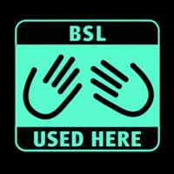

**Agenda for workshops (room 114, first floor)**

**11:30am-12pm**

**How to use SignVideo app** presented by SignVideo.

Learn how to use SignVideo app for BSL Video Relay services to communicate with hearing individuals and businesses.

**12:15pm-12:45pm**

**BSL 999 App: Emergency Access for the Deaf community** presented by SignVideo.

Understand how to use the BSL 999 app to contact emergency services directly in British Sign Language.

**1pm-1:30pm**

**Domestic Abuse Awareness for the deaf community** presented by SignHealth.

Learn about recognising abuse in deaf community, overcoming barriers and accessing support services