**Deaf and Hard of Hearing Drop-in Service**

If you have a hearing loss and need information, guidance, or advice, the Sensory Team are available in person every week; or you can contact us by email, please find details below.

**When:** Tuesday 10am -1pm and 2pm - 4pm

**Where:** Dagenham Heathway Library**,** 1 Church Elm Lane, Dagenham**,** RM10 9QS

**Email**: [sensory@lbbd.gov.uk](mailto:sensory@lbbd.gov.uk)

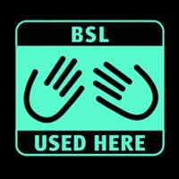**.**

**Holidays closure dates:**

**24 December 2024**

**31st December 2024**

**7th January 2025**

**15th April 2025**

**22nd April 2025**

**5th August 2025**

**12th August 2025**

**19th August 2025**

**26th August 2025**

**2nd September 2025**

**23rd December 2025**

**30th December 2025**