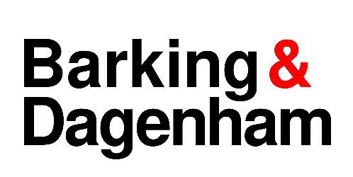

**LICENSING ACT 2003 NOTICE OF APPLICATION TO VARY A PREMISES LICENCE**

Notice is given that Dagenham & Redbridge FC 2017 Ltd has applied to the London Borough of Barking & Dagenham on 13 June 2025 to Vary a Premises Licence under Section 34 of the Licensing Act 2003 for:

|  |  |
| --- | --- |
| Premises | Dagenham & Redbridge FC  Victoria Road  Dagenham, RM10 7XL |

|  |
| --- |
| **Proposed variations:** |
| The purpose of this application is to vary the existing premises licence to permit the consumption of alcohol throughout the stadium grounds. This includes the addition of a designated fan zone located behind the Bury Road Terrace. The proposed change aims to bring the stadium’s licensing permissions in line with those of comparable venues at a similar level, thereby enhancing the overall matchday experience for supporters. This new licensed area would complement, rather than replace, the current licensed premises the clubhouse and the West Stand bar where alcohol consumption is already permitted. |

Anyone who wishes to make representations regarding this application must give notice in writing to the: Licensing Department, Regulatory Service**,** Barking Town Hall, 1 Clock House Avenue, Barking IG11 7LU or by email to [licensing@lbbd.gov.uk](mailto:licensing@lbbd.gov.uk)

Representations must be received by:

11 July 2025

The Application Record and Register may be viewed during normal office hours at the above address or at [www.lbbd.gov.uk](http://www.lbbd.gov.uk).

The Licensing Authority must receive representations by the date given above. The Licensing Authority will have regard to any such representation in considering the application. It is an offence, under section 158 of the Licensing Act 2003, to knowingly or recklessly make a false statement in or in connection with an application for premises licence. To do so could result in prosecution and a fine of any amount.