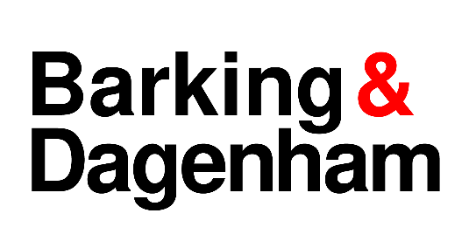
LICENSING ACT 2003 NOTICE OF APPLICATION TO GRANT A PREMISES LICENCE

Notice is given that LondonEast UK Ltd has applied to the London Borough of Barking & Dagenham on 13 October 2025 to Grant a Premises Licence under Section 17 of the Licensing Act 2003 for:

Premises | May and Baker Club  Dagenham Road  Dagenham  RM7 0QX

The Licensable activities are:
Live music, Recorded Music and Supply of Alcohol
Monday to Wednesday – 11:00 to 23:00
Thursday – 11:00 to 00:00
Friday – 11:00 to 01:00
Saturday – 10:00 to 01:00
Sunday – 10:00 to 23:00

Anyone who wishes to make representations regarding this application must give notice in writing to the: Licensing Department, Regulatory Service, Barking Town Hall, 1 Clock House Avenue, Barking IG11 7LU or by email to licensing@lbbd.gov.uk

Representations must be received by: 10 November 2025

The Application Record and Register may be viewed during normal office hours at the above address or at www.lbbd.gov.uk.

The Licensing Authority must receive representations by the date given above. The Licensing Authority will have regard to any such representation in considering the application. It is an offence, under section 158 of the Licensing Act 2003, to knowingly or recklessly make a false statement in or in connection with an application for premises licence. To do so could result in prosecution and a fine of any amount.

