Deaf and Hard of Hearing Drop-in Service

If you have a hearing loss and need information, guidance, or advice, the Sensory Team are available in person every week; or you can contact us by email, please find details below.

When: Tuesday 10am -1pm and 2pm - 4pm

Where: Dagenham Heathway Library, 1 Church Elm Lane, Dagenham, RM10 9QS

Email: sensory@lbbd.gov.uk

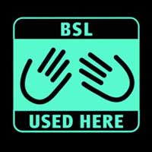.
Holidays closure dates (may change):
31st March 2026
7th April 2026
5th May 2026
26th May 2026
18th August 2026
25th August 2026
1st September 2026
22nd December 2026
29th December 2026
5th January 2027

