PLAY AND COMMUNICATE
FOR CHILDREN 0-5 YEARS WITH SPEECH & LANGUAGE NEEDS
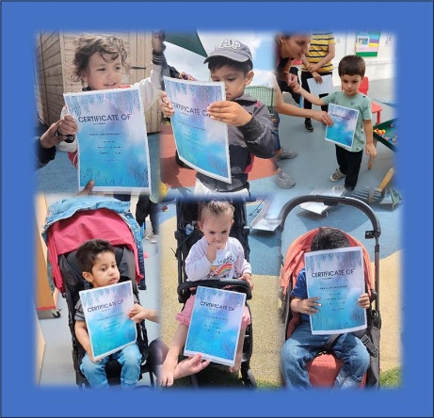
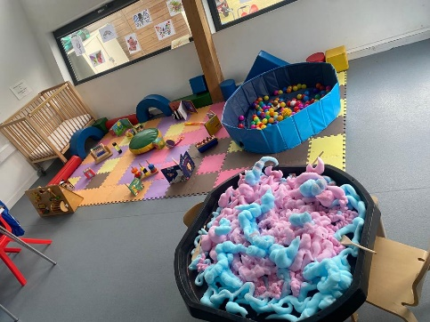

The next sessions would start on 11^{h}, and 18th, 25th of June, and 2nd, 9th and 16th of July (Thursdays)
Come along with your child to explore different range of activities that support their communication. You will meet other parents/guardians, and you will be able to speak to professionals about concerns related to your child’s growth and development for advice and suggestions.
Address: Becontree Community Hub
Stevens Road Dagenham
RM8 2QR
Main Hall
THURSDAYS: 4:15-5:45 PM
Click https://app.10to8.com/book/cypd-hub/1921925
FRIDAY: 1O:00-11:30AM
Click https://app.10to8.com/book/cypd-hub/1921928
020 8227 5500/07849836795

