London Borough of Barking and Dagenham
Post 16 Travel Arrangements Policy
2026/27

1 Statement
Local Authorities have a duty to prepare and publish an annual Post-16 Transport Policy Statement (TPS) specifying the arrangements for the provision of transport, or otherwise, that the authority considers it necessary to make to facilitate the attendance of persons of sixth form age receiving education or training. This Policy Statement is issued having regard to sections 509AA–509AD of the Education Act 1996 and the Department for Education statutory guidance ‘Post-16 transport to education and training’ (January 2019). It also sets out the separate duty under section 508F of the Education Act 1996 in respect of adult learners (aged 19 and over) with Education, Health and Care Plans (EHCPs).
We are committed to ensuring that students/young people of sixth form age, and adults with EHCPs where necessary under section 508F, have appropriate access to educational opportunities at school, college or other training establishments. Where travel assistance is provided, it facilitates attendance for the core timetabled day and does not extend to extracurricular activities, medical appointments, inter-site travel, work experience or other non-core travel unless expressly stated.

Post-19 Learners with an Education, Health and Care Plan (EHCP)
Under section 508F of the Education Act 1996, the Local Authority has a duty to consider travel assistance for adult learners aged 19 and over who hold an Education, Health and Care Plan (EHCP). This section outlines the operational arrangements that apply specifically to these learners.
Where transport is provided under section 508F, it must be provided free of charge.

2 Travel options and costs
Details of all concessionary / free fares, discounts, subsidies, passes or travel cards available for student/young person aged 16–18 and who provides them, plus details of any costs to the student/young person.
Free or reduced-price travel
Most students/young people of sixth form age and adult learners will be able to get to school/college or training on foot or by using public transport.
There are many travel options for students/young people within our Borough, and within London, and this is either free or offered at a reduced rate by Transport for London for many students/young people who are 16 or over.
Transport for London travel for students/young people of sixth form age
16+ Oyster Photo Card
Students/young people who are 16–18, live in London and are in full-time education, can apply for free travel on buses and public transport using a 16+ Oyster photo card if they are:
- Under 19 on the 31st August prior to the start of the current academic year;
- Living in a London Borough; and
- In full-time education (as defined under the scheme).
This enables students/young people to travel for free on Buses and Trams. Students can also get reduced travel fares on the Tube, DLR and London Overground Services.
Students/young people may apply for an Oyster Card through the Transport for London website:
Zip Oyster photocards – Transport for London
Freedom Pass
The Freedom Pass is for people who have a permanent disability that imposes a mobility problem or who are registered blind.
The 16–19 Bursary Fund
This is a discretionary award available for education-related costs for students/young people between the ages of 16 and 18. It can also be made to pupils who are 19 or over if they continued on a course they started when they were 16, 17 or 18 or if they have an Education Health and Care Plan (EHCP).
Find out more at 16 to 19 Bursary Fund – GOV.UK
Dial-a-Ride
Some students/young people may be eligible for travel assistance from Dial-a-Ride (TfL) if they meet any of the following criteria:
- A Taxi Card Member
- In receipt of the Higher Rate Mobility component of Disability Living Allowance
- Registered blind or partially sighted
- In receipt of Higher Rate Attendance Allowance
Other students/young people can apply but will need to complete a paper-based assessment to determine their eligibility.
How to apply to Dial-a-Ride: you may apply for this service by downloading the application form from the website Dial-a-Ride – Transport for London or by calling 0343 222 7777.
Apprentices and trainees can make use of TfL concessions as above and may obtain some assistance from their employer. Information is available at Gov.uk.

3 SEND Applicants
Where a young person/student and/or their parent/carer (acting on their behalf) has a learning difficulty and/or disability, a transport needs assessment will be undertaken as part of the EHCP annual review and/or transition planning. Applications for assistance must be made annually. For learners of sixth form age, eligibility is determined under the post-16 transport framework and is not an extension of the compulsory school-age scheme.
Decisions focus on whether it is reasonable to provide support to facilitate attendance, having regard to the student/young person’s age, capacity for safe and independent travel (with training or reasonable adjustments where appropriate), their SEND/medical needs, journey times and reliability of available transport, and overall value for money. There is no expectation at post-16 that parents or carers will escort the young person to and from education.
Eligibility and Assessment
An EHCP does not of itself confer entitlement to travel assistance. Where a particular institution is named in an EHCP in accordance with parental or student/young person preference and it is not the nearest suitable institution, the Council may take into account any additional costs arising. Assessments are conducted on an individual basis. Support may include but is not limited to: Independent Travel Training (ITT), a personal travel budget or allowance, or arranged transport where necessary. Eligibility is reviewed at least annually with a continued emphasis on developing independence where appropriate.
In considering distance, the Council may have regard to the statutory walking distance of 3 miles applicable to compulsory school age as a useful benchmark. However, there is no automatic entitlement to travel assistance beyond any specified distance at post-16. Each case will be assessed individually, considering distance, journey time, safety of the route, the student/young person’s ability to travel independently, and other relevant factors.

Eligibility and Assessment for Adult Learners (19+)
Eligibility for travel assistance is determined following an individual transport needs assessment. This section applies to relevant young adults aged 19–25 with an EHCP who started their current course after their 19th birthday. The assessment considers the student’s capacity for safe and independent travel, their SEND or medical needs, the suitability and reliability of available travel options, journey times, and overall value for money. Where a preferred institution is not the nearest suitable provider named in an EHCP, the Local Authority may take into account any additional transport costs arising.
The Local Authority aims to promote and support independence for adult students wherever appropriate. Assistance may include Independent Travel Training (ITT), a personal travel budget or allowance, or arranged transport where necessary. Where ITT is assessed as suitable, participation may be required unless there are exceptional circumstances.
Adult learners with EHCPs must apply for travel assistance annually. Awards are not automatically renewed and will be reviewed each academic year, or sooner where circumstances change, such as a change of address, place of learning, or SEND/health needs.
Applicants must provide all required evidence at the point of application. Incomplete applications or missing information may result in no award being made. Eligibility checks may be undertaken during the academic year to ensure the appropriate use of public funds.
Where transport assistance is provided, it supports attendance for the core timetabled day only. It does not cover extracurricular activities, medical appointments, inter-site travel, work placements, or other non-core travel unless explicitly stated.
Where a student/young person is eligible for travel assistance, it will be reviewed each year, ensuring that the student/young person’s independence is maximised.

Independent Travel Training for students/young people who face difficulty with transport
The Council’s preferred option for students/young people with an EHCP is Independent Travel Training (ITT), which seeks to promote independence so that students/young people will ultimately be able to travel on their own.
For some students/young people ITT would not be appropriate due to their complex needs, but where students have the potential to benefit from ITT it is expected that those students will take part in the programme.
It is a programme of support that aims to enable a student/young person to become an independent and safe traveller; as a result it covers topics such as road safety, personal safety, journey planning and coping strategies.
If it is identified through a transport needs assessment process that travel training would be an option for an individual student/young person, a referral can be made by the school, EHCP team or the family/student/young person. On receipt of a referral, the team will evaluate the suitability of travel training for that particular student/young person and, where appropriate, begin a personalised programme of training to meet their needs.
If a place is offered and a student/young person (and/or their parent/carer acting on their behalf) declines to participate in Independent Travel Training, the Council may review the overall travel assistance arrangements. Any review will be proportionate and based on individual circumstances; travel assistance will not be withdrawn automatically.

When to apply for travel assistance or support
You can apply any time after you know where you have been offered a place at school/college and you are encouraged to submit your application as soon as possible. All students/young people need to apply on an annual basis.

4 Vulnerable Students/Young People
The Council may also offer assistance to a student/young person of 16 or 17 who is vulnerable to not being in education, employment or training (NEET), or who has already become NEET if it considers this necessary to support their participation.

5 How to apply for Travel Assistance
Applications must be made online using the link below:
https://www.lbbd.gov.uk/travel-assistance-application-form
Applicants must provide all evidence listed or requested by the Council. Where a form is incomplete and/or evidence is not provided as requested within any given time limit, no award can be made.
Notes for applicants for discretionary awards
Awards
A decision will be given in writing, including reasons for a refusal. Where an application is successful, assistance will be given for a specified period, or until it is reviewed. No award will be for more than one academic year. It is the responsibility of the student/young person and/or their parent/carer (acting on their behalf) to make a further application. Awards cannot be backdated.
Reviews
Assessments of the need for assistance will be reviewed annually and more frequently where circumstances change within the year.
Changes in circumstances
Students/young people and/or their parent/carer (acting on their behalf) must inform the Council of any changes in circumstances that may affect entitlement to assistance.
Eligibility Checks
The Council has a duty to ensure that it protects public funds. The Council may contact students/young people and/or their parent/carer (acting on their behalf) during the academic year to ensure they are still eligible for assistance.
Awards made in error
Where an award of assistance has been made in error, the Council has the right to withdraw this after first considering the circumstances of each case to determine whether there are exceptional reasons for provision to continue.
Fraud
Where an award of assistance has been made as a result of fraud it will be withdrawn immediately.

Compliments, Complaints and Appeals
We value feedback from students/young people and/or their parent/carer (acting on their behalf), whether it is a compliment, a complaint, or an appeal regarding our post-16 travel assistance.
Complaints
If you have a complaint regarding our post-16 travel assistance, please follow these steps:
Stage 1:
We aim to respond within 10 working days.
Stage 2:
If dissatisfied, you may request escalation within 28 days.

Appeals
If you disagree with the local authority’s decision regarding eligibility for post-16 transport, you have the right to appeal.
Stage One – Review by a senior officer
A student/young person and/or their parent/carer (acting on their behalf) has 20 days from receipt of the post-16 transport decision to request a review.
Within 20 days of receipt of the request, a senior officer will review the original decision and provide a detailed written notification.
Stage Two – Independent appeal panel
A student/young person and/or their parent/carer (acting on their behalf) has 20 days from receipt of the Stage One decision to request escalation to Stage Two.
Within 40 days of receipt of the Stage Two request, an independent appeal panel will consider written and verbal representations and will issue a written decision within 5 working days of the panel hearing.
The appeal panel members are independent of the original decision-making process.
Appeals can be made to:
transport.appeals@lbbd.gov.uk
The Council follows the two-stage review and appeal process recommended in the Department for Education statutory guidance (January 2019).

LGSCO
There is a right of complaint to the Local Government and Social Care Ombudsman (LGSCO). If a complainant considers the decision of the independent panel to be flawed on public law grounds, they may also apply for judicial review.
The LGSCO is an independent organisation that investigates complaints against councils. It is a free service and information can be found online at:
www.lgo.org.uk

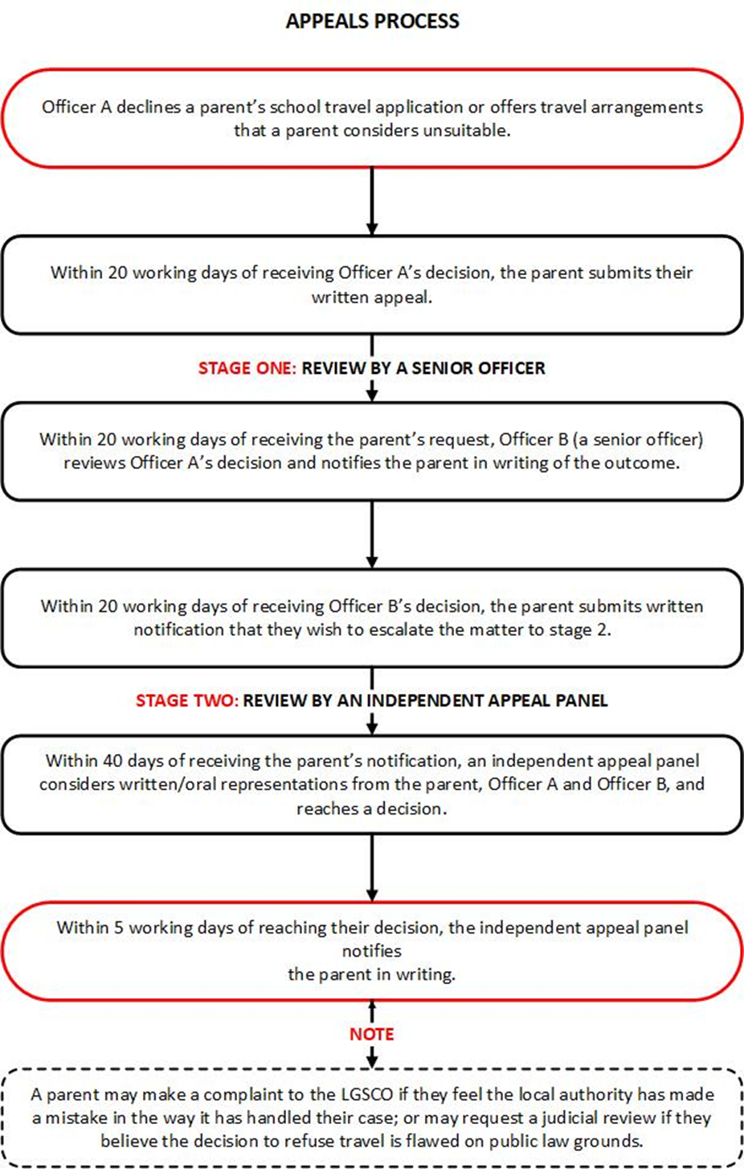

Contact Details
Transport Commissioning
Opening times: 07.00am - 10.30am - 2pm – 17.30pm
Contact Numbers: 020 8227 2713
E-mail – transport.request@lbbd.gov.uk
Mobility Services
Contact Number: 020 8227 2334 - 020 8227 2325
E-mail: mobility@lbbd.gov.uk
Community Learning Development Team
Contact number: 020 8227 5432
E-Mail: cldtintake@lbbd.gov.uk
7 Local Colleges
Barking & Dagenham College, Dagenham Road, Romford, RM7 0XU – 020 8090 3020
Redbridge College, Little Heath, Barley Lane, Romford R6 4XT – 020 8548 7400
Havering College, Ardleigh Green Road, Hornchurch, RM11 2LL – 01708 455 011

