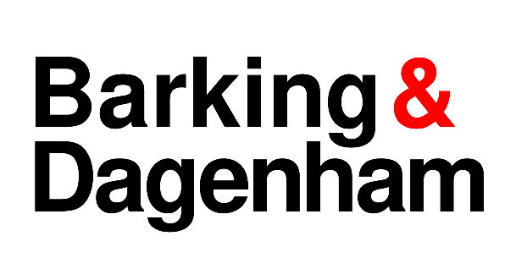

Notice is hereby given that the London Borough of Barking and Dagenham, as the Licensing Authority under the Gambling Act 2005, is undertaking a statutory review of its Statement of Principles (Gambling Policy) for the period 2026–2029.

The Gambling Act 2005 requires every Licensing Authority to prepare, consult upon and publish a Statement of Principles at least every three years. The policy sets out the principles the Council will apply when carrying out its licensing functions under the Act.

The draft Statement of Principles is available for inspection at the Council’s offices at Barking Town Hall, Town Hall Square, Barking IG11 7LU during the consultation period and can be viewed on the Council's One Borough Voice consultation webpage.

The consultation will run from: 13 July 2026 to 24 August 2026

The Council welcomes comments from residents, businesses, licence holders, responsible authorities and any other interested parties.

Responses should be submitted via email at gamblingconsultation@lbbd.gov.uk or in writing at Licensing Department, Regulatory Service, Barking Town Hall, 1 Clock House Avenue, Barking IG11 7LU.

